

SECURE VOTING SYSTEM WITH AADHAR VERIFICATION THROUGH BLOCKCHAIN
AegisBallot: a local e-voting web application with Aadhaar verification, encrypted ballots and an auditable hash-chained ledger
A project report submitted in partial fulfilment of the requirements for the award of the degree of
BACHELOR OF TECHNOLOGY
in
COMPUTER SCIENCE AND ENGINEERING
Submitted by
Mohammed Anwar-Ul-Haq | 23K91A05F6
Mohammad Mosin | 23K91A05F4
Manda Akshitha | 23K91A05E4
Kothlapur Ganesh | 24K95A0516
Batch C1 (CSE-C)
Under the esteemed guidance of
B Shruthi
[DESIGNATION]
DEPARTMENT OF COMPUTER SCIENCE AND ENGINEERING
TKR COLLEGE OF ENGINEERING & TECHNOLOGY (AN AUTONOMOUS INSTITUTION)
Medbowli, Meerpet, Balapur, Hyderabad, Telangana - 500 097
Academic year [ACADEMIC YEAR]

CERTIFICATE
This is to certify that the project report entitled "SECURE VOTING SYSTEM WITH AADHAR VERIFICATION THROUGH BLOCKCHAIN" is a bonafide record of the work carried out by Mohammed Anwar-Ul-Haq (23K91A05F6), Mohammad Mosin (23K91A05F4), Manda Akshitha (23K91A05E4), Kothlapur Ganesh (24K95A0516), in partial fulfilment of the requirements for the award of the degree of Bachelor of Technology in Computer Science and Engineering, during the academic year [ACADEMIC YEAR], under my supervision.

Project Guide | Head of the Department | Principal
B Shruthi | [HOD NAME] | [PRINCIPAL NAME]
[DESIGNATION] | Department of Computer Science and Engineering | TKR College of Engineering & Technology

External Examiner: [NAME AND SIGNATURE]
Place: [PLACE]
Date: [DATE]

DECLARATION
We hereby declare that the project report entitled "SECURE VOTING SYSTEM WITH AADHAR VERIFICATION THROUGH BLOCKCHAIN", submitted to the Department of Computer Science and Engineering, TKR College of Engineering & Technology, in partial fulfilment of the requirements for the award of the degree of Bachelor of Technology in Computer Science and Engineering, is a record of original work carried out by us under the guidance of B Shruthi, [DESIGNATION]. The results embodied in this report have not been submitted to any other university or institution for the award of any degree or diploma.

Mohammed Anwar-Ul-Haq 23K91A05F6
Mohammad Mosin 23K91A05F4
Manda Akshitha 23K91A05E4
Kothlapur Ganesh 24K95A0516

Place: [PLACE]
Date: [DATE]

ACKNOWLEDGEMENT
We express our sincere gratitude to our project guide, B Shruthi, [DESIGNATION], for valuable guidance, encouragement and constructive suggestions throughout this project.
We thank [HOD NAME], Head of the Department of Computer Science and Engineering, for providing the facilities and support needed to complete this work, and [PRINCIPAL NAME], Principal, TKR College of Engineering & Technology, for the encouragement given to us.
We thank the project coordinators and all faculty and staff members of the department for their help, and our families and friends for their constant support.
We also acknowledge the authors of the base paper, the maintainers of the open-source software used in this project (FastAPI, SQLAlchemy, the cryptography and argon2-cffi libraries, React, Vite, Tailwind CSS and Recharts), and the researchers whose published work on blockchain voting is listed in the references.

Mohammed Anwar-Ul-Haq
Mohammad Mosin
Manda Akshitha
Kothlapur Ganesh
Elections depend on public confidence that every eligible person votes once, that no vote is altered, and that the result can be checked. Manual polling is slow and error-prone, while a conventional electronic voting system keeps ballots in a database that an administrator could change without trace. This project presents AegisBallot, a local web application that combines Aadhaar-style identity verification with an append-only, hash-chained ledger. A voter signs in, enters a 12-digit Aadhaar number that is checked for format, Verhoeff checksum and membership of a salted-hash registry (a synthetic demonstration registry; UIDAI is not contacted), and receives a single-use token that expires in ten minutes. The chosen candidate is encrypted with AES-256-GCM, the transaction is signed with Ed25519 and committed as a block approved by two of three validators; the voter keeps a receipt. Administrators manage elections and candidates, and auditors recompute the chain and read the audit log. The backend uses FastAPI and SQLite and the interface uses React.
Evaluation is functional and performance based because the system contains no learned model. All 17 automated tests passed and 25 of 25 HTTP security and functional checks returned the expected status. A benchmark of 1000 synthetic voters completed every vote without failure at a mean of 44.9 ms per vote on a shared PC (about 16-17 ms on an idle PC), and a complete voter journey over HTTP took 161 ms on average. A tamper study showed that the product's integrity check detects 7 of 13 kinds of tampering; it misses edits to the table the tally is read from, edits made with every hash recomputed, forged validator signatures and removal of the newest block, which a stricter audit written for the study detects. The ledger is a single-machine simulation of a permissioned chain, ballot secrecy is partial, and TLS is not configured; the base paper's Ethereum results are not directly comparable.
Keywords: secure electronic voting, Aadhaar verification, blockchain, cryptographic hashing, role-based access control, audit logging, election integrity, digital democracy.

TABLE OF CONTENTS
CERTIFICATE i
DECLARATION ii
ACKNOWLEDGEMENT iii
TABLE OF CONTENTS v
LIST OF FIGURES vii
LIST OF TABLES ix
LIST OF ABBREVIATIONS x
CHAPTER 1: INTRODUCTION 1
1.1 Domain and Background 1
1.2 Motivation 2
1.3 Problem Statement 2
1.4 Need of the Project 3
1.5 Objectives 3
1.6 Scope 4
1.7 Contributions 4
1.8 Limitations and Assumptions 5
1.9 Organisation of the Report 5
CHAPTER 2: LITERATURE SURVEY 7
2.1 Overview 7
2.2 Base Paper Analysis 7
2.3 Related Work 9
2.4 Datasets and Algorithms Used 11
2.5 Strengths and Limitations of the Existing Work 12
2.6 Research Gap 13
CHAPTER 3: FEASIBILITY STUDY 14
3.1 Technical Feasibility 14
3.2 Economic Feasibility 15
3.3 Operational Feasibility 16
3.4 Schedule Feasibility 16
3.5 Advantages and Constraints 17
CHAPTER 4: SYSTEM REQUIREMENTS AND ANALYSIS 18
4.1 Existing System and Its Limitations 18
4.2 Proposed System and Its Advantages 18
4.3 Functional Requirements 19
4.4 Non-Functional Requirements 20
4.5 Hardware Requirements 21
4.6 Software Requirements 21
4.7 User Roles 22
4.8 Requirement Traceability 22
4.9 Constraints and Assumptions 22
CHAPTER 5: SYSTEM DESIGN 24
5.1 Design Goals and Architecture 24
5.2 High-Level Workflow 25
5.3 Data Flow Diagrams 27
5.4 UML Diagrams 29
5.5 Database Design 31
5.6 Module Design 33
5.7 Algorithm Design 35
5.8 User-Interface Design 37
5.9 Design Decisions and Their Reasons 37
CHAPTER 6: METHODOLOGY AND SOFTWARE IMPLEMENTATION 38
6.1 Overall Methodology 38
6.2 Data and Test Data 38
6.3 Input Validation and Normalisation 39
6.4 Algorithm Choice and Justification 39
6.5 Mathematical Formulation 40
6.6 Security Design 42
6.7 Application Architecture 43
6.8 API Design 43
6.9 Security Handling and Error Handling 44
6.10 Implementation Notes and Behaviour Found on Review 45
6.11 Installation and Execution 46
CHAPTER 7: SYSTEM TESTING 47
7.1 Testing Strategy and Environment 47
7.2 Unit Tests 47
7.3 Integration Tests over HTTP 48
7.4 Functional Tests 49
7.5 Security Tests 50
7.6 Tamper-Detection Tests 51
7.7 Validation and Edge Cases 52
7.8 Performance Tests 53
7.9 User Acceptance 55
7.10 Limits of the Testing Done 55
7.11 Summary of Testing 56
CHAPTER 8: RESULTS AND OUTPUT SCREENS 57
8.1 Experimental Set-up and Data 57
8.2 Output Screens 57
8.3 System Performance Results 62
8.4 Security and Integrity Results 63
8.5 Comparison with the Base Paper 64
8.6 Sample Inputs and Outputs 65
8.7 Success and Failure Analysis 66
8.8 Limitations of the Results 67
8.9 Objectives Versus Outcomes 68
CHAPTER 9: CONCLUSION 69
9.1 Summary of the work 69
9.2 Objectives achieved 69
9.3 Key findings 69
9.4 Practical applications 70
9.5 Known limitations 71
CHAPTER 10: FUTURE SCOPE 72
10.1 Improvements to the present design 72
10.2 Additional features 72
10.3 Scalability and deployment 73
10.4 Further research 73
REFERENCES 75
APPENDIX A: IMPORTANT CODE 77
A.1 Verhoeff checksum (`app/identity/verhoeff.py`) 77
A.2 Aadhaar verification provider (`app/identity/provider.py`) 77
A.5 Issuing the one-time token (`app/services/voting_service.py`) 77
A.6 Casting a ballot (`app/services/voting_service.py`) 78
A.8 Block proposal, validator quorum and commit (`app/ledger/ledger.py`) 78
A.9 Chain validation (`app/ledger/ledger.py`) 79
A.11 Session guard, role guard and login route (`app/api_v1.py`) 80
APPENDIX B: INSTALLATION AND USER GUIDE 81
B.1 Requirements 81
B.2 Installation and start (automatic) 81
B.3 Manual start 81
B.4 Demonstration accounts 81
B.5 User guide by role 82
B.6 Tests, benchmark and smoke test 82
B.7 Troubleshooting 82
APPENDIX C: ADDITIONAL SCREENS 84

LIST OF FIGURES
Figure 1: Four-tier architecture of AegisBallot: React single-page app, FastAPI application, service layer with the local ledger, SQLite storage. 25
Figure 2: Election life cycle and the path of one vote, from election creation to the auditor's check. 26
Figure 3: Context diagram (DFD level 0) of AegisBallot with its three user roles and two stores. 27
Figure 4: DFD level 1: eight processes and six data stores. 28
Figure 5: DFD level 2: processes 4.0 and 5.0 expanded into eleven sub-processes (cast_vote and propose_block). 28
Figure 6: Class diagram of the persistent models with the service modules and the identity-provider interface. 29
Figure 7: Use cases of the voter, the administrator and the auditor. 30
Figure 8: Sequence of Aadhaar verification and casting one ballot through the JSON API. 31
Figure 9: Entity-relationship diagram of the thirteen tables. 32
Figure 10: Flowchart of casting a ballot: checks, encryption, signing, quorum and commit. 36
Figure 11: Flowchart of validate_chain, the function behind the auditor's integrity check. 36
Figure 12: Cost of each primitive on a logarithmic scale. 55
Figure 13: Landing page (dark theme): the headline, a "demonstration environment - synthetic identities only" badge, and a live-ledger card listing the latest blocks (209 to 211) with their "2/3 signed" status and "chain valid". 57
Figure 14: Landing page, live figures: 8 elections, 211 ballots recorded, 212 blocks, 3 validator nodes, read from /api/public/overview, and the three feature cards (encrypted ballots, ledger integrity, independent audit). 57
Figure 15: Landing page, "How it works": the four steps (verify who you are, one-time authorisation, encrypted ballot, ledger receipt), with step 1 expanded. The capture caught the header over the section title. 58
Figure 16: Landing page, "What is on the ballot": all eight elections with their status and window, including the closed Community Welfare Board 2026 and the smoke-test election. 58
Figure 17: Landing page in the light theme (toggle in the header). 58
Figure 18: Light theme: live figures and feature cards. 58
Figure 19: Light theme: the four-step explanation. 58
Figure 20: Light theme: the election list. 58
Figure 21: Sign-in page: username and password, the demonstration badge and quick-fill buttons for the admin, voter and auditor demo accounts; voters are voter1 to voter20. 59
Figure 22: Administrator dashboard: 200 registered voters, 211 votes cast across 8 elections, ledger height 212 with a "ledger healthy" badge, a turnout-by-election bar chart (a tooltip shows 0 of 20 for Campus Council) and the three validators, all active, quorum 2 of 3. 59
Figure 23: Elections list: each card shows status, window, votes against eligible voters and a progress bar, with Open, Pause, Close, Results and Manage controls. The benchmark elections show 50 of 50 voted. 59
Figure 24: "Create an election" dialog: title, description, start and end. A new election starts as a draft and every registered voter is made eligible automatically. 59
Figure 25: Election detail for the Screenshot Demo Election: 200 eligible voters, 2 votes, 1.0 % turnout, the three candidates with party and manifesto, and Add candidate and Deactivate controls. 59
Figure 26: Results of the closed Community Welfare Board 2026: 8 ballots decrypted for the count, a vote-share chart and a ranked table (3, 3 and 2 votes; the first two marked "tied for lead"). 60
Figure 27: Performance benchmarks: the stored run of 50 voters (62.2 operations per second synchronous, 61.7 batched, mean latency 16.1 ms), throughput and latency charts and the list of recent runs. 60
Figure 28: The administrator dashboard at phone width (390 x 844): the layout collapses to one column with a bottom navigation bar. 60
Figure 29: Voter home (voter3, shown as Aditya Verma): open elections with "Verify and vote", a closed election with "View results" and, where the voter has already voted, a "Vote confirmed" box with the receipt id. 61
Figure 30: Step 1 of 3, Aadhaar verification: the masked number on file, the 12-digit entry field and the note that only a salted hash is kept. 61
Figure 31: Step 2 of 3: identity verified, a ten-minute countdown for the one-time authorisation, three candidate cards with one selected and a "Confirm and submit vote" bar that warns that the choice is encrypted and cannot be changed. 61
Figure 32: Step 3 of 3, receipt: ballot receipt id, transaction hash, block number 212 and block hash, with the statement that two of three validators signed the block and that the receipt does not reveal the candidate. 61
Figure 33: Voter home after voting: the Screenshot Demo Election now shows "Vote confirmed" with the receipt id and "Your ballot is sealed; results appear when the election closes". 61
Figure 34: Auditor ledger audit: 213 blocks and the tip hash, "Verified just now: all 213 blocks are consistent", the result of the tamper-detection demo on a clone, the validator list and tabs for blocks, transactions and the audit log. 62
Figure 35: Block detail (block 1): index, timestamp, number of transactions, previous hash, Merkle root, block hash and the three validator signatures (3 of 3 signed, quorum 2), with previous and next navigation. 62
Figure 36: Latency of login, Aadhaar verification, cast and the whole voter journey through HTTP (27 voters). 63
Figure 37: Result of the tamper study: 7 of 13 cases are detected by the product's check, all by the stricter audit. 63
Figure 38: Landing page, live counters (elections, ballots recorded, blocks on the ledger, validators) and the three feature cards. 84
Figure 39: Landing page, "From Aadhaar check to a verified receipt": the four steps of a vote. 84
Figure 40: Landing page, "What is on the ballot": the elections held in the database with their status. 84
Figure 41: Administrator: election list with status, turnout and the open, pause, close and results actions. 84
Figure 42: Administrator: election detail with eligible voters, votes cast, turnout and the candidate cards. 84
Figure 43: Administrator: stored benchmark run with throughput, mean latency and per-mode charts. 84

LIST OF TABLES
Table 1: Abbreviations used in this report x
Table 2: Objectives of the project and how each was addressed 3
Table 3: Comparison of the surveyed work 11
Table 4: Algorithms and mechanisms used in the literature and in AegisBallot 11
Table 5: Research gap and the response in AegisBallot 13
Table 6: Technical risks identified during the study 14
Table 7: Cost items of the prototype and of a production deployment 15
Table 8: Phases of the project 16
Table 9: Existing approaches and their limitations 18
Table 10: Advantages of the proposed system over the existing approaches 19
Table 11: Functional requirements and the routes that implement them 19
Table 12: Non-functional requirements and measured values 20
Table 13: Hardware 21
Table 14: Software 21
Table 15: User roles and permissions 22
Table 16: Traceability of objectives to requirements 22
Table 17: Tiers of the base paper's model and of AegisBallot 25
Table 18: Processes and data stores of the level-1 diagram 27
Table 19: Use cases by actor 29
Table 20: Tables for users, elections and eligibility 32
Table 21: Tables that implement one voter, one vote 32
Table 22: Tables of the ledger and the audit trail 33
Table 23: Modules of AegisBallot 33
Table 24: Pages of the React application (frontend/src/App.tsx) 35
Table 25: Principal design decisions 37
Table 26: Data used by the system and by the evaluation 38
Table 27: Algorithms and why they were chosen 39
Table 28: Threats and controls 42
Table 29: Routes of app/api_v1.py 44
Table 30: HTTP status codes used by the API 44
Table 31: The 17 pytest tests and their result 47
Table 32: HTTP security and functional checks: expected and observed status 48
Table 33: Functions, evidence and outcome 49
Table 34: Security properties and the checks that cover them 50
Table 35: Tamper cases and whether each check detects them 51
Table 36: Benchmark of 1000 voters (shared PC) 53
Table 37: Earlier benchmark runs on an idle PC (8 September 2026) 53
Table 38: validate_chain time against chain length 54
Table 39: Latency of the voter journey over HTTP (27 voters, milliseconds) 55
Table 40: Headline performance results 62
Table 41: AegisBallot against the base paper 64
Table 42: Sample refused requests and what the application answers 65
Table 43: Objectives and outcomes 68
Table 44: Objectives against outcomes 69
Table 45: Suggested order of work 73
Table 46: Accounts created by the seed script 81
Table 47: Common problems 82

LIST OF ABBREVIATIONS
Table 1: Abbreviations used in this report
Abbreviation | Expansion
AES | Advanced Encryption Standard
API | Application Programming Interface
CSRF | Cross-Site Request Forgery
DFD | Data Flow Diagram
ER | Entity-Relationship
GCM | Galois/Counter Mode
HTTP | Hypertext Transfer Protocol
HTTPS | HTTP over TLS
JSON | JavaScript Object Notation
KYC | Know Your Customer
OTP | One-Time Password
ORM | Object-Relational Mapping
PBFT | Practical Byzantine Fault Tolerance
RBAC | Role-Based Access Control
REST | Representational State Transfer
SHA | Secure Hash Algorithm
SPA | Single-Page Application
SQL | Structured Query Language
TLS | Transport Layer Security
UIDAI | Unique Identification Authority of India
UML | Unified Modeling Language
UI | User Interface
UUID | Universally Unique Identifier
ZKP | Zero-Knowledge Proof

CHAPTER 1: INTRODUCTION
This chapter introduces the domain of the project, the motivation for building AegisBallot, the problem it addresses, the objectives set for it, the scope that was actually delivered, the contributions, and the limitations and assumptions that govern every result reported later. It closes with a map of the rest of the report.

1.1 Domain and Background
An election is a procedure by which a population chooses its representatives, and its value rests on public confidence that each eligible person voted at most once, that no vote was altered after it was cast, and that the published result follows from the votes. Traditional polling achieves this with physical infrastructure: voter lists, polling booths, paper ballots or electronic voting machines, and a manual or semi-automated count. These processes are slow, they need large numbers of staff, and they concentrate trust in the people who run the booth and the count. The base paper of this project lists the same weaknesses for conventional systems: security and manipulation concerns, a lack of transparency, limited accessibility, high cost and slow counting [1].
Digital voting removes some of these weaknesses and introduces others. A web application can accept a vote from any connected device and tally it in seconds, but a conventional implementation stores the ballots in a database whose administrator can edit or delete rows without leaving a visible trace. Two further questions then decide whether the system can be trusted: who is allowed to vote, and how an outsider can check the outcome. The first is a question of identity; the second is a question of auditability.
Blockchain technology offers a way to address the second question. A blockchain is a list of records, called blocks, in which each block contains the cryptographic hash of the previous block, so that changing an old record changes every later hash and is therefore detectable [15], [19]. When the blocks are produced by a small, known set of validators rather than by anonymous miners the ledger is called permissioned [17], and agreement among the validators can follow a Byzantine fault-tolerant protocol [18]. Blockchain voting proposals are numerous, and surveys agree that privacy protection and transaction speed are the most frequently reported difficulties [8].
India's national identity number, Aadhaar, is a 12-digit number whose last digit is a check digit computed with the Verhoeff algorithm [25]. The number is issued under the Aadhaar Act of 2016 [27] and is widely used to bind a person to a record. A voting system for Indian users that wants to enforce one voter, one vote needs to tie each ballot to a verified identity without letting the ballot reveal the person who cast it. This project, AegisBallot, examines that combination in a working local prototype: Aadhaar-style identity verification in front of an encrypted, hash-chained, validator-signed ledger, with an administrator console and an auditor console around it.
Three terms are used throughout the report. A ballot is the encrypted record of one voter's choice. A block is a ledger entry that holds one signed transaction and the hash of the block before it. An audit is the recomputation of hashes by a person who does not control the system, which in AegisBallot is the auditor role.

1.2 Motivation
Three observations motivated the project. First, identity and ledger are usually studied separately. The Oman model that serves as the base paper authenticates voters with biometric technology and records votes through Ethereum smart contracts, but its administration workflow is simulated by client programs and it is not tied to an Indian national identity [1]. The Aadhaar-based proposal in the batch folder describes hashing of identity documents and a chain of vote records but reports no performance or tamper tests [2]. A system that joins identity, ledger, administration and audit in one deployable application is the gap named in the batch literature survey.
Second, the security claims of voting software are only as strong as the checks that can be run against them. Real deployments have been found to contain weaknesses that an analysis of the running system exposed: the Estonian internet voting system was analysed in use and attack paths were found [10], and the Voatz mobile voting application, which was marketed with blockchain, was shown to have exploitable weaknesses outside the blockchain itself [12]. The team therefore decided that the project should not only claim integrity but also measure which kinds of tampering its own integrity check detects, and report the cases it does not.
Third, a student-built system can be run, inspected and measured in full on one ordinary computer, which allows every number in this report to come from a run the reader can repeat. The whole platform, from the database to the validators, starts with one script and needs no network service or cryptocurrency.

1.3 Problem Statement
The batch problem statement lists four weaknesses of the present situation. The team restates them as the problem that the project addresses:
• Manual voting is slow, needs heavy physical infrastructure and delays the declaration of results.
• Conventional digital voting stores ballots in a database that an administrator could alter.
• Without binding a ballot to a verified identity, duplicate or ineligible voting cannot be prevented reliably.
• Voters and observers have no way to verify independently that the result was not manipulated.
The need that follows from these weaknesses is a voting platform that verifies identity, records every ballot so that later alteration is detectable, and gives an auditor the means to recompute the result and the chain.

1.4 Need of the Project
The need is both practical and methodological. Practically, an election authority that wants an electronic channel needs a design in which no single operator can change a vote unnoticed, in which a voter can obtain proof that the vote was recorded, and in which the same voter cannot vote twice. Methodologically, a project that claims such properties needs an evaluation that tests them: functional tests of the rules, a test of what the integrity check detects, and measurements of the cost of the added safeguards. The base paper concentrates on the time taken by registration and voting transactions on a test chain [1]; AegisBallot adds the identity and administration layers and also tests the audit mechanism.
It is equally important to state what the project does not provide. It does not contact the Unique Identification Authority of India, it does not run a distributed network of validators, and it is not a system for a national election. It is an academic prototype whose purpose is to show the design, to measure it honestly and to record where its protection ends.

1.5 Objectives
The batch fixed six objectives. The table below lists each of them with the feature of AegisBallot that addresses it and the evidence collected in the later chapters.
Table 2: Objectives of the project and how each was addressed
No. | Objective (batch document 6) | Feature of AegisBallot | Evidence
1 | Voter registration and authentication with Aadhaar-based identity verification | Argon2id login; Aadhaar check of 12 digits, Verhoeff checksum, salted-hash registry lookup and match with the signed-in account | Chapter 7: HTTP checks on format, checksum, unknown and foreign numbers
2 | One-voter-one-vote through identity binding and duplicate checks | Eligibility row, single-use token, unique participation row and ledger nonce check | Chapter 7: replay and second-verify checks; unit test for duplicate vote
3 | Immutable recording of each ballot using blockchain and cryptographic hashing | AES-256-GCM ballot, Ed25519-signed transaction, SHA-256 hash-chained block approved by 2 of 3 validators | Chapter 8: tamper study, 7 of 13 cases detected by the product check
4 | Administration portal for elections, candidates and polling windows | Admin console: create, open, pause, close elections; add and deactivate candidates | Chapter 8: output screens
5 | Automatic results at close with a chronological audit trail | Tally from decrypted ballots after CLOSED; audit_logs table and auditor view | Chapter 8: results and auditor screens
6 | RBAC, input validation and TLS; evaluate integrity and performance | Three roles, CSRF token, rate limits, schema validation; benchmark and timing study; TLS not configured | Chapter 7 and 8: 25 of 25 security checks, benchmark of 1000 voters

Objective 6 is only partly met. Role-based access control, input validation and rate limiting are implemented and tested, and the integrity and performance evaluations were carried out, but Transport Layer Security is not part of the shipped configuration: the application runs over plain HTTP on the local machine.

1.6 Scope
The delivered scope has four parts. The identity part covers registration of synthetic voters with a salted, peppered hash of the Aadhaar number, the Verhoeff checksum, a registry lookup behind an interface (IdentityVerificationProvider) that a real adapter could replace, and the rule that the verified number must belong to the signed-in voter. The ballot part covers the one-time authorisation token, AES-256-GCM encryption of the choice, the Ed25519-signed transaction and the receipt. The ledger part covers a genesis block, one block per vote, three validators with a quorum of two, hash chaining, a chain validation function and an auditor tamper demonstration. The administration part covers elections with a status life cycle (draft, open, paused, closed), candidates, turnout, tallies, an audit log and a benchmark page.
The platform is a web application with a FastAPI backend on port 8401, a SQLite database of 13 tables and a React interface on port 5401. Out of scope are connection to UIDAI or any biometric or one-time-password factor, a distributed network of validators, public blockchains and smart contracts, ballot anonymisation techniques such as mix-nets or homomorphic tallying, mobile applications, accessibility certification and any use in a real election.

1.7 Contributions
The team makes the following contributions. They are stated at the level at which they were verified.
1. An end-to-end prototype that joins Verhoeff-checked, hashed Aadhaar verification, single-use authorisation tokens, encrypted Ed25519-signed ballots and a hash-chained ledger with three-validator quorum, behind three role consoles.
2. A four-layer enforcement of one voter, one vote (eligibility, unique participation row, single-use token, ledger nonce and transaction-hash uniqueness) that is checked by automated tests and by HTTP attacks.
3. A measurement of cost: a benchmark of 1000 synthetic voters in the same style as the base paper, component timings, a stage breakdown of one vote, the growth of integrity-check time with chain length and the end-to-end latency over HTTP.
4. A tamper study of 13 kinds of modification that shows which ones the product's validate_chain detects (7) and which a stricter signature-aware audit would also catch (13).
5. An explicit list of the properties the prototype does not have, so that a reader can tell a demonstration from a deployable system.

1.8 Limitations and Assumptions
The principal limitations are stated here so that the reader meets them before the results. Each is treated in detail in Chapters 7 to 9.
• The identity check uses a locally generated synthetic registry; UIDAI is not contacted and no second factor is used.
• The ledger is a simulation of a permissioned chain on one machine. The three validator keys are files on the same server, there are no network messages between validators, and the 'Merkle root' is a flat hash of the sorted transaction hashes.
• Ballot secrecy is partial: the participation table stores the voter id with the ballot id, one server-held key encrypts every ballot, and the administrator can read a live tally of an open election.
• The integrity check does not verify validator signatures or recompute transaction hashes, and it does not cover the ballots table from which the tally is read.
• TLS is not configured, the session cookie lacks the Secure flag, sessions and rate-limit counters live in memory.
• The 'asynchronous' benchmark batches run one after another, so no concurrency result exists; concurrent voting was not tested.
• All measurements were taken on one shared personal computer, so absolute times vary between runs.
The assumptions are that the server and its key files are controlled by the election authority, that the voters' devices and browsers are not compromised, and that the synthetic data stand in for real voters without affecting the measured behaviour. The benchmark comparisons with the base paper are therefore indicative only. On an idle machine the earlier committed runs processed 58 to 62 votes per second (16.1 to 17.3 ms per vote), while the 1000-voter run of this documentation, taken while other jobs used the processor, reached 22.3 votes per second (44.9 ms per vote).

1.9 Organisation of the Report
The report has ten chapters followed by references and three appendices.
• Chapter 1 (this chapter) introduces the domain, motivation, problem, objectives, scope, contributions and limitations.
• Chapter 2 surveys the literature: the base paper in depth, related work grouped by theme, the techniques used and the research gap.
• Chapter 3 examines technical, economic, operational and schedule feasibility.
• Chapter 4 analyses the existing and proposed systems and states the functional and non-functional requirements, the hardware and software and the user roles.
• Chapter 5 presents the system design: architecture, workflow, data flow diagrams, UML diagrams, database, modules and user interface.
• Chapter 6 describes the methodology and implementation: the vote protocol, cryptographic choices, the ledger, application and API design, security and error handling, and installation.
• Chapter 7 reports the testing: unit, integration, functional, security, validation, performance and the limits of the testing done.
• Chapter 8 presents the output screens, the measured results, the comparison with the base paper and the objectives against outcomes.
• Chapter 9 concludes, and Chapter 10 gives the future scope.
• The references follow in IEEE style; Appendix A lists important code, Appendix B the installation and user guide and Appendix C additional screens.
Within the report, measured values are quoted from the experiment files of the project (experiments/voting/metrics.json, the benchmark file and the pytest record). As an example, a complete voter journey over HTTP, from login to receipt, averaged 161 ms in the final run. Where a value was not measured, the report says so.

CHAPTER 2: LITERATURE SURVEY
This chapter reviews the work on which AegisBallot builds. It first gives an overview of the survey, then analyses the base paper in depth, groups the related work by theme, summarises the datasets and algorithms that the literature and the project use, weighs strengths against limitations and closes with the research gap. Every statement about a paper is limited to what the team read: the three papers kept in the batch folder were read in full, the other items were confirmed online and are used only for what their abstracts state.

2.1 Overview
The batch literature survey lists five papers: the base paper [1], a study of an electronic voting system powered by blockchain [4], a decentralised-trust framework [5], a review of trust and security challenges [6] and a decentralised application on the Vexanium blockchain [7]. The team added two papers that were already in the batch folder, an Aadhaar-based proposal [2] and a study of voting between decentralised autonomous organisations [3], and further reviews and analyses of deployed systems [8], [9], [10], [11], [12].
Taken together, the work falls into four groups: proposals that bind a voter's identity to a blockchain ballot, frameworks and applications that demonstrate a design, reviews that collect the open problems, and security analyses of systems that were actually used in elections. The literature agrees on the promise of blockchain voting, which is a record that cannot be altered silently, and on its difficulties, which are privacy, speed, identity and trust in the operator. It rarely reports a test of the integrity check itself.

2.2 Base Paper Analysis
The base paper is "Blockchain-enhanced electoral integrity: a robust model for secure digital voting systems in Oman" by Shaikh, Adhikari, Nazir, Shah, Baig and Al Shihi, published in F1000Research in 2025 (article 223, version 3 of September 2025) [1]. The journal publishes openly refereed articles; the third version carries a peer-review status of two reviewers approving, one approving with reservations and one not approving. The version analysed here is the revised one that added a discussion of Ethereum scalability and of Layer-2 rollups.

2.2.1 Problem and approach
The paper studies Oman's electronic voting, which was used in the 2019 Majlis Al-Shura elections, and argues that blockchain can strengthen integrity, transparency and trust. It proposes a simplified model, prototypes it and measures how long registration and voting transactions take. The research design is quantitative and experimental: open-source software is run with synthetic population data that contain national identity numbers and basic demographic fields.

2.2.2 Architecture
The model has four tiers. Tier 1 stores data in MySQL and on the blockchain ledger. Tier 2 is the Ethereum network on which smart contracts register voters, officers and candidates, record a vote cast by a registered voter and answer queries about registration and vote counts. Tier 3 is a web application written in C# that lets administrators register campaign officers, voters and candidates and deploy the contracts. Tier 4 consists of client devices and crypto wallets; in the experiments, .NET Core 7 programs simulate them. The actors are election administrators, voters, auditors, Ethereum nodes and smart-contract developers. The pseudocode of the contract (its Algorithm 1) keeps maps of owner, voters and candidates and offers procedures for candidate registration, voter registration, casting a vote and counting.

2.2.3 Experiment
The experiment ran on a Geth test chain accessed through the Nethereum library on a machine with an Intel Core i7-12700 processor, 16 GB of memory and Windows 10 Enterprise. Communication used HTTP for simplicity. One thousand synthetic voters, each with a synthetic social security number, name, address, phone number and e-mail address, were loaded into SQL Server, and a client produced one thousand registration and one thousand voting transactions. Each was run synchronously, one after another, and asynchronously in batches of 10, 20, 30 and 50 transactions.

2.2.4 Reported results
The paper presents its timings only as charts. Reading Figure 6 by eye, a synchronous registration transaction takes roughly 2,000 ms and a voting transaction roughly 4,000 ms; Figure 9, the average per transaction in asynchronous batches of ten, shows about 2,000 ms for registration and about 3,000 ms for voting. These are approximations made by the team, not figures quoted in the text, and they are used in this report only as an order of magnitude. The text states qualitatively that the model processed the simulated load with minimal delay, that recorded votes could not be altered by outside parties and that biometric authentication blocked duplicate votes; the biometric step is part of the narrative and the simulation, but it is not specified in the contract pseudocode.
The discussion also quotes a theoretical Ethereum throughput of 119.1 transactions per second against 65,000 for Solana, 2,516 for Tron, 1,137 for Stellar, 2,222 for BNB Chain and 714.1 for Polygon, and reviews Layer-2 rollups and zero-knowledge proofs as remedies. Threats such as Sybil attacks, 51 percent attacks, smart-contract vulnerabilities and denial of service are discussed with mitigations (staking, practical Byzantine fault tolerance among approved validators, auditing, rate limiting), but none of them is tested.

2.2.5 Strengths and limitations of the base paper
• Strength: a complete tiered design with an administrator, voter and auditor view, and a performance experiment of the same size (1,000 voters) that AegisBallot repeats.
• Strength: it states its own boundary clearly in the revised version, separating what the experiment supports from speculation about public trust and network readiness.
• Limitation: all data are synthetic and the system is a simulation; the authors themselves call for a pilot with real data and adversarial stress tests.
• Limitation: the identity layer is described through biometrics and the Omani national identity card, so it does not address Aadhaar, and no identity-verification step is measured.
• Limitation: security is argued, not measured; no test shows what happens when a stored record is altered.
• Limitation: Layer-1 Ethereum throughput and cost limit national-scale use, as the paper concedes. A reviewer of the paper also noted that the algorithms lack a complexity analysis such as gas cost and that the synthetic data lack real-world validation.

2.2.6 What AegisBallot takes from the base paper
AegisBallot keeps the actor model (administrator, voter, auditor), the separation of a web tier from a ledger tier, the use of synthetic voters and the performance experiment with one thousand voters, batch sizes of 10, 20 and 30 and synchronous and batched modes. It replaces Ethereum and C# with a local permissioned ledger written in Python, replaces biometric authentication with a Verhoeff-checked Aadhaar number and a one-time token, and adds what the paper leaves untested: a tamper study, an HTTP security matrix and the cost of the identity step.

2.3 Related Work

2.3.1 Identity-bound blockchain voting
Chouhan and Sharma [2] propose a blockchain voting system with layered identity verification. The voter's Aadhaar card or driving licence is hashed with BLAKE2b-512, a fingerprint is reduced to minutiae and hashed with SHA-256, and a picture-rotation pattern is hashed in the same way; the three hashes are concatenated and hashed again into a unified identity, and the vote record is the SHA-256 hash of that identity joined with the choice. The record is stored on an election-specific chain. The paper presents a Visual Studio and SQL Server implementation and example blocks, and its hash analysis reports an avalanche effect well below the desired 50 percent. It is the closest published idea to AegisBallot, because it uses Aadhaar in a voting chain, but it reports no throughput, no latency and no tamper test.
The base paper [1] authenticates by biometrics against the Omani national identity infrastructure; together with the paper above, it shows that binding a ballot to a national identity is a recurring design goal and that the strength of the binding is rarely evaluated.

2.3.2 Frameworks and applications
Krishan, Raj and Raj [5] describe, in a short preprint, a design that runs self-executing smart contracts on a permissioned distributed ledger, uses cryptographic hashing to keep voters anonymous while allowing public verification of the tally, and claims better resistance to denial-of-service attacks and unauthorised changes than legacy systems; they acknowledge scalability as an open problem and suggest an optimised consensus mechanism. The team read the abstract only, so the claims are the authors' own. Bramasto, Savitri and Djuwitaningrum [7] build an e-voting decentralised application on the Vexanium blockchain with PHP 8.2, Apache and PostgreSQL and report that it passed black-box testing; they note that only smart contracts were created, not the default Ricardian contracts, and list blockchain-level hardening (reentrancy protection, a better source of randomness for nonces, protection against front-running) as future work. Hjalmarsson et al. [13] propose a blockchain-based voting system on a permissioned blockchain. Ray, Ojha and Rhmann [4] study a blockchain-powered electronic voting system; only the abstract's framing of election integrity as central to public confidence was available to the team.
The paper on DAO-to-DAO voting [3] belongs to a different setting: it identifies, on Ethereum, how decentralised organisations vote in each other's decisions (metagovernance) and builds a network of 61 organisations with 72 relationships. It is relevant to this project only as a reminder that transparent on-chain voting can still hide who effectively decides.

2.3.3 Reviews and surveys
Jafar, Ab Aziz and Shukur [8] review blockchain voting in the journal Sensors and find that privacy protection and transaction speed are the issues raised most often and that proposals need improvement before they suit elections. Ohize et al. [9] survey architectures, trends and solutions and name cybersecurity risk, resource intensity and infrastructure as the main obstacles to scalability and reliability. Aswini [6] reviews trust and security challenges; the abstract lists malware, server compromise, insider threats and limited verifiability as the main vulnerabilities, suggests hybrid designs that combine zero-knowledge proofs, homomorphic encryption and sharding, and argues that legitimacy also needs institutional frameworks, accessibility measures and regular technical audits. Kshetri and Voas [14] discuss the promise and the challenges of blockchain-enabled voting for practitioners.

2.3.4 Deployed systems and security analyses
Springall et al. [10] analysed Estonia's internet voting system, the best-known national deployment based on a national identity card, and found concrete attack paths. Adida [11] introduced Helios, a web-based voting system in which anyone can audit the election, a goal shared by the auditor role of AegisBallot. Specter, Koppel and Weitzner [12] analysed Voatz, a mobile voting application used in United States federal elections, and showed that its weaknesses lay in the application and its servers, not in the blockchain it advertised. These analyses are the reason the project tests the surrounding application (authentication, authorisation, replay, rate limiting) and not only the ledger.

2.3.5 Foundations
The ledger uses ideas from several foundational works: hash-chained blocks [15], Merkle's use of hash trees [19], permissioned blockchains [17], Byzantine fault-tolerant agreement among known replicas [18] and, for ballot secrecy, Chaum's work on untraceable communication [26], which also shows what a mix network would add beyond this prototype.
Table 3: Comparison of the surveyed work
Work | Year | Approach | Result / limitation
Shaikh et al. [1] (base paper) | 2025 | Ethereum (Geth test chain) smart contracts; biometric voter authentication; C# clients | 1000 synthetic voters; ~2 s / ~3-4 s per registration / vote tx (read from figures)
Chouhan & Sharma [2] | 2025 | Aadhaar / licence hashed with BLAKE2b-512, fingerprint and picture-rotation factors, hash chain | Concept and demo blocks; no throughput or tamper evaluation
Ray, Ojha & Rhmann [4] | 2024 | Study of a blockchain-powered electronic voting system | Abstract only available; no numbers used here
Krishan, Raj & Raj [5] | 2026 | Permissioned ledger, smart contracts, hashing for anonymity, real-time tally | Short preprint; scalability acknowledged as open, claims unverified
Aswini [6] | 2025 | Review of trust and security challenges; hybrid ZKP / homomorphic / sharding designs | Review, no implementation; lists malware, insiders, verifiability as limits
Bramasto et al. [7] | 2024 | DApp on the Vexanium blockchain (PHP 8.2, Apache, PostgreSQL) | Black-box tests passed; only smart contracts, no Ricardian contract or hardening
Jafar et al. [8] | 2021 | Systematic review of blockchain e-voting proposals | Privacy protection and transaction speed are the most reported issues
Springall et al. [10] | 2014 | Security analysis of Estonia's internet voting in real use | Found real attack paths against a deployed system with national ID

2.4 Datasets and Algorithms Used
None of the surveyed voting systems uses a public dataset in the machine-learning sense. The experiments are run with synthetic populations: the base paper loads one thousand synthetic voters with fictitious social security numbers [1], the Aadhaar proposal uses sample identity data in its demonstration [2], and AegisBallot generates synthetic voters with Verhoeff-valid Aadhaar numbers. This is appropriate for a prototype, because real identity data must not be used, but it means that no result says anything about real voters.
Table 4: Algorithms and mechanisms used in the literature and in AegisBallot
Purpose | Literature | AegisBallot
Identity number check | Hash of identity card or number (BLAKE2b-512); biometric hash | 12 digits and Verhoeff checksum [25], salted-peppered SHA-256 lookup, masked display
Password protection | Not described in the surveyed abstracts | Argon2id [23], [24]
Ballot confidentiality | Hashing of identity with choice; encryption not detailed | AES-256-GCM [21] with a random 96-bit nonce
Transaction authenticity | Wallet signatures on Ethereum | Ed25519 signature [22] by a system key
Chain integrity | Hash-linked blocks on Ethereum or a permissioned ledger | SHA-256 [20] block hash over the previous hash; flat hash of sorted transaction hashes as Merkle root
Agreement | Ethereum consensus; PBFT among approved validators is discussed | Two-of-three approval by three validators that each sign the block hash (simulated on one server)
Web security | HTTP in the experiments; threats discussed | Server-side sessions, CSRF header, role checks, rate limits, audit log (topics that web-security guidance such as [28] lists)

A word on consensus is needed because the surveyed systems differ most there. A public chain such as Ethereum lets anonymous participants agree on the next block, which gives strong resistance to a single dishonest operator but limits speed and adds fees; the base paper quotes 119.1 transactions per second for it and proposes Layer-2 rollups and zero-knowledge proofs as remedies [1]. A permissioned chain restricts block production to approved validators, which is faster and easier to govern but moves the trust to whoever selects the validators; practical Byzantine fault tolerance [18] is the classical protocol for agreement among such known replicas and tolerates a minority of faulty ones. AegisBallot sits at the simple end of this range: three validators and a quorum of two, in the manner of a Byzantine quorum, but all three run inside one process, so the project demonstrates the commit rule and not the fault tolerance.
The surveyed work also says little about how the voter's identity and the voter's choice are kept apart. The base paper relies on wallets and on the anonymity of addresses [1]; the Aadhaar proposal hashes the identity together with the choice [2]; the review of trust challenges names zero-knowledge proofs and homomorphic encryption as ways to keep both secrecy and verifiability [6]. None of these is implemented in AegisBallot, which separates identity from ballot only through a one-time token and a ballot table without a voter column, and which therefore falls short of the strongest forms of secrecy, as Chapter 9 states.

2.5 Strengths and Limitations of the Existing Work
The strengths of the literature are a convincing case that an append-only, hash-linked record makes silent alteration detectable, a growing set of working prototypes, and, in the security analyses, a realistic view of how deployed systems fail. The limitations are consistent across the group:
• Evaluation is mostly qualitative or limited to the time of a transaction; tests that alter stored data and ask whether the system notices are almost absent.
• Prototypes use synthetic data and simulated networks, and several use HTTP without transport protection.
• Identity is handled through biometrics, wallets or hashes of cards; combination with an Indian national identity check and an administrator workflow is rare.
• Public-chain designs inherit the speed and cost of the chain (the base paper quotes 119.1 transactions per second for Ethereum), and permissioned designs are rarely reported with measurements.
• Ballot secrecy and verifiability pull in different directions; most prototypes state a goal without showing where the identity-to-ballot link is stored.

2.6 Research Gap
The batch survey states the gap as: the surveyed work establishes blockchain models for electoral integrity, but it does not combine such a ledger with national identity verification and a full election administration workflow in one deployable system. The team refines this into five points that the project addresses:
Table 5: Research gap and the response in AegisBallot
Gap in the literature | Response in this project
Ledger models without a national-identity step | Verhoeff-checked Aadhaar number, salted hash, match with the logged-in voter, single-use token
Administration workflow only simulated | Admin console with election life cycle, candidates, turnout, results and benchmarks
Performance reported per transaction on a test chain | Per-vote cost of the whole platform, 1000-voter benchmark, stage breakdown and HTTP latency
Integrity claimed but not tested | Tamper study of 13 modifications; result: 7 detected by the product check, 13 by a stricter audit
Limits of the prototype seldom stated | Explicit list of what is simulated: validators, registry, secrecy, TLS, concurrency

The remaining chapters show how far the prototype closes each gap and where it does not.

CHAPTER 3: FEASIBILITY STUDY
A feasibility study asks whether the proposed system can be built and used with the resources at hand. This chapter examines the technical, economic, operational and schedule feasibility of AegisBallot and ends with its advantages and constraints. The assessments rely on what was actually built and measured, not on projections.

3.1 Technical Feasibility
The technical question is whether the security mechanisms that the batch objectives require can be implemented with freely available components on an ordinary computer, and whether their cost leaves the system usable. The team answered it by building the platform and measuring it.

3.1.1 Availability of the required techniques
Every mechanism has a maintained open-source implementation. Password hashing uses Argon2id from argon2-cffi 23.1.0 [23]. Ballot encryption (AES-256 in Galois/Counter Mode [21]), hashing (SHA-256 [20]) and signatures (Ed25519 [22]) come from the cryptography library 42.0.7 and Python's standard hashlib. The Verhoeff checksum [25] is a short table-driven function written for the project and checked by a unit test. The backend uses FastAPI 0.110.0 [29] with SQLAlchemy 2.0.30 [30] and SQLite, and the interface uses React [31] with Vite.

3.1.2 Cost of the mechanisms
The measured cost shows that the mechanisms are affordable on one machine. The cryptography of a vote is cheap: an AES-GCM encryption took 20 microseconds and an Ed25519 signature 0.13 ms on average. Password hashing is the dominant cost, at 80 ms per Argon2id hash with the library defaults, which is intended. The whole in-process cost of a vote, covering authorisation, encryption, a three-validator block and the database commit, was 37.9 ms in the stage-breakdown run, and a complete voter journey over HTTP (login, Aadhaar verification and cast) averaged 161 ms. Checking a chain of 301 blocks took 146 ms.

3.1.3 Technical risks
Table 6: Technical risks identified during the study
Risk | Observation | Mitigation or status
Concurrent writers on SQLite and on the ledger | One block per vote; the next block index is read from the latest block, and block_index is unique | Not tested under parallel load; single-process demonstration only
Key files on the server | AES key, validator keys and system key are plain files in data/ | Acceptable for a prototype; production would need a hardware security module
Sessions and rate limits held in memory | Lost on restart and not shared between processes | Acceptable for one process; a shared store is future work
Integrity check shallower than the claim | Signatures and transaction hashes are not recomputed by validate_chain | Measured in the tamper study; a stricter audit is described as future scope
Identity registry is synthetic | No contact with UIDAI | Provider interface allows a real adapter; not feasible within the project

3.1.4 Alternatives considered
Two alternatives to the local ledger were weighed. A public Ethereum chain, as in the base paper [1], needs a node, a contract language and tooling that the team did not have, and the paper itself reports transaction times of seconds on a test chain and quotes a theoretical throughput of 119.1 transactions per second for the main network. A framework for permissioned chains such as Hyperledger Fabric [17] needs several services and containers to run even a minimal network, which conflicts with the aim of a one-script installation. The team therefore wrote a small permissioned ledger on top of the database that the application already uses. This choice makes the project feasible, and it is also the reason why the ledger must be described as a simulation of a distributed system.
The conclusion of the technical study is that the design is feasible with the chosen components for a single-machine prototype, and that the open risks concern deployment, not the algorithms.

3.2 Economic Feasibility
The project was carried out with computers that the team already used, so no hardware or licence was purchased for it. The team does not give a rupee estimate, because none was recorded and an invented figure would not be reliable; the table below lists the cost items qualitatively.
Table 7: Cost items of the prototype and of a production deployment
Item | In this project | In a production deployment
Software licences | None; every library is open source (FastAPI, SQLAlchemy, cryptography, argon2-cffi, React, Vite, Tailwind CSS, Recharts) | None for these components; support contracts optional
Development hardware | Existing personal computers; measurements on one Core i5-12500 PC with 15.7 GB of memory | Servers sized by a load test that was not done here
Cloud or blockchain network fees | None; the ledger is local and no cryptocurrency is used | Validator hosting at independent institutions; not costed
Identity service | None; synthetic registry | Authorised access to Aadhaar authentication would need an arrangement with UIDAI and is not costed here
Key management and TLS certificates | None; keys are files, TLS not configured | Hardware security modules and certificates; not costed
Security assessment | Self-made tests only | Independent penetration test and audit; not costed
Staff | Four students and a guide | Not estimated

A second economic consideration is the cost of failure. A voting prototype that is mistaken for a production system could cause harm out of proportion to its development cost, which is why the interface labels the identity step as a demonstration environment and why this report lists the missing safeguards (transport security, key custody, independent validators) instead of describing them as future conveniences.
The economic position is therefore that the prototype costs nothing beyond the team's time, and that the cost of a real deployment is dominated by items outside this project: identity authorisation, independent validators, key custody and assurance.

3.3 Operational Feasibility
Operational feasibility asks whether the intended users can operate the system. A voter needs three steps: sign in, enter an Aadhaar number and choose a candidate, after which the receipt is shown. The screens of Chapter 8 show the flow with a step indicator, a ten-minute countdown for the token, a confirmation dialog and a receipt with copy buttons. The administrator works from a dashboard that lists elections with turnout and from forms to create elections and candidates. The auditor has one page with the chain status, a button that verifies the ledger, a tamper demonstration and tabs for blocks, transactions and the audit log.
For the operator, the installation is one script (run.bat) that creates a virtual environment, installs the requirements, seeds demonstration data and starts the backend and the frontend on fixed ports (8401 and 5401). A Docker file is also provided. A restart clears sessions and rate-limit counters, which the operator must expect, and the files in data/ must be backed up because they hold the keys without which encrypted ballots cannot be tallied. The demonstration is labelled in the interface as a demo verification environment so that no user mistakes it for an official service.
Errors are reported in a form that an operator or voter can act on. A rejected verification or vote returns a short message with status 400 or 403 (for example that the checksum is invalid, that the number does not belong to the signed-in voter, or that the token has expired), a throttled client receives status 429 and a message to try again in a minute, and an unexpected failure while recording a vote returns a message that nothing was submitted and the vote may be tried again. Each of these events is also written to the audit log, so that an operator can reconstruct what happened.

3.4 Schedule Feasibility
The work was organised in phases that depend on one another. The project records do not contain a planned calendar, so the table below gives the order of the phases and the date that the files of the repository carry as evidence; planned start and end dates are left as placeholders.
Table 8: Phases of the project
Phase | Output | Evidence in the repository | Planned dates
1. Study and design | Abstract, base paper, literature survey, objectives | Batch documents 2 to 6 | [DATE]
2. Backend | FastAPI services, models, ledger, identity provider, security | app/; 17 automated tests | [DATE]
3. Benchmarks | Synthetic voters, synchronous and batched runs | benchmark_results/ files dated 8 September 2026 | [DATE]
4. Interface | JSON API layer and React single-page application | app/api_v1.py, frontend/; screenshots dated 19 October 2026 | [DATE]
5. Measurement and documentation | Experiment script, figures, decks and report | scripts/run_experiments.py, docs/; run of 26 October 2026 | [DATE]

The sequence shows that the work is realistic for an academic term: the backend and the measurements are separable from the interface, and each phase has a checkable output.

3.5 Advantages and Constraints
The study yields the following advantages and constraints.
• Advantage: no licence, cloud or network cost, and a one-script installation.
• Advantage: the security mechanisms are standard, well-documented primitives, and their cost is small relative to the cost of password hashing.
• Advantage: the measured results are repeatable by anyone who runs the experiment script.
• Constraint: a single machine, single process and single SQLite file, so no result applies to concurrent or distributed operation.
• Constraint: synthetic identities and a local registry, so no result applies to real voters or to UIDAI.
• Constraint: partial ballot secrecy and no TLS, which disqualify the prototype from real elections.

CHAPTER 4: SYSTEM REQUIREMENTS AND ANALYSIS
This chapter describes the systems that voters and election authorities use today, sets the proposed system against them, and states what the proposed system must do and how well. It then lists the hardware and software, the user roles and the constraints.

4.1 Existing System and Its Limitations
Three kinds of system exist today. In manual polling, voters are identified at a booth against a printed list, mark paper ballots or press a button on a machine, and officials count the result. In central-database e-voting, a web application checks a password or one-time code and stores ballots in a database controlled by the operator. In public-chain prototypes, votes are transactions on a network such as Ethereum, as in the base paper [1].
Table 9: Existing approaches and their limitations
Existing approach | Typical limitations
Paper ballots or electronic machines with manual verification and counting | Queues, human error and slow counting in manual polling
Central-database e-voting: one administrator controls ballots and results | A database ballot box can be edited without trace
Identity checks by password or OTP alone, with no one-voter-one-vote binding | Duplicate or ineligible votes are hard to exclude without identity binding
Public-chain prototypes: strong integrity but slow, costly, hard to link to identity | Public chains cost time and fees per transaction (base paper: seconds per tx)
Audit by trusting the operator rather than recomputing the record | Observers cannot recompute the result themselves

The limitations common to the three approaches are that the voter cannot check that the vote was recorded, an observer cannot recompute the result, and identity checks are either weak (a password) or tied to a particular biometric infrastructure [1], [2]. Security analyses of real systems [10], [12] add that the surrounding application is often the weakest part.

4.2 Proposed System and Its Advantages
AegisBallot is a web application with three roles. The voter authenticates, proves identity with an Aadhaar number, obtains a single-use token and casts one encrypted ballot; the choice is committed to a hash-chained ledger that three validators sign, and the voter receives a receipt of ballot id, transaction hash, block number and block hash. The administrator manages elections and candidates and reads results. The auditor recomputes the chain, inspects blocks and the audit log and runs a tamper demonstration.
The architecture of the proposed system is drawn in Chapter 5.
The central design idea is to keep four things apart. The voter's identity is held in the users and voter-profile tables and is checked once, at verification. The authorisation is a random token whose hash, not the token, is stored, which allows exactly one ballot and expires after ten minutes. The ballot is stored under a random ballot id with its ciphertext and carries no voter column. The ledger transaction repeats the ciphertext, the ballot id and a nonce under a signature, and it is what the auditor can check. A record that joins voter and ballot id is kept in a participation table, because the database needs it to enforce one vote per voter; this is the point at which secrecy is only partial, and it is discussed again in Chapter 9.
Table 10: Advantages of the proposed system over the existing approaches
Advantage | How it is achieved | Evidence
Identity bound to the ballot | Verhoeff-checked, hashed Aadhaar number that must belong to the signed-in account | HTTP checks: bad checksum, unknown and foreign numbers rejected
One voter, one vote | Eligibility, unique participation row, single-use token, ledger nonce uniqueness | Replay and second-verify attempts rejected; unit test for duplicates
Tamper evidence | SHA-256 hash chain, per-block validator signatures, auditor verification | 7 of 13 tamper cases detected by the product check
Ballot confidentiality at rest | AES-256-GCM per ballot; no voter id in the ballots table | Unit test for identity separation; limits stated in Chapter 9
Accountability | Audit log of logins, verifications, casts, status changes and checks | Unit test for audit logging
Measured cost | Benchmark, stage breakdown and HTTP latency | 161 ms mean per complete voter journey

4.3 Functional Requirements
The functional requirements were derived from the six batch objectives and are implemented by the JSON routes of app/api_v1.py (prefix /api). The table below gives each requirement with the route that realises it.
Table 11: Functional requirements and the routes that implement them
ID | Requirement | Role | Implemented by
FR-1 | Sign in with username and password, sign out, restore the session | All | POST /api/auth/login, POST /api/auth/logout, GET /api/auth/me
FR-2 | Show public information: elections, ledger height and validity, votes cast, validators | Public | GET /api/public/overview
FR-3 | Create an election with title, description and polling window; grant eligibility to all voters | Admin | POST /api/admin/elections
FR-4 | Open, pause or close an election; reject any other status | Admin | POST /api/admin/elections/{id}/status
FR-5 | Add a candidate and activate or deactivate it | Admin | POST /api/admin/elections/{id}/candidates, POST /api/admin/candidates/{id}/toggle
FR-6 | Show dashboard figures, election list and election detail with turnout | Admin | GET /api/admin/overview, /api/admin/elections, /api/admin/elections/{id}
FR-7 | Show stored benchmark runs | Admin | GET /api/admin/benchmarks
FR-8 | List the elections a voter can see and whether the voter has voted | Voter | GET /api/voter/elections, GET /api/voter/elections/{id}
FR-9 | Verify the Aadhaar number (format, checksum, registry, own identity, eligibility, not yet voted) and issue a ten-minute token | Voter | POST /api/voter/elections/{id}/verify
FR-10 | Cast one encrypted, signed ballot with the token and return a receipt | Voter | POST /api/voter/elections/{id}/cast
FR-11 | Publish the tally of a closed election; let the administrator read any tally | Admin, all after close | GET /api/elections/{id}/results
FR-12 | Verify chain integrity, browse blocks and transactions, show validators | Auditor | GET /api/auditor/overview, POST /api/auditor/verify, GET /api/auditor/blocks/{index}
FR-13 | Run the tamper demonstration on a copy of the ledger | Auditor | POST /api/auditor/tamper-test
FR-14 | Record every important action with actor, entity, details and address | System | audit_logs written by log_event

The batch objectives also mention registration of voters. In the prototype, voters are created by the seeding script and by the benchmark generator, and there is no self-registration route; the 13-table database holds the registry that the verification step queries. This is a deliberate narrowing, recorded in the scope.
The identity route (FR-9) deserves a precise statement because it carries the main security rule. The checks run in this order, and the first failure ends the request with an audit-log entry:
1. the client address is under the verification rate limit of 15 requests per minute (otherwise status 429);
2. the election exists;
3. the number has twelve digits after spaces and hyphens are removed and its Verhoeff checksum is valid (status 400);
4. the salted hash of the number is present in the voter registry (status 400);
5. the registered voter is the signed-in voter (status 403);
6. the voter is eligible for this election (status 403);
7. the voter has not already voted (status 400) and has no pending unexpired token.
Only then is a token issued and the active candidates of the election returned.

4.4 Non-Functional Requirements
The non-functional requirements are stated with the value that was measured, so that each can be judged as met or not met. The measurements were taken on the machine of Section 4.5 while other jobs were using the processor, so the figures are indicative.
Table 12: Non-functional requirements and measured values
Quality | Requirement | Measured / observed | Status
Performance | A vote is recorded without a perceptible delay | Mean 44.9 ms per vote in the 1000-voter benchmark (16-17 ms on an idle PC); 35 ms for the cast request over HTTP | Met
Performance | Whole voter journey under a second | 161 ms mean, 214 ms p95 over HTTP (27 voters) | Met
Reliability | No vote lost or duplicated | 1000 of 1000 votes succeeded in every benchmark mode; duplicates rejected | Met for sequential voting; concurrency not tested
Scalability | Integrity check stays practical as the chain grows | 52 ms at 101 blocks and 146 ms at 301 blocks (linear, about 0.5 ms per block) | Partly: linear, single machine
Security | Roles, CSRF, input validation, rate limiting | 25 of 25 HTTP checks returned the expected status | Met
Security | TLS for transport | Plain HTTP; cookie without Secure flag | Not met
Integrity | Detect alteration of stored votes | 7 of 13 tamper cases detected by the product check | Partly
Privacy | No link between voter and choice | Participation table stores voter id with ballot id; one key encrypts all ballots | Partly
Usability | Voter completes the flow unaided | Three-step flow with step indicator; no user study done | Not measured
Maintainability | Tests and modular code | 17 automated tests, all passing; services separated from routes | Met
Portability | Runs on a common desktop | Windows 11 tested; Python and Node are cross-platform; Docker file provided but not run for this report | Windows only verified

The cost of the vote also changes little as the chain grows: in a run of 300 votes the mean was 33.4 ms for the first hundred and 35.0 ms for the last hundred.

4.5 Hardware Requirements
Table 13: Hardware
Component | Used for the measurements | Minimum suggested
Processor | Intel Core i5-12500, 6 cores / 12 threads, 3.0 GHz | Any dual-core 64-bit processor; Argon2id and block creation are single-threaded
Memory | 15.7 GB | 4 GB (the application itself is small); not measured
Storage | Local SSD; the development database held 213 blocks, 212 ballots and 200 voters | A few hundred megabytes; not measured
Network | Loopback only | None for the prototype; browser and server on one machine
Display | 1440 x 900 for screenshots; a 390 x 844 capture of the dashboard was also taken | Any current browser

The 'minimum suggested' column is a suggestion of the team, not a measured threshold.

4.6 Software Requirements
Table 14: Software
Layer | Component | Version
Operating system | Windows 11 Pro | Build used for the measurements
Language | Python | 3.11.9
Web framework | FastAPI / Uvicorn / Pydantic | 0.110.0 / 0.29.0 / 2.7.0 (pinned in requirements.txt)
Persistence | SQLAlchemy / SQLite | 2.0.30 / bundled with Python
Security | cryptography / argon2-cffi | 42.0.7 / 23.1.0
Templates and PDF | Jinja2 / reportlab | 3.1.4 / 4.1.0 (legacy pages, product document)
Frontend runtime | Node.js / npm | v24.19.0
Frontend framework | React, React Router, TanStack Query, Axios | ^18.3.1, ^7.18.4, ^5.103.2, ^1.20.0 (declared ranges in package.json)
Styling and charts | Tailwind CSS, Radix UI, Recharts, Framer Motion | ^4.3.3, ^1.6.7, ^3.10.1, ^14.2.0 (declared ranges)
Build tooling | Vite, TypeScript | ^8.3.0, ~5.9.3
Testing | pytest, httpx, Playwright | pytest 9.1.1 used; httpx 0.27.0 and Playwright 1.44.0 pinned in requirements-dev.txt
Browser | A current Chromium-based browser | Used to capture the screenshots

The batch abstract names a Java-based backend, bcrypt password hashing and TLS as possible techniques. The delivered system differs on three points: the backend is Python with FastAPI, passwords are hashed with Argon2id (the variant that RFC 9106 names as the primary choice [24]), and TLS is not part of the shipped configuration. These differences are recorded here and again in the scope document and the conclusion.

4.7 User Roles
Table 15: User roles and permissions
Role | Created by | Can | Cannot
Voter | Seeding script or benchmark generator | List elections, verify own Aadhaar number, cast one ballot per election, read results of closed elections | Access admin or auditor routes (403), vote twice, use another voter's number
Administrator | Seeding script | Create elections and candidates, change status, read dashboards, benchmarks and any tally | Cast a vote through the voter route; its session is of the ADMIN role
Auditor | Seeding script | Verify the chain, browse blocks, transactions and the audit log, run the tamper demonstration | Change elections or candidates
Anonymous visitor | - | Read the public overview and the landing page | Call any route that needs a session (401)

The use cases of the three roles are drawn in Chapter 5.
The demonstration accounts are admin, auditor and voter1 to voter20; their passwords are given in the installation guide of Appendix B.

4.8 Requirement Traceability
The table below traces each batch objective to the requirements that realise it and to the chapter that evaluates it, so that an objective with no evidence would be visible.
Table 16: Traceability of objectives to requirements
Objective | Functional requirements | Non-functional requirements | Evaluated in
1 Identity-based authentication | FR-1, FR-9 | Security, usability | Chapters 7 and 8
2 One voter, one vote | FR-9, FR-10 | Reliability, security | Chapter 7
3 Immutable recording | FR-10, FR-12, FR-13 | Integrity, performance | Chapter 8 (tamper study)
4 Administration portal | FR-3, FR-4, FR-5, FR-6 | Usability | Chapter 8 (screens)
5 Results and audit trail | FR-11, FR-14 | Integrity, privacy | Chapters 8 and 9
6 RBAC, validation, TLS, evaluation | FR-1, FR-7, FR-12 | Security, performance, scalability | Chapters 7 and 8; TLS not met

4.9 Constraints and Assumptions
The design was subject to the following constraints.
1. The system must run on one ordinary computer, started by one script, with no external service.
2. Real Aadhaar data and the UIDAI service must not be used; identities are synthetic and the identity provider is replaceable.
3. Every number in the report must come from a run of the project; a quantity that was not measured is stated as such.
4. The interface must work on a desktop browser and remain readable on a narrow screen.
5. The legacy server-rendered pages must continue to work beside the new JSON routes.
The assumptions are that the server operator is trusted with the key files, that browsers are not compromised, that the synthetic registry represents real voters well enough for the measurements to be informative, and that elections of a few hundred or thousand voters are the intended size of the demonstration.

CHAPTER 5: SYSTEM DESIGN
This chapter turns the requirements of Chapter 4 into a design. It gives the architecture, the workflow of an election and of one vote, the data flow diagrams at three levels, the UML diagrams, the database design with the way identity and ballot are kept apart, the module design, the algorithms in flow-chart form and the user-interface design. Every diagram was drawn from the code of 8.ProjectCode (the JSON routes in app/api_v1.py, the services, the ledger and the thirteen SQLAlchemy models), and all twelve diagrams are listed again with longer explanations in the block-diagram document.

5.1 Design Goals and Architecture
Six goals shaped the design. Integrity: once a ballot has been accepted it must not be changeable without the change being detectable. One voter, one vote: the rule must hold even if a single layer of the application is bypassed. Separation of identity and ballot: the record that proves a person voted should not be the record that shows what was chosen. Auditability: an independent party must be able to recompute the state of the ledger. Local operation and simplicity: one launcher, one configuration file, one database file, no external service, so that the system can be demonstrated on any laptop. Role separation: the administrator who runs the election, the voter who takes part and the auditor who checks it are different accounts with different rights.
The architecture has four tiers, shown in the figure below. The presentation tier is a React 18 single-page application served by Vite on port 5401; it holds the public pages and the three role consoles and talks to the backend through an Axios client that forwards /api to port 8401. The application tier is FastAPI: app/api_v1.py provides the JSON routes used by the React app, and app/main.py keeps the original server-rendered Jinja pages, which still work but are no longer the main interface. The service tier contains the identity provider, the voting service, the cryptographic helpers, the audit logger and the ledger module with its three validators. The data tier is a single SQLite database, data/aegisballot.db, with thirteen tables, plus three small key files in data/ (secrets.json, validators.json, system_key.json).
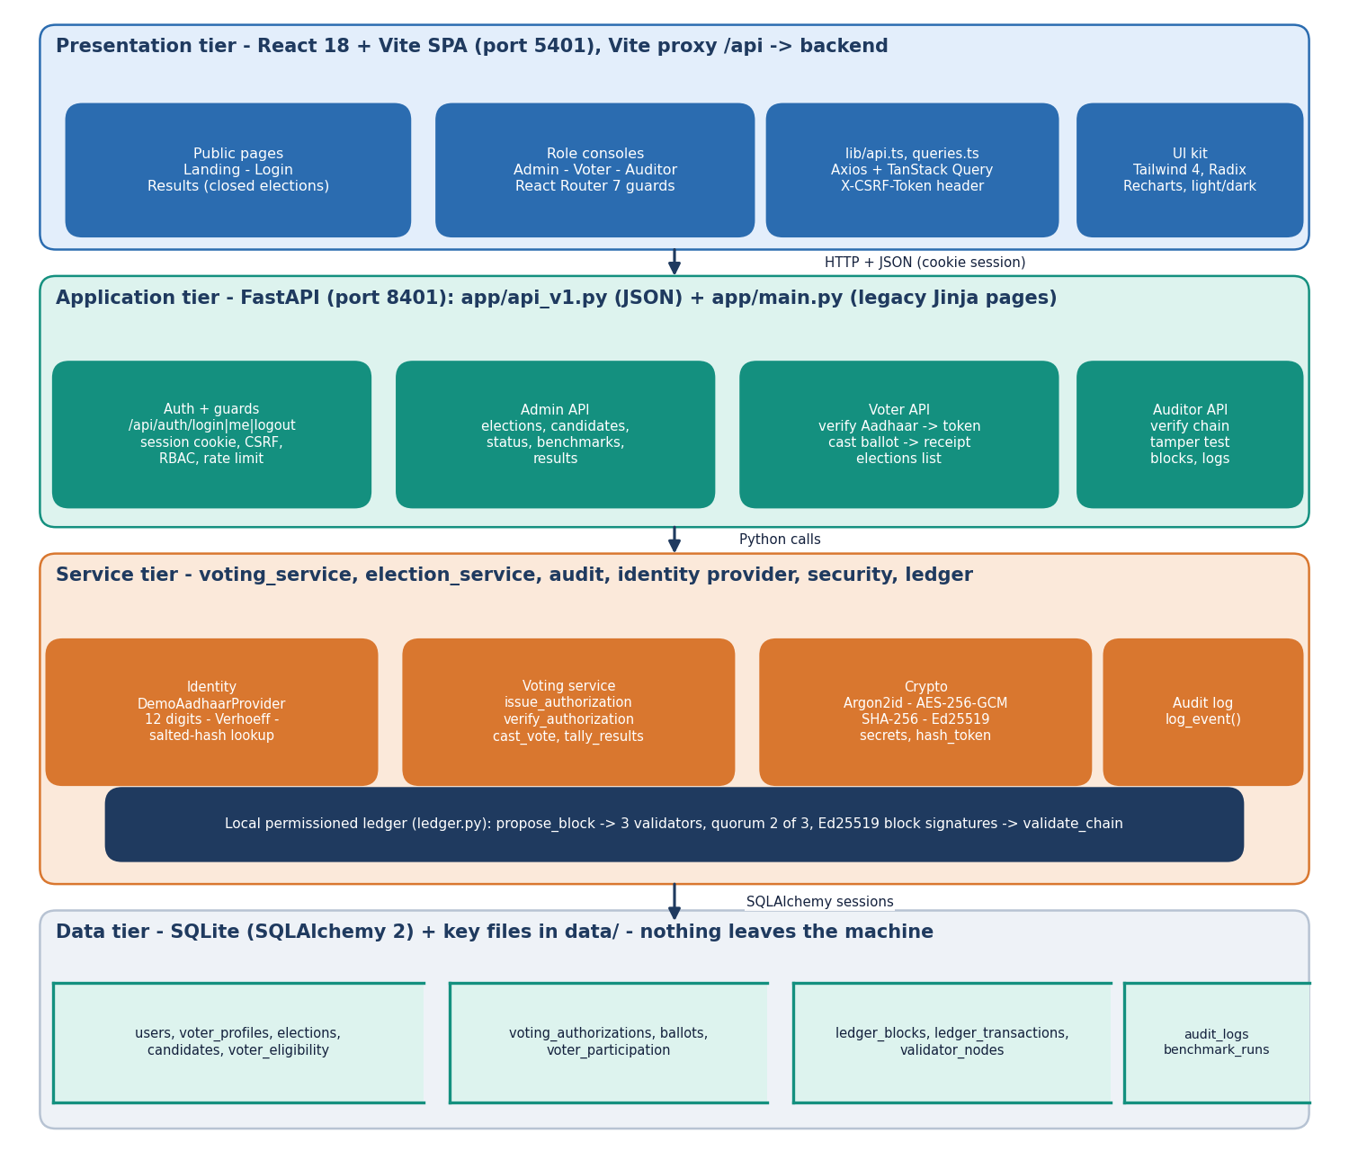
Figure 1: Four-tier architecture of AegisBallot: React single-page app, FastAPI application, service layer with the local ledger, SQLite storage.
The base paper [1] uses a four-tier model as well: MySQL and an Ethereum ledger for storage, Ethereum nodes running smart contracts, a C# web-application tier and client devices. AegisBallot keeps the same separation of concerns but replaces the public-chain tier with a local permissioned ledger, which is the main design departure. The table maps the two designs.
Table 17: Tiers of the base paper's model and of AegisBallot
Tier | Base paper (Oman model) | AegisBallot
Storage | MySQL for credentials and voter data; Ethereum ledger for votes | One SQLite database; the ledger is two tables in the same database
Ledger / consensus | Ethereum nodes execute smart contracts on a Geth test chain | Three in-process validators with Ed25519 keys; a block needs 2 of 3 approvals
Business logic | C# web application | FastAPI services (voting_service, election_service, audit, identity provider)
Client | .NET Core 7 simulators; crypto wallets in the proposal | React 18 browser application with cookie session and CSRF header
Identity | Biometric authentication (simulated) | Aadhaar number checked for format, Verhoeff checksum and registry membership (synthetic registry)

5.2 High-Level Workflow
The life cycle of an election has two parts. In the administration part the administrator creates the election with its title, description and polling window, adds candidates, and sets the status to OPEN. Creating an election also creates a voter_eligibility row for every registered voter. In the voting part each voter passes the identity check, receives a token, casts one ballot and keeps a receipt. When the administrator sets the status to CLOSED the tally is published and the auditor can check the chain.
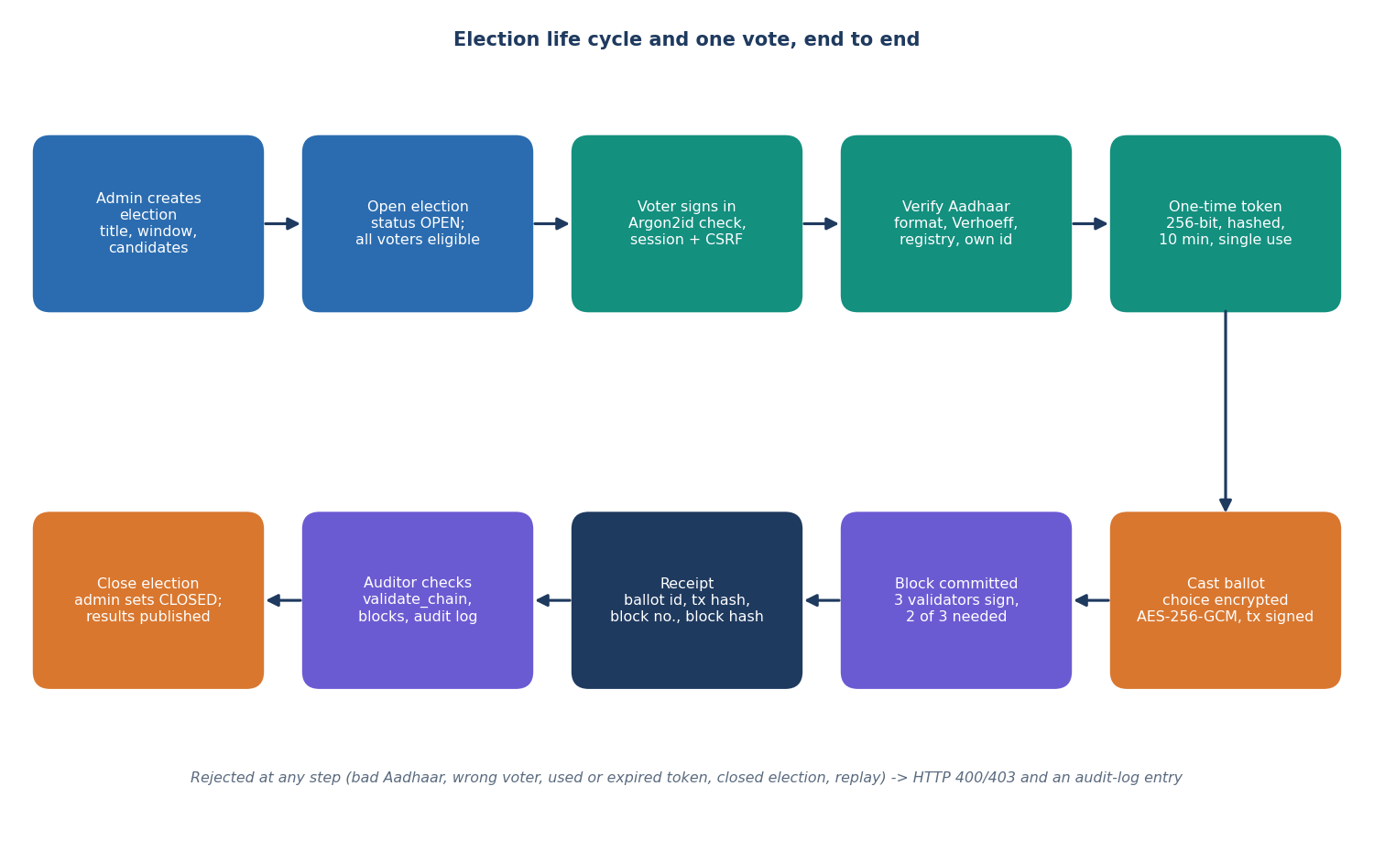
Figure 2: Election life cycle and the path of one vote, from election creation to the auditor's check.
1. Sign in. The voter sends a username and password. The password is verified against an Argon2id hash; a server-side session and a CSRF token are created; an audit entry is written.
2. Verify identity. The voter types the 12-digit Aadhaar number. The provider removes spaces and hyphens, requires twelve digits, checks the Verhoeff checksum and looks up the salted hash. The number must belong to the signed-in account, the voter must be eligible and must not have voted.
3. Receive a token. A 256-bit random token is generated; only its SHA-256 hash is stored, with an expiry of ten minutes; the plain token is returned once to the browser.
4. Cast. The browser sends the candidate id and the token. The service checks the election is OPEN, the candidate is active in that election, the token is valid and unused, and that no participation row exists.
5. Commit. The choice is encrypted with AES-256-GCM, the transaction is hashed and signed, and three validators check and sign the block; two approvals commit it. The ballot row, the used token and the participation row are saved in one commit.
6. Receive a receipt. The voter gets the ballot id, transaction hash, block number and block hash. Any failure returns HTTP 400 or 403, writes an audit entry and stores nothing.
7. Close and audit. After closing, the tally is computed from the ballots table and published; the auditor recomputes the chain with validate_chain, browses blocks and reads the audit log.

5.3 Data Flow Diagrams

5.3.1 Level 0: context diagram
At level 0 AegisBallot is a single process with three human actors and two stores. The voter supplies credentials, an Aadhaar number and a choice and receives a receipt and the published results. The administrator supplies election, candidate and status changes and receives turnout and tallies. The auditor supplies integrity-check requests and receives chain status, blocks and the audit log. The only data sources are the voter registry (a table of hashed synthetic Aadhaar numbers) and the store of ledger, ballots and log entries.
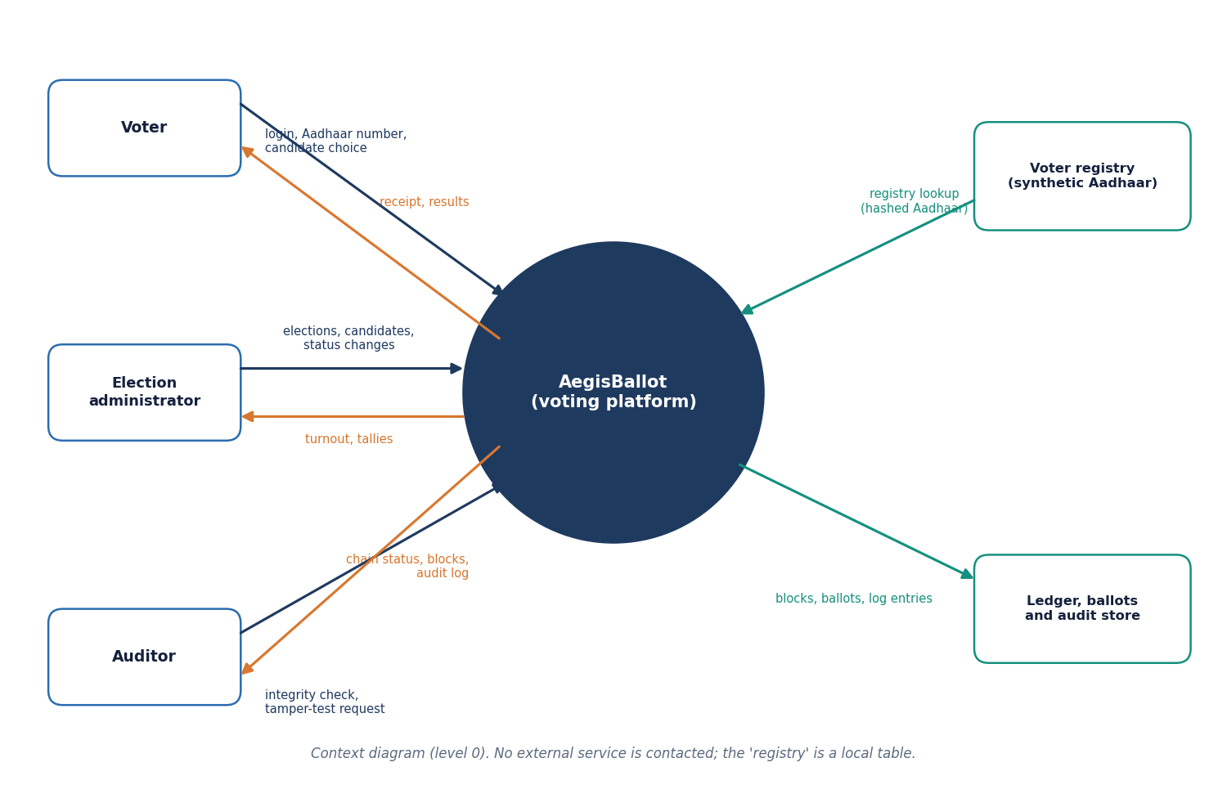
Figure 3: Context diagram (DFD level 0) of AegisBallot with its three user roles and two stores.

5.3.2 Level 1
Level 1 divides the platform into eight processes. The table lists what each process does and which stores it reads and writes.
Table 18: Processes and data stores of the level-1 diagram
Process | Function (code) | Reads | Writes
1.0 Authenticate | POST /api/auth/login: Argon2id verify, session, CSRF token, rate limit | D1 users | session store (memory), D5 audit
2.0 Verify identity | DemoAadhaarProvider.verify: digits, Verhoeff, registry lookup | D1 users and registry | D5 audit
3.0 Issue authorization | issue_authorization: eligibility, not voted, one pending token | D6 elections, D3 | D2 tokens
4.0 Cast and encrypt | cast_vote: checks, AES-GCM, tx hash, signature | D2, D3, D6 | D3 ballots and participation
5.0 Propose and commit block | propose_block: validator checks, quorum, commit | D4 ledger | D4 ledger
6.0 Manage elections | admin routes: create, status, candidates | D6 | D6, eligibility rows
7.0 Audit and verify chain | validate_chain, tamper_test_clone, block browser | D4, D5 | D5 audit
8.0 Tally and publish | tally_results: decrypt and count | D3, D6 | -

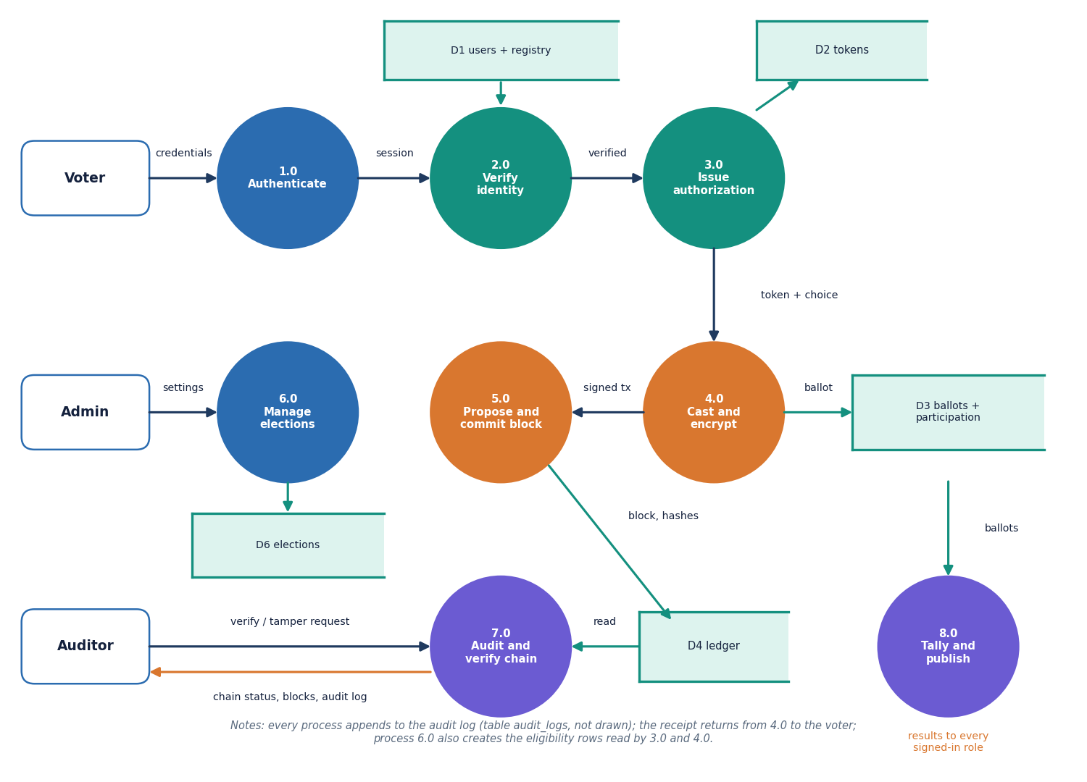
Figure 4: DFD level 1: eight processes and six data stores.

5.3.3 Level 2: casting a ballot
Level 2 expands processes 4.0 and 5.0, the heart of the system. The three guard checks (election and candidate, token, no prior participation) come before any cryptography; the encryption and signing steps produce a transaction; and the ledger steps (schema and uniqueness, validator checks, quorum, commit) decide whether it becomes a block. Only after the block is committed does 4.6 save the ballot, mark the token used and add the participation row, all in one database commit, so that a rejected block leaves no trace.
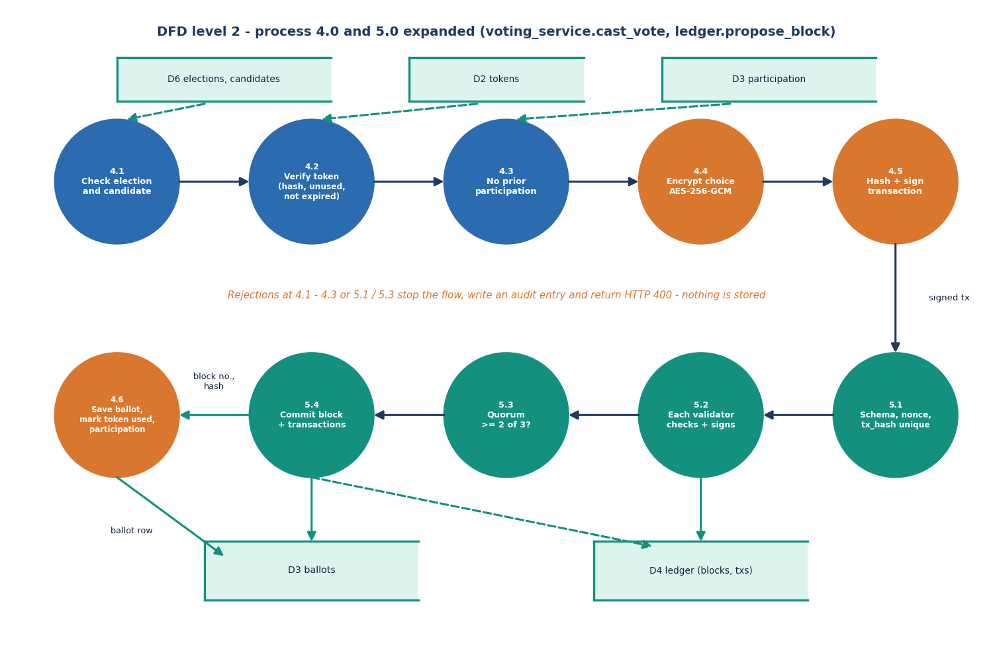
Figure 5: DFD level 2: processes 4.0 and 5.0 expanded into eleven sub-processes (cast_vote and propose_block).

5.4 UML Diagrams

5.4.1 Class diagram
The classes of the diagram are the SQLAlchemy models in app/models/models.py, together with the two service modules and the identity-provider interface. User has at most one VoterProfile. Election owns Candidate rows. VoterEligibility, VotingAuthorization and VoterParticipation are each unique on the pair (election, voter), which is what lets the database refuse a second vote independently of the application code. Ballot has no voter column. LedgerBlock and LedgerTransaction are linked by block index, ValidatorNode stores the three public keys, and AuditLog records actions. IdentityVerificationProvider is an abstract class with one method, verify; DemoAadhaarProvider implements it with the local registry, so a real adapter could be substituted without touching the routes.
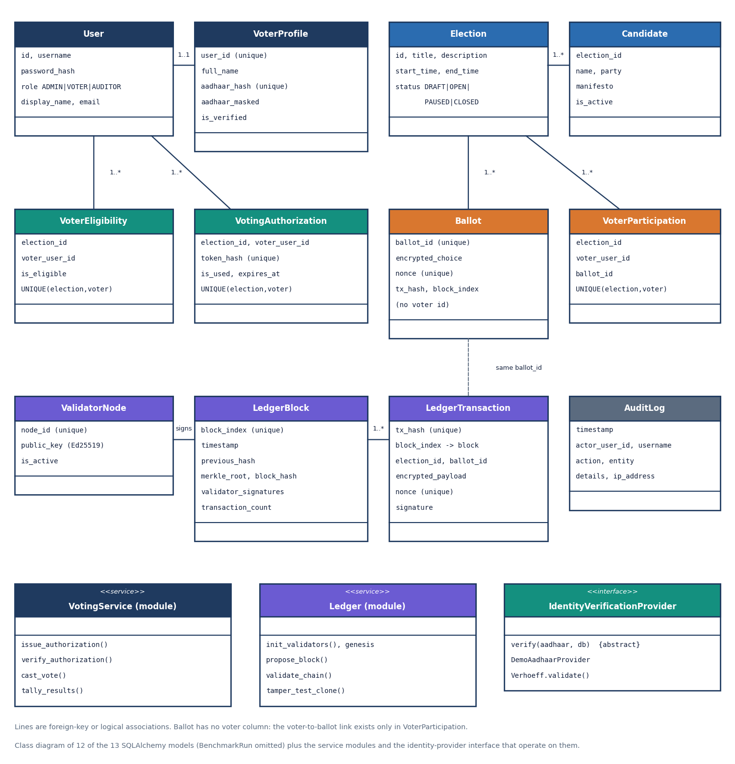
Figure 6: Class diagram of the persistent models with the service modules and the identity-provider interface.

5.4.2 Use-case diagram
There are three actors. The table lists their use cases and the API group that serves each.
Table 19: Use cases by actor
Actor | Use cases | Served by
Voter | Sign in and out; verify Aadhaar identity; cast one encrypted ballot; see receipt and election history; read results of closed elections | /api/auth/*, /api/voter/*, /api/elections/{id}/results
Administrator | Create and configure elections; add and deactivate candidates; open, pause and close elections; read results of any election; read benchmark runs | /api/admin/*, /api/elections/{id}/results
Auditor | Verify chain integrity; browse blocks and their validator signatures; run the tamper demonstration; read the audit log | /api/auditor/*

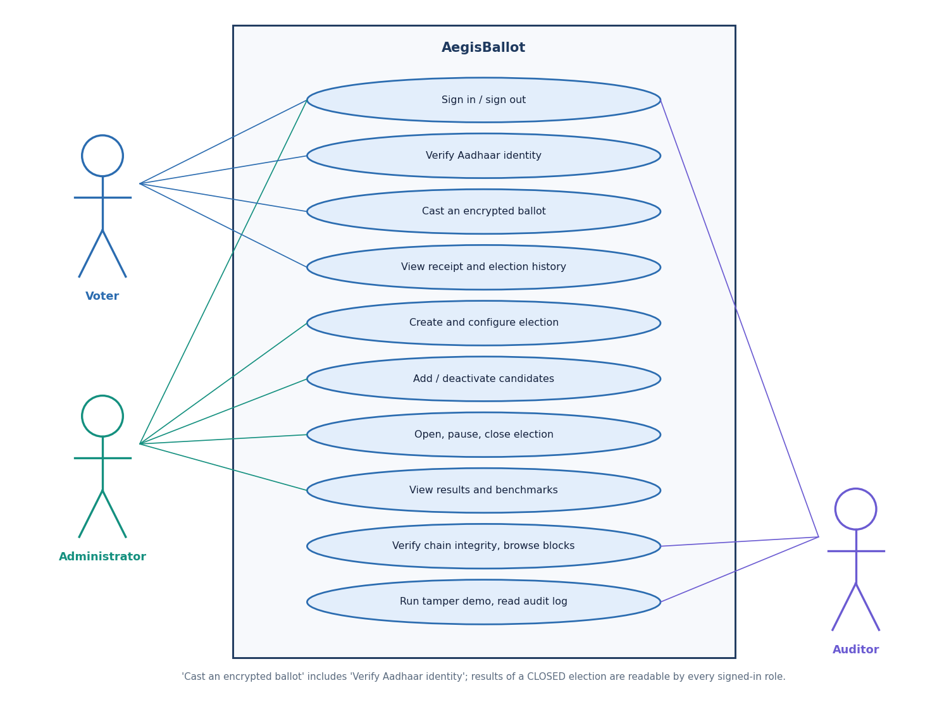
Figure 7: Use cases of the voter, the administrator and the auditor.

5.4.3 Sequence diagram
The sequence diagram follows the two calls that matter, verify and cast. The verify call touches the identity provider and the token store; the cast call goes through the voting service to the ledger and then writes four kinds of rows (block, ballot, token, participation) and the audit entry. The second call returns the receipt. Two details are worth noticing: the token returned by the first call is the only copy of the secret (the database holds only its hash), and the ledger call happens before the ballot row exists, so a failed quorum aborts the whole cast.
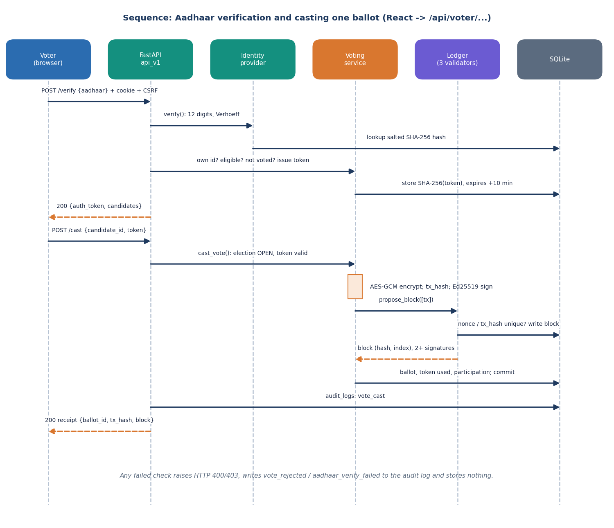
Figure 8: Sequence of Aadhaar verification and casting one ballot through the JSON API.

5.5 Database Design
The database has thirteen tables, created by Base.metadata.create_all at start-up. The entity-relationship diagram shows the tables with their keys; the tables that follow list the columns. Types are those of the SQLAlchemy models; UQ means a unique constraint.
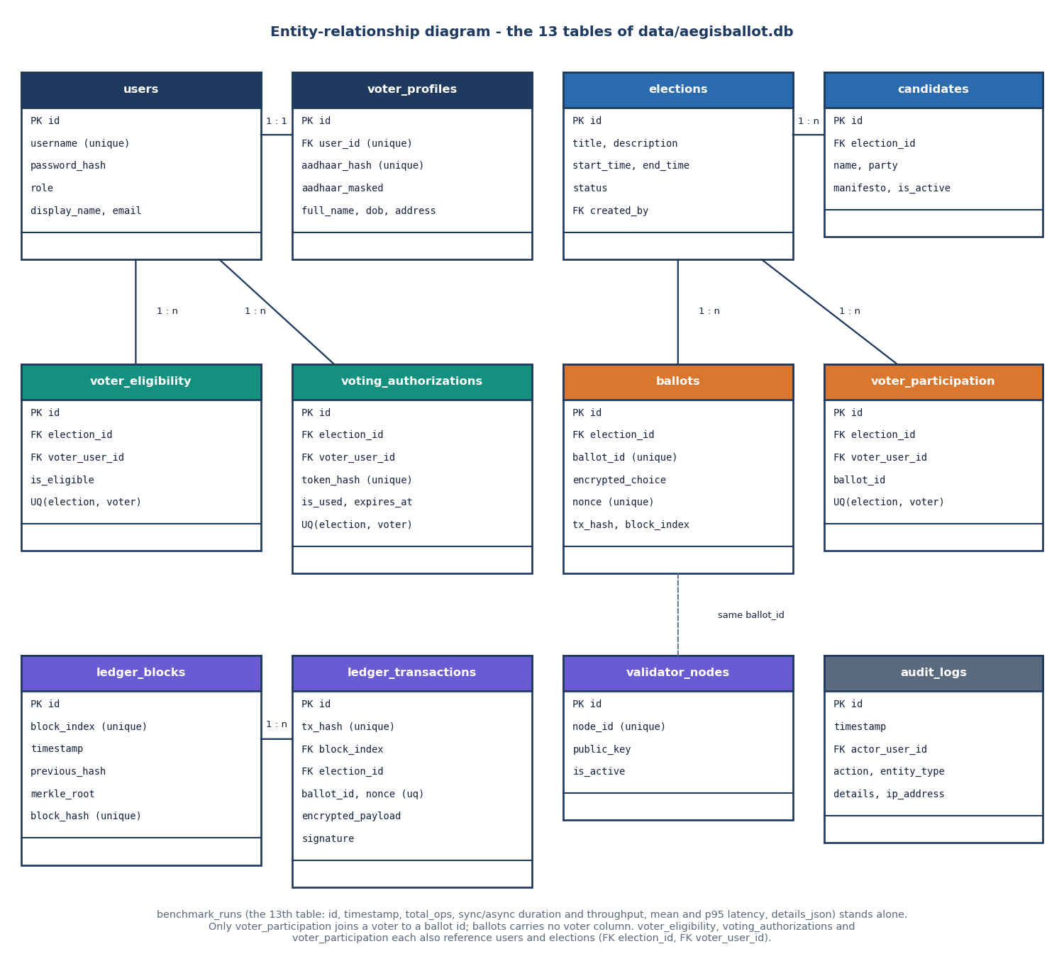
Figure 9: Entity-relationship diagram of the thirteen tables.

5.5.1 People, elections and eligibility
Table 20: Tables for users, elections and eligibility
Table | Columns | Keys and constraints
users | id, username, password_hash (Argon2id), role (ADMIN, VOTER, AUDITOR), display_name, email, created_at | PK id; username unique
voter_profiles | id, user_id, full_name, aadhaar_hash, aadhaar_masked, dob, address, is_verified | PK id; FK user_id (unique, one profile per user); aadhaar_hash unique
elections | id, title, description, start_time, end_time, status (DRAFT, OPEN, PAUSED, CLOSED), created_by, created_at | PK id; FK created_by
candidates | id, election_id, name, party, description, manifesto, is_active, created_at | PK id; FK election_id (cascade)
voter_eligibility | id, election_id, voter_user_id, is_eligible | UQ (election_id, voter_user_id)

5.5.2 Authorization, ballots and participation
Table 21: Tables that implement one voter, one vote
Table | Columns | Keys and constraints
voting_authorizations | id, election_id, voter_user_id, token_hash, is_used, expires_at, created_at | UQ token_hash; UQ (election_id, voter_user_id)
ballots | id, election_id, ballot_id (blt_ + 32 hex), encrypted_choice, nonce, tx_hash, block_index, created_at - no voter column | UQ ballot_id; UQ nonce
voter_participation | id, election_id, voter_user_id, ballot_id, created_at | UQ (election_id, voter_user_id)

5.5.3 Ledger, validators, audit and benchmarks
Table 22: Tables of the ledger and the audit trail
Table | Columns | Keys and constraints
ledger_blocks | id, block_index, timestamp, previous_hash, merkle_root, block_hash, validator_signatures (JSON text), transaction_count, created_at | UQ block_index; UQ block_hash
ledger_transactions | id, tx_hash, block_index, election_id, ballot_id, encrypted_payload, nonce, timestamp, signature | UQ tx_hash; UQ nonce; FK block_index; index on election_id
validator_nodes | id, node_id, public_key, is_active | UQ node_id
audit_logs | id, timestamp, actor_user_id, actor_username, action, entity_type, entity_id, details, ip_address | PK id; FK actor_user_id
benchmark_runs | id, timestamp, total_ops, sync_duration, async_duration, throughput_sync, throughput_async, mean_latency_ms, p95_latency_ms, details_json | PK id

5.5.4 Separation of identity and ballot
The design intends the person and the ballot to live in different places. The ballots table carries an anonymous ballot id (blt_ followed by 32 random hex digits), the ciphertext, a random nonce, the transaction hash and the block index, but no user id. The ledger_transactions table repeats the ballot id and the ciphertext. The record that a given user has voted is a separate row in voter_participation, which exists to enforce the uniqueness rule. Three layers are visible to the voter: the account (users), the Aadhaar number (stored only as a salted hash plus a masked form XXXX-XXXX-1234) and the one-time token (stored only as a hash).
The separation is partial, and the report says so plainly. voter_participation stores the voter id and the ballot id in the same row, so anyone with read access to the database can join a voter to a ballot id; the ballot ciphertext is under one AES key that the server holds, so a party with the database and data/secrets.json can then decrypt the choice. The measurement run after the HTTP test found 28 of 28 ballots joinable to a voter in this way. The README describes a per-election key, but app/config.py generates a single key. What the design does give is that the receipt page, the ledger and the auditor interface never show a choice, and that the ordinary application code has no query that returns a voter together with a choice. A blind-signature or mix-network design in the line of Chaum [26] would be needed for unlinkability against the operator; it is listed under future scope.

5.6 Module Design
The code is organised as small packages with one responsibility each. The table lists them with their sizes in non-blank lines of Python or TypeScript, counted from the source tree.
Table 23: Modules of AegisBallot
Module (path) | Responsibility
app/main.py | Creates the FastAPI app, mounts the JSON router and the static files, initialises the database, validators and genesis block, and keeps the legacy HTML routes
app/api_v1.py | 21 JSON routes in four groups (auth, admin, voter, auditor) with Pydantic input models, CSRF and role dependencies
app/identity/ | verhoeff.py (checksum and generator) and provider.py (IdentityVerificationProvider, DemoAadhaarProvider)
app/services/ | voting_service.py (authorization, cast, tally), election_service.py (create, status, candidate), audit.py (log_event)
app/ledger/ledger.py | validators, genesis, Merkle root, block hash, propose_block, validate_chain, tamper_test_clone
app/security/ | Argon2id hashing, AES-GCM and Ed25519 helpers, session store, in-memory rate limiter
app/models/models.py | The thirteen SQLAlchemy models
app/benchmarks/run_benchmark.py | Synthetic voters, synchronous and batched voting, latency statistics, JSON and database output
app/seed.py | Demo data: admin, auditor, 20 voters with synthetic Aadhaar numbers, two elections, eight seeded votes
frontend/src | React pages, UI kit, API client, query hooks, theme and auth context

5.6.1 Identity module
DemoAadhaarProvider.verify implements three checks in order: the cleaned string must have exactly twelve digits; the Verhoeff checksum must hold; and the salted SHA-256 of the number must exist in voter_profiles. It returns the profile and the user, and the route then confirms that the user is the logged-in voter. The class is explicitly labelled a demonstration provider in code and in the interface: it does not contact UIDAI and holds only synthetic numbers generated by generate_valid_aadhaar. The Aadhaar Act, 2016 [27] governs real use; a production adapter would implement the same interface against an authorised service.

5.6.2 Voting service
issue_authorization checks eligibility and prior participation, refuses a second pending token, creates a 256-bit URL-safe token and stores its hash with a ten-minute expiry. verify_authorization re-hashes the presented token and checks existence, use and expiry. cast_vote runs the guard checks, encrypts, signs, calls the ledger and then persists the rows. tally_results decrypts every ballot of an election and counts the choices; the result is sorted by votes.

5.6.3 Ledger module
Three validator key pairs are created on first use and written to data/validators.json; the public keys are in validator_nodes. propose_block loads the last block, builds the next index, computes the Merkle root and block hash, lets each validator check the block, collects the signatures of those that approve and commits the block if at least two did. validate_chain recomputes the Merkle root, the block hash and the previous-hash link of every block. tamper_test_clone simulates a changed hash on a copy held in memory.

5.6.4 Security and audit modules
security/auth.py wraps Argon2id from argon2-cffi [23]. crypto.py provides SHA-256, canonical JSON, AES-256-GCM, Ed25519 and the Aadhaar salted hash. sessions.py keeps sessions in a dictionary in memory, each with a CSRF token. rate_limit.py is a sliding window of timestamps per key. audit.log_event writes one audit_logs row with actor, action, entity, details and client address; the API calls it for login success and failure, logout, verification success and failure, token issue, vote cast, vote rejected, election and candidate changes, integrity checks and tamper tests.

5.6.5 Benchmark module
run_benchmark creates synthetic voters (Argon2-hashed passwords, Verhoeff-valid Aadhaar numbers), runs a synchronous series and three batched series (batch sizes 10, 20 and 30), computes the mean, median, 95th percentile, minimum, maximum and standard deviation per series and the throughput, writes benchmark_results/*.json and stores a benchmark_runs row that the administrator's page displays. The batched series process each batch one vote after another in a single thread; they model the batch structure of the base paper but are not concurrent, and the results chapter treats them accordingly.

5.6.6 Front-end pages
Table 24: Pages of the React application (frontend/src/App.tsx)
Route | Role | Content
/ | public | Landing: live counts from /api/public/overview, how it works, elections on the ballot
/login | public | Sign-in with quick-fill demo accounts
/app/admin, /app/admin/elections, /app/admin/elections/:id, /app/admin/benchmarks | ADMIN | Dashboard with KPIs, validators and turnout chart; election list and creation; election detail with candidates and results; benchmark charts
/app/voter, /app/voter/:id/verify | VOTER | Election list; the three-step vote flow (verify, choose, receipt)
/app/auditor, /app/auditor/blocks/:index | AUDITOR | Chain integrity, validators, blocks, transactions, audit log; block detail with signatures
/app/results/:id | ADMIN, VOTER | Vote-share chart and ranked table of one election

A Protected wrapper redirects unauthenticated visitors to the login page and sends a signed-in user whose role does not match to the home page of their own role. This is a convenience only: every route is protected again on the server by the role dependencies, and the server is the only authority.

5.7 Algorithm Design
Two algorithms carry the design. The first is the casting algorithm, which decides whether a ballot is accepted; the second is the audit algorithm, which decides whether the recorded chain is still consistent. Their mathematics is given in Chapter 6; the flow charts show the control flow.
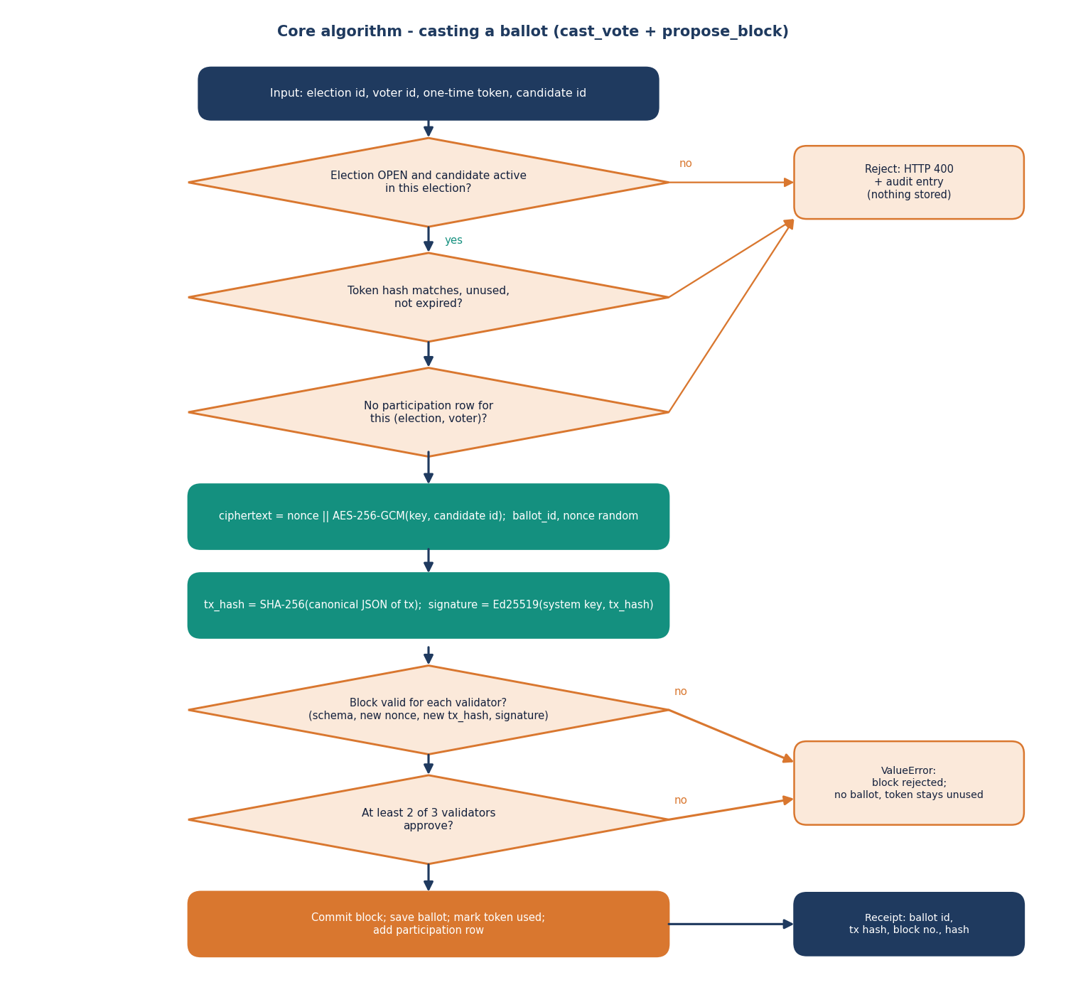
Figure 10: Flowchart of casting a ballot: checks, encryption, signing, quorum and commit.
The casting flow has three guard decisions before any cryptography is done. Failing one returns HTTP 400 and an audit entry and stores nothing. Two further decisions are taken by the validators: whether the block is valid for each of them, and whether at least two approve. If the quorum fails a ValueError is raised, the route answers with 400 and the token stays unused, so the voter may retry within the ten minutes.
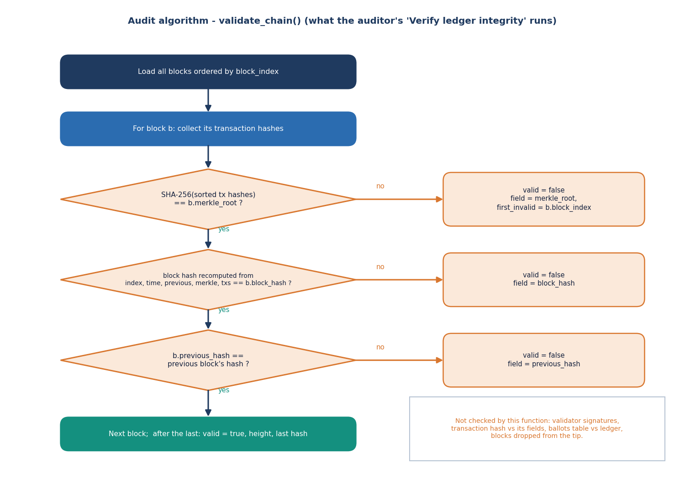
Figure 11: Flowchart of validate_chain, the function behind the auditor's integrity check.
The audit flow is deliberately simple: it uses only information in the ledger tables, so any holder of a copy can repeat it. The chart also shows its limits, which the tamper study of Chapter 8 measures: signatures and transaction hashes are not re-verified, and the ballots table is not compared with the ledger.

5.8 User-Interface Design
The interface is a single-page application with a dark and a light theme. The design follows five rules: one task per screen (the vote flow has three visible steps: verify identity, choose a candidate, receive the receipt); the state of the system is always visible (ledger height and health on the dashboards and on the landing page); destructive or irreversible actions ask for confirmation (the vote asks the voter to confirm the selection; closing an election is a separate button); every failure is shown as a toast with the server's message; and the notice "Demo verification environment - synthetic identities only" is shown wherever Aadhaar is entered.
Accessibility and layout choices are modest and honest: colour is never the only carrier of status (badges carry words), forms use labelled fields, and the layout was checked at 1440 by 900 pixels and at a 390 by 844 pixel phone width (the mobile administrator dashboard is shown in Appendix C). No formal accessibility audit or usability test with real voters was done.

5.9 Design Decisions and Their Reasons
Table 25: Principal design decisions
Decision | Alternatives considered | Reason
Local permissioned ledger, three in-process validators, quorum 2 of 3 | Public Ethereum chain as in the base paper; a real PBFT network | Runs on one laptop with no wallet or fees; Ethereum is quoted by the base paper at about 119.1 tx/s [1]; PBFT [18] needs a network of nodes that the project could not provide. The cost is that the trust is simulated
One transaction per block | Batching many votes in a block | Simple receipts (each voter gets a block number) and simple recovery; the cost is a longer chain and linear validation time
Aadhaar checked locally with Verhoeff and a salted-hash registry | Calling UIDAI; storing the number | UIDAI is not available to a student project; the Verhoeff check [25] catches mistyped numbers; storing only a hash avoids keeping the number
Token between identity and ballot | Sending the Aadhaar number with the ballot | The cast call carries a token, not an identity, and the token is stored only as a hash
Four overlapping one-vote rules | A single check in code | Unique constraints in the database hold even if the application logic is bypassed
AES-256-GCM for the choice | Plain candidate id; per-voter keys; homomorphic encryption | Authenticated encryption [21] hides choices from the ledger and the auditor view at low cost; a single key is the simplification
Ed25519 signatures | RSA; HMAC | Small, fast signatures [22]; 0.13 ms to sign in the micro-benchmark
Argon2id for passwords | bcrypt as in the batch abstract | Memory-hard, current guidance [24]; one verification costs about 83 ms, which dominates the HTTP latency
React single-page app over a JSON API | Server-rendered Jinja pages only | Role consoles with live data and charts; the Jinja pages remain as a fallback
SQLite | A client-server database | No installation; adequate for a demonstration; concurrent writers were not tested

CHAPTER 6: METHODOLOGY AND SOFTWARE IMPLEMENTATION
This chapter describes how the system was built and evaluated: the methodology, the data, the choice and the mathematics of each algorithm, the security design, the application architecture, the API and the way to install and run it. Because there is no machine-learning component, the chapter replaces model architecture and training with the cryptographic and ledger design.

6.1 Overall Methodology
AegisBallot is a systems and security project, not a learning project: no model is trained and no accuracy or F1 value exists. The methodology is therefore an engineering one. The team took the problem statement and objectives of the batch, derived security requirements from them, chose a small set of well-understood cryptographic primitives, built a backend that enforces the requirements in several independent layers, put role-based consoles on top, and then evaluated the result with automated tests, a measured tamper study and performance benchmarks. The steps were:
1. Requirements to controls. Each objective was turned into a testable control: identity binding became the Aadhaar check and the single-use token; one voter one vote became four overlapping rules; immutability became the hash-chained ledger; the audit trail became the audit_logs table and the auditor console.
2. Backend first. The models, services and ledger were written and covered by pytest before any user interface; the original interface was server-rendered Jinja pages.
3. Additive JSON layer and React interface. app/api_v1.py was added next to the existing routes without changing them, and the React single-page application was built on it.
4. Evaluation. Seventeen unit and integration tests, an HTTP security matrix, a tamper study that applies thirteen kinds of modification to a real chain, and benchmarks of one thousand synthetic voters were run on one PC (Chapters 7 and 8).
5. Honest reporting. Every limitation found during the evaluation (Sections 6.6 and 6.10 and Chapter 9) is stated in the documents rather than hidden.

6.2 Data and Test Data
There is no external dataset. A voting system is evaluated on its behaviour, and real voter data would be both unavailable and inappropriate. All identities are synthetic and generated locally, as in the base paper, which also used synthetic population data and 1000 synthetic voters [1]. The sources of data are:
Table 26: Data used by the system and by the evaluation
Data | How it is produced | Size
Demo accounts | app/seed.py: one administrator, one auditor, voters voter1 to voter20 with Argon2id password hashes | 22 users
Synthetic Aadhaar numbers | generate_valid_aadhaar: first digit 2-9, ten random digits, Verhoeff check digit appended; stored as salted SHA-256 plus a masked form; plain numbers written to data/synthetic_identities.json for the demo | 20 in the seed; one per benchmark voter
Elections and candidates | Two seeded elections (four and three candidates); eight seeded votes in the closed one | 2 elections, 7 candidates
Benchmark voters | run_benchmark: Argon2-hashed passwords, Verhoeff-valid numbers, eligibility rows | 1000 per series
Measurement databases | scripts/run_experiments.py builds scratch SQLite files and never touches data/aegisballot.db | up to 361 blocks

The names in the seed file are common Indian given names combined arbitrarily and do not refer to real people. The Aadhaar numbers are random numbers that satisfy the checksum; any resemblance to a real number is coincidental, and the interface states on every verification screen that the environment is a demonstration.

6.3 Input Validation and Normalisation
The only transformation applied to inputs is normalisation and validation, the counterpart of preprocessing in a data-driven project. The Aadhaar number is cleaned by removing spaces and hyphens, so that 1234 5678 9012 and 1234-5678-9012 are treated alike; the result must consist of exactly twelve digits and satisfy the Verhoeff checksum. The Pydantic models of api_v1.py bound every text field (username 1 to 64 characters, password 1 to 256, Aadhaar 1 to 32, election title 1 to 200, candidate name and party 1 to 128); dates are parsed with datetime.fromisoformat and an election whose end is not after its start is rejected; a status must be one of DRAFT, OPEN, PAUSED, CLOSED. Database access goes through SQLAlchemy with bound parameters, which is why the SQL-injection-style username in the security matrix returns an ordinary 401. Before hashing, structures are serialised canonically: keys sorted and separators , and : without spaces, so the same transaction always has the same bytes.

6.4 Algorithm Choice and Justification
Each primitive was chosen to meet one requirement with the least complexity, and each choice has an alternative that was considered and rejected. The table summarises the reasoning; the sections after it give the formulation.
Table 27: Algorithms and why they were chosen
Requirement | Chosen | Alternative | Reason
Catch mistyped identity numbers | Verhoeff checksum [25] | Length check only; Luhn | Detects all single-digit errors and all adjacent transpositions; the same scheme protects real Aadhaar numbers
Find a voter without storing the number | Salted and peppered SHA-256 lookup | Store the number; slow hash | A fixed-length hash allows an indexed unique lookup; the number is never stored. A salted fast hash is weak against brute force of a 12-digit space, which is why only synthetic numbers are used (see 6.6)
Store passwords | Argon2id [23], [24] | bcrypt (batch abstract); plain SHA-256 | Memory-hard and the current recommendation; 83 ms per check on the test PC
Separate identity from ballot | Random 256-bit single-use token, stored hashed | Session id as ballot key | A token with expiry and single use makes the cast call independent of the login
Hide the choice | AES-256-GCM [21] | Plain id; CBC | Authenticated encryption detects modification of the ciphertext; the 12-byte random nonce is stored with it
Authenticate transactions and blocks | Ed25519 [22] | RSA; HMAC | Compact public-key signatures; sign 0.13 ms, verify 0.18 ms
Tamper evidence | SHA-256 hash chain [20] with a flat Merkle-style root [19] | Merkle tree with proofs | Simple to implement and to recompute; no inclusion proofs
Agreement on a block | Quorum of 2 of 3 validators | PBFT [18]; Ethereum | Needs no network; simulates the rule 'more than half of the validators approve'; trust is not actually distributed

Why a local permissioned ledger
The base paper builds on Ethereum with smart contracts [1] and reports transaction times of about two seconds for registration and three to four seconds for voting on a Geth test chain (read from its Figures 6 and 9). It quotes Ethereum's theoretical throughput as 119.1 tx/s against 65,000 tx/s for Solana. A public chain gives strong decentralisation but also fees, wallets, latency and no direct link to a national identity; Hyperledger Fabric [17] gives a permissioned design but needs several containers and an ordering service. For an academic prototype that must run on one laptop and be explained completely, the project chose to implement the properties it can test - append-only blocks, hash linking, signed approvals, a quorum rule and a recomputing auditor - in about 280 lines of Python. The consequence, stated throughout the documents, is that all three validators run in one process and keep their keys in one file, so a single operator controls the whole quorum.

No learned model
No machine-learning model, training procedure or evaluation split exists in this project. Model architecture, hyper-parameters, loss functions and training curves are therefore not applicable; the corresponding sections of the report template are replaced by the cryptographic and ledger design in this chapter.

6.5 Mathematical Formulation
This section states exactly what the code computes. Strings are UTF-8 encoded before hashing, and ‖ denotes concatenation.

Verhoeff checksum
Let d be the multiplication table of the dihedral group D5 (a 10 by 10 table), p the permutation table with eight rows, and inv the inverse table. For a number with digits n(1) (rightmost) to n(L), the code iterates from the right and keeps a running value c:
c(0) = 0; c(i) = d( c(i−1), p( i mod 8, n(i) ) ), i = 1 … L (1)
The number is valid when c(L) = 0. To generate a check digit for an eleven-digit prefix the code uses the shifted index and takes the inverse of the final value:
c(i) = d( c(i−1), p( (i+1) mod 8, n(i) ) ); check digit = inv( c(11) ) (2)

Registry key and masked form
h = SHA-256( salt ‖ pepper ‖ a ) with salt = “aegisballot-aadhaar-salt-v1”, pepper = SECRET_KEY, a = the 12 digits (3)
The registry lookup compares h with voter_profiles.aadhaar_hash. The stored display form is XXXX-XXXX- followed by the last four digits of a.

Authorization token
A token t of 256 random bits is produced by secrets.token_urlsafe(32). Only the digest is stored. A presented token t′ is accepted for election e and voter v when all three conditions hold:
SHA-256(t′) = token_hash(e, v) ∧ is_used = false ∧ now ≤ created_at + 10 min (4)

Ballot encryption
The plaintext m is the decimal candidate id. With the 256-bit key K, a fresh 12-byte nonce r and no associated data, the stored ciphertext is the base64 encoding of
c = r ‖ AES-256-GCM_K( r, m ) (5)
where the GCM output includes the 16-byte authentication tag [21]. Decryption splits the first 12 bytes and fails with an exception if the tag does not verify; the tally skips undecryptable ballots.

Transaction, Merkle value and block hash
Let canon(x) be the JSON serialisation of x with sorted keys and compact separators. A transaction contains the election id, ballot id, ciphertext, a 128-bit random nonce and an ISO timestamp:
txh = SHA-256( canon( { election_id, ballot_id, encrypted_payload, nonce, timestamp } ) ); sig = Ed25519-Sign( sk_system, txh ) (6)
The signed message is the hexadecimal text of txh. For a block with transaction hashes sorted in ascending order, h(1) … h(n), the code computes a flat value, not a binary tree:
M = SHA-256( h(1) ‖ h(2) ‖ … ‖ h(n) ) (M = SHA-256 of the empty string when n = 0) (7)
H(b) = SHA-256( canon( { block_index, timestamp, previous_hash, merkle_root = M, tx_hashes = [h(1) … h(n)] } ) ) (8)
The genesis block has index 0, previous hash of sixty-four zeros, no transactions and a hash computed with the same formula.

Quorum
Each validator v in {1, 2, 3} evaluates the block and returns a Boolean a(v): the schema is complete, the nonce and the transaction hash have not been used before and, when the transaction carries a public key and signature, the signature verifies. The approving validators sign the block hash:
s(v) = Ed25519-Sign( sk(v), H(b) ) if a(v); the block is committed if Σ a(v) ≥ 2 (9)

Chain validity
validate_chain returns valid when, for every block b(i) with transaction hashes recomputed from the stored transactions,
M(i) = SHA-256( stored tx hashes ) ∧ H(b(i)) = stored block hash ∧ previous(b(i)) = H(b(i−1)) for i ≥ 1 (10)

Tally and benchmark statistics
For candidate k of an election the tally is the number of ballots whose decrypted plaintext equals the candidate id: count(k) = |{ b : Dec_K(c_b) = k }|. For N operations with total wall time T the benchmark reports throughput N / T, the mean and median of the per-operation times, and the 95th percentile as the element at index ⌊0.95 N⌋ of the sorted times.

6.6 Security Design
The security design follows the controls of the OWASP application security verification standard [28] that apply to a small web application. The table maps each threat considered to the control that addresses it and to the test that exercises it.
Table 28: Threats and controls
Threat | Control in the code | Evidence
Guessing or stealing a password | Argon2id hashes; login limited to 10 requests per 60 s per client address; failed logins audited | unit test for hashing; matrix check 25 (429)
Using another voter's Aadhaar number | The number must belong to the signed-in account (HTTP 403) | matrix check 12
Mistyped or invented number | Twelve-digit, Verhoeff and registry checks (HTTP 400) | matrix checks 9-11; unit tests
Voting twice | Four layers: eligibility, unique participation, single-use token, unique nonce and transaction hash | unit tests; matrix checks 18-19
Replaying a token | Token marked used in the same commit as the ballot; expiry after 10 minutes | matrix check 18; expired-token test
Acting beyond one's role | role_required dependencies (HTTP 403) | matrix checks 5-7; unit tests
Cross-site request forgery | Mutating /api calls need the session's X-CSRF-Token header; cookie is SameSite=Lax | matrix check 8
Reading the choice from the ledger | AES-256-GCM ciphertext only; the receipt and auditor pages show no choice | identity-separation test
Changing the ledger | Hash chain recomputed by the auditor | tamper study: 7 of 13 cases detected (Chapter 8)
Abuse of the verification route | 15 verification attempts per 60 s per client address (HTTP 429) | code review (voter_verify)

What the design does not do. The ledger check does not verify validator signatures or re-derive transaction hashes (Chapter 8 shows which tampering this misses); the three validator keys and the system key sit in files in data/ next to the database; the AES key is one key for all elections (the README says per-election; app/config.py creates one key and stores it in data/secrets.json); voter_participation links a voter to a ballot id; sessions live in process memory and never expire on the server; the rate limiter is per client address, so a polling station behind one address is limited to ten logins a minute; the cookie has no Secure attribute and no TLS is configured, although the batch objectives name TLS; the legacy HTML form routes do not require a CSRF token; the admin can read the tally of an election that is still open; and the polling window dates are not enforced (Section 6.10). None of these is hidden: each is listed in the limitations chapter and in the future scope.

6.7 Application Architecture
The backend is a FastAPI application served by uvicorn on 127.0.0.1. On import, app/main.py creates the application, mounts the JSON router, calls init_db to create missing tables, and then calls init_validators and create_genesis_block so that the chain always has a block 0 and three validator keys. Requests are handled by synchronous route functions with a SQLAlchemy session per request (get_db). The session store, the rate limiter and the in-memory validator key table are module-level dictionaries, which keeps the code short and is the reason state is lost on restart (the database survives).
The frontend is a Vite project in frontend/. src/lib/api.ts creates the Axios client, stores the CSRF token returned by login and sends it on every mutating call; src/lib/queries.ts wraps each endpoint in a TanStack Query hook; src/lib/auth.tsx holds the user in a context and maps each role to its home route; src/pages holds one file per page; src/components/ui is a small component kit (cards, tables, badges, dialogs, toasts) built on Radix primitives and Tailwind CSS. Pages are loaded lazily, and the production build splits the chart, motion and Radix libraries into separate chunks. The Vite development and preview servers proxy /api to the backend, so the browser sees one origin and the session cookie needs no cross-origin settings.
Configuration comes from .env at the project root (BACKEND_PORT=8401 and FRONTEND_PORT=5401, read by run.bat and the Vite configuration) and from environment variables read in app/config.py (DATABASE_URL, SECRET_KEY, SESSION_SECRET, ELECTION_ENCRYPTION_KEY). The shipped defaults for SECRET_KEY and SESSION_SECRET are development strings in the source and must be replaced for any real use; the Aadhaar pepper is SECRET_KEY.

6.8 API Design
The JSON API has twenty-one routes in four groups, all under /api. Authentication is the aegis_session cookie; every route other than the three public ones resolves the session to a user, and every POST requires the X-CSRF-Token header to equal the CSRF token of the session. Errors are JSON of the form {"detail": "..."} with the status codes listed in the next section. The same functions back the legacy HTML pages, so the two interfaces cannot disagree.
Table 29: Routes of app/api_v1.py
Method | Path | Access | Purpose
POST | /api/auth/login | public | Verify credentials, create session and CSRF token, set cookie; 401 bad credentials, 429 throttled
POST | /api/auth/logout | signed in | Destroy the session, clear the cookie, write audit entry
GET | /api/auth/me | public | Current user and CSRF token, or user: null (200, so the console stays free of expected 401s)
GET | /api/public/overview | public | Elections, ledger validity and height, ballots cast, validator count (landing page)
GET | /api/admin/overview | ADMIN | Voters, votes, turnout, chain status, validators, latest benchmark, elections, five blocks, ten log rows
GET | /api/admin/elections | ADMIN | All elections with eligible, votes, turnout and candidate counts
POST | /api/admin/elections | ADMIN | Create an election (201); creates eligibility rows for all voters; 400 if end ≤ start
GET | /api/admin/elections/{eid} | ADMIN | Election, candidates, counts and, if CLOSED, the tally
POST | /api/admin/elections/{eid}/status | ADMIN | Set DRAFT, OPEN, PAUSED or CLOSED (400 otherwise)
POST | /api/admin/elections/{eid}/candidates | ADMIN | Add a candidate (201)
POST | /api/admin/candidates/{cid}/toggle | ADMIN | Activate or deactivate a candidate
GET | /api/admin/benchmarks | ADMIN | Last five benchmark runs with parsed details
GET | /api/elections/{eid}/results | signed in | Tally; ADMIN at any time, other roles only when CLOSED (else 404)
GET | /api/voter/elections | VOTER | Open, paused and closed elections with the voter's own participation
GET | /api/voter/elections/{eid} | VOTER | Election, masked Aadhaar, voted flag, ballot id
POST | /api/voter/elections/{eid}/verify | VOTER | Aadhaar checks; returns the one-time token (600 s) and candidates; 400, 403 or 429 on failure
POST | /api/voter/elections/{eid}/cast | VOTER | Candidate id and token; returns the receipt; 400 on any rejected check, 500 on an unexpected error
GET | /api/auditor/overview | AUDITOR | Chain status, validators, 20 blocks, 20 transactions, 20 log rows
POST | /api/auditor/verify | AUDITOR | Run validate_chain; audit entry integrity_check
POST | /api/auditor/tamper-test | AUDITOR | Run tamper_test_clone; audit entry tamper_test
GET | /api/auditor/blocks/{index} | AUDITOR | One block with parsed signatures and its transactions

6.9 Security Handling and Error Handling
Authentication state is held in an in-memory dictionary keyed by a 256-bit random token; the cookie is set with HttpOnly, SameSite=lax and Path=/. It has no Secure attribute because the application is served over plain HTTP on localhost, and the server never expires a session by time (only logout or a restart ends it). Passwords are never logged; a failed login writes the attempted username to the audit log, which means a mistyped password could be recorded if it is entered in the username field - a small privacy gap noted for the future.
Table 30: HTTP status codes used by the API
Status | Meaning in AegisBallot | Examples
200 / 201 | Success; 201 for created elections and candidates | login, cast, create election
400 | A business rule failed; nothing was stored | bad Aadhaar format or checksum, not in registry, already voted, invalid token, unknown candidate, election not open, end before start, invalid status
401 | No valid session | any protected route without cookie; wrong username or password
403 | Role not allowed, CSRF token missing or wrong, or the Aadhaar belongs to another voter | voter calling an admin route
404 | Resource missing, or results not yet published to a non-admin | unknown election; results of an OPEN election as a voter
422 | Request body failed Pydantic validation | empty username
429 | Rate limit reached | more than 10 logins or 15 verifications in 60 s from one address
500 | Unexpected failure while recording a vote | message: "Vote could not be recorded. Nothing was submitted; try again."

Failures that follow from business rules are raised as ValueError in the services and converted to HTTP 400 in the route; the route also writes the reason to the audit log (vote_rejected, aadhaar_verify_failed). If the ledger rejects a block, nothing is written, and the token remains valid until it expires. The React client converts every error into a toast with the server's message, and a failed request on the landing page shows a clear "Cannot reach the AegisBallot server" state.

6.10 Implementation Notes and Behaviour Found on Review
Writing the documents involved re-reading every route against the objectives of the batch. The review confirmed most behaviour and also produced a short list of facts that a reader of the report should know; they are repeated in the limitations chapter.
• Voting windows are not enforced. An election has start_time and end_time, and the administrator sets them, but cast_vote tests only that the status is OPEN. The status, changed by the administrator, is what opens and closes voting; the dates are information shown in the interface. The seeded closed election shows the effect: its end time was in the past while its status was still OPEN until the seed script closed it.
• There is no voter-registration route. Voters, their profiles and their synthetic Aadhaar numbers are created by app/seed.py or by the benchmark; the registry is therefore prepared offline, and objective 1 of the batch (registration and authentication) is met by authentication and verification against that registry, not by a self-service sign-up page.
• Eligibility is created with the election. POST /api/admin/elections inserts an eligibility row for every voter that exists at that moment; a voter added later is not eligible for earlier elections unless a row is added.
• One transaction per block. cast_vote always proposes a block of one transaction. The chain therefore grows by one block per vote, the receipt's block number identifies the vote, and validate_chain is linear in the number of votes.
• Validators approve in a fixed order and always agree. Because the three validators run the same checks on the same database inside one process, a block rejected by one is rejected by all; the quorum matters only if a validator key is missing, in which case the code records the string missing-priv as that validator's signature and still counts it as an approval.
• The transaction's public key travels inside the transaction. The validators verify the Ed25519 signature against the key supplied with the transaction; the system key is not pinned and the key is not stored in ledger_transactions. The check proves the transaction was not altered after signing, not that the signer was authorised.
• Times are naive UTC. Timestamps are produced by datetime.utcnow() and serialised without a zone, so the interface shows UTC.
• Concurrency was not tested. Each block takes the next index from the last block; two simultaneous votes could compute the same index, and the unique constraint on block_index would make one of them fail with a 500. The benchmark's "batched" series are sequential and do not exercise this.

6.11 Installation and Execution
The project needs Python 3.11 or 3.12 and Node.js 20 or newer; no database server, wallet or external credentials are required. On Windows, double-clicking run.bat creates .venv, installs requirements.txt, seeds the database (python -m app.seed), installs the front-end packages on the first run, checks that the ports are free, starts uvicorn on 8401 and Vite on 5401, and opens the browser. The manual method is five commands. Appendix B gives the full instructions, the demonstration accounts and troubleshooting.
python -m venv .venv
.venv\Scripts\activate
pip install -r requirements.txt
python -m app.seed
uvicorn app.main:app --host 127.0.0.1 --port 8401
:: second window
cd frontend
npm install
npm run dev

To reproduce the measurements: python -m pytest tests (17 tests; the fixture drops all tables, so set DATABASE_URL to a scratch file first), python -m app.benchmarks.run_benchmark --voters 1000, and python scripts/run_experiments.py <scratch-directory> for the growth, tamper and HTTP studies. A smoke test, python scripts/smoke_test.py, exercises the API and the main voting flow against running servers.

CHAPTER 7: SYSTEM TESTING

7.1 Testing Strategy and Environment
AegisBallot contains no learned model, so there is no accuracy or F1 to report. What can be tested is whether the rules of an election are enforced, whether the ledger exposes tampering, whether the access controls hold, and how fast the platform is. The strategy therefore has six levels, each answering a different question and each backed by a script or test file that is part of the repository.
Environment. Every run used one PC: an Intel Core i5-12500 (6 cores, 12 threads), 15.7 GB of memory, Windows 11 Pro, Python 3.11.9, FastAPI 0.110.0, SQLAlchemy 2.0.30, cryptography 42.0.7 and argon2-cffi 23.1.0. The PC was shared with other running jobs, so about a third of the processor was already busy when the measurements began. Latency figures are therefore upper-ish bounds and they move from run to run; the earlier runs kept in benchmark_results/ were made on an idle machine and give 16.1 to 17.3 ms per vote against the 44.9 ms of the 1000-voter run reported below.
Scratch databases. The pytest fixture calls Base.metadata.drop_all on whatever database DATABASE_URL names. To protect the development database that holds the data shown in the screenshots, every test and experiment in this chapter was run with DATABASE_URL pointing at a scratch SQLite file, and the experiment harness builds its own users, elections and chains there. The HTTP checks start a separate uvicorn process on port 18401 against another scratch file, so the product's ports 8401 and 5401 were not used.

7.2 Unit Tests
The repository's test file holds 17 pytest tests. They were run with Python 3.11.9 and pytest 9.1.1 on a scratch database: 17 passed, 0 failed, in 5.41 s. The table below lists what each test checks.
Table 31: The 17 pytest tests and their result
No. | Test | What it checks | Result
1 | test_password_hashing | Argon2id hash differs from the password; correct password verifies, wrong one does not | Pass
2 | test_verhoeff_valid | A generated Aadhaar number has 12 digits and a valid Verhoeff checksum (its negative assertion is weak, see below) | Pass
3 | test_invalid_checksum_rejection | DemoAadhaarProvider.verify refuses 123456789012 with a checksum, format or not-found reason | Pass
4 | test_unknown_voter_rejection | A checksum-valid number that is not in the registry fails with "not found" | Pass
5 | test_ineligible_voter_rejection | issue_authorization raises for a voter with no eligibility row | Pass
6 | test_duplicate_vote_rejection | After one vote, a second authorisation and a replay of the old token both raise | Pass
7 | test_unauthorized_admin_route | A voter session requesting the legacy /admin page is redirected or refused (accepts 302, 307, 401 or 403) | Pass
8 | test_unauthorized_auditor_route | An admin session requesting /auditor is redirected or refused | Pass
9 | test_tampered_block_detection | A valid chain passes; tamper_test_clone reports detection; overwriting a real block hash makes validate_chain fail | Pass
10 | test_invalid_previous_hash_rejection | Overwriting a block's previous_hash makes validate_chain fail (field accepted: previous_hash or block_hash) | Pass
11 | test_duplicate_transaction_rejection | propose_block with a reused nonce and transaction hash raises a "duplicate" error | Pass
12 | test_malformed_input_rejection | Empty username and password on the login form give 400, 401 or 422 | Pass
13 | test_expired_authorization_rejection | A token whose expiry is moved five minutes into the past is refused as expired | Pass
14 | test_ballot_identity_separation | The ledger transaction text contains neither the Aadhaar number nor the voter's name; ballots has no voter column | Pass
15 | test_audit_logging | A failed login adds a row to audit_logs | Pass
16 | test_election_status_enforcement | Casting in a PAUSED election raises "not open" | Pass
17 | test_encryption_roundtrip | AES-256-GCM decrypt(encrypt("42")) returns "42" | Pass

Reading the tests critically gives four observations that bear on how much weight the green result deserves.
• Most tests call the service layer (issue_authorization, cast_vote, propose_block, validate_chain) directly or use the legacy HTML routes; the JSON API that the React interface uses is exercised only by the HTTP checks of Section 7.3.
• The assertion in test_verhoeff_valid that should show a corrupted number is rejected is satisfied trivially (not validate_verhoeff("123456789012") or validate_verhoeff(a)), and the corrupted number it builds is never used. The checksum itself is tested properly by the HTTP checks 10 and 11 of Section 7.3, which send a number whose last digit was changed.
• The two role tests accept several status codes (a redirect, 401 or 403), and the previous-hash test accepts either of two failing fields, so they show that access is not granted and that tampering is noticed, not exactly how.
• test_tampered_block_detection calls tamper_test_clone as well as editing the real database; the former only simulates the change in memory (Section 7.6), but the real edit that follows it does make validate_chain fail.

7.3 Integration Tests over HTTP
The integration tests drive a real uvicorn process through its JSON API, as the React interface does: one client per user, cookies kept, the CSRF token read from the login reply and sent as X-CSRF-Token on every POST. The server and its database were created for the run (an election with three candidates, an administrator, an auditor, 28 voters with synthetic Verhoeff-valid Aadhaar numbers). 25 of the 25 checks returned the expected status (table below).
Table 32: HTTP security and functional checks: expected and observed status
No. | Check | Expected | Got | Result
1 | Anonymous GET /api/admin/overview | 401 | 401 | Pass
2 | Anonymous POST /api/voter/.../cast | 401 | 401 | Pass
3 | SQL-injection style username on login | 401 | 401 | Pass
4 | Login with empty body fields | 422 | 422 | Pass
5 | Voter GET /api/admin/overview (RBAC) | 403 | 403 | Pass
6 | Voter GET /api/auditor/overview (RBAC) | 403 | 403 | Pass
7 | Voter POST status change (RBAC) | 403 | 403 | Pass
8 | Voter POST verify without X-CSRF-Token | 403 | 403 | Pass
9 | Aadhaar with 11 digits | 400 | 400 | Pass
10 | Aadhaar 12 digits, bad Verhoeff checksum | 400 | 400 | Pass
11 | Valid checksum, not in registry | 400 | 400 | Pass
12 | Another voter's valid Aadhaar | 403 | 403 | Pass
13 | Cast with forged auth token | 400 | 400 | Pass
14 | Voter reads results of an OPEN election | 404 | 404 | Pass
15 | Verify with own correct Aadhaar | 200 | 200 | Pass
16 | Cast with candidate id from nowhere | 400 | 400 | Pass
17 | Valid cast | 200 | 200 | Pass
18 | Replay of used token (duplicate vote) | 400 | 400 | Pass
19 | Second verify after voting | 400 | 400 | Pass
20 | Admin invalid status value | 400 | 400 | Pass
21 | Admin election with end before start | 400 | 400 | Pass
22 | Admin reads tally of OPEN election | 200 | 200 | Pass
23 | Auditor integrity check on live chain | 200 | 200 | Pass
24 | Auditor tamper-test on cloned ledger | 200 | 200 | Pass
25 | 11th failed login inside a minute is throttled | 429 | 429 | Pass

Check 25 needs a remark. The login limiter allows ten attempts per minute from one address and it counted the four successful logins made just before the check, so the first rejection arrived on the 7th request of the burst (status sequence 401, 401, 401, 401, 401, 401, 429, 429, 429, 429, 429, 429), not on the eleventh. The rule works; the check's wording "11th" is loose. Check 22 passes by design: the administrator can read a running tally of an election that is still open, a property that the success and failure analysis in Chapter 8 returns to as a limitation.

7.4 Functional Tests
Functional testing asks whether each function promised by the abstract and the objectives can be performed. The table below sets each function against the evidence collected and states where the evidence is thin.
Table 33: Functions, evidence and outcome
Function | Evidence | Outcome
Authenticate with a password | Unit test 1; HTTP: login for 28 voters, an administrator and an auditor; empty body 422; injection-style name 401 | Works
Verify identity with Aadhaar | Unit tests 3-4; HTTP checks 9-12 and 15: short number, bad checksum, unknown number, another voter's number, own number | Works against the synthetic registry; no real UIDAI service exists in the product
One voter, one vote | Unit tests 5-6; HTTP checks 18-19 (replay, second verification); database constraints UNIQUE(election, voter) on three tables | Works; four layers each refuse a second vote
Cast an encrypted ballot and obtain a receipt | Unit tests 14 and 17; HTTP check 17; 28 receipts from the HTTP run; screenshots 17-19 | Works
Immutable record in a ledger | Unit tests 9-11; Section 7.6 | Partly: hash links are checked, signatures and the tally source are not
Administer elections and candidates | HTTP checks 20-21; screenshots 11-13; the screenshot run created an election and candidates through the interface | Works; no test edits a candidate beyond activate and deactivate
Results when the poll closes | Check 14 (404 while open for a voter); screenshots 14 and 20; the seeded closed election tallies 8 ballots | Works
Chronological audit trail | Unit test 15; the development database holds audit rows for login, verification, vote, status and integrity actions | Works
Voter registration | No self-registration route exists in api_v1.py; voters are created by the seed script or the benchmark | Not provided as a user function
Polling window | Start and end times are stored and shown; a search of the code finds no comparison of them with the clock when a vote is cast, only the status OPEN | Not enforced automatically; the administrator opens and closes the poll

Besides the pytest and HTTP evidence, the repository holds scripts/smoke_test.py, a standard-library script that needs both servers running: it creates a "Smoke Test" election, casts a ballot with a seeded voter, closes the election and checks the ledger. It was run by the interface build on 19 October 2026; its election and one ballot are visible in the development database and in screenshot 04. It was not re-run for this report, and no pass count from it is quoted.

7.5 Security Tests
The security-relevant checks of Section 7.3 are grouped below by the property they test.
Table 34: Security properties and the checks that cover them
Property | Checks | Observation
Authentication required | 1, 2 | Anonymous calls to an admin and a voter route return 401
Role-based access control | 5, 6, 7 | A voter session receives 403 from the admin and auditor routes and cannot change an election's status
Cross-site request forgery | 8 | A POST without the X-CSRF-Token header is refused with 403 even with a valid session cookie
Injection-style input | 3 | The username admin' OR '1'='1 returns 401, not an error; queries are built by SQLAlchemy with bound parameters
Input validation | 4, 9, 10, 16, 20, 21 | Empty body 422; Aadhaar of 11 digits 400; wrong checksum 400; unknown candidate 400; unknown status 400; end before start 400
Identity binding | 11, 12 | A checksum-valid number that is not registered fails with 400; another voter's registered number fails with 403
Replay and duplicates | 13, 18, 19 | A forged token fails; a used token fails; a second verification after voting fails; unit test 6 adds the same at service level
Brute-force limit | 25 | After ten login attempts in a minute the server answers 429; the same limiter guards verification at fifteen per minute
Audit of failures | unit test 15 | Failed logins, failed verifications and rejected votes each write an audit row

Three weaknesses were also confirmed by observation and are reported here so that the green checks are not over-read.
• No Secure flag and no TLS. The session cookie is issued as HttpOnly; Path=/; SameSite=lax. It is HttpOnly and SameSite=lax, but there is no Secure attribute because the application is served over plain HTTP; the abstract's TLS requirement is not met by the shipped configuration.
• Per-address rate limit. The limiter keys on the client's IP address and lives in memory. Ten voters signing in within a minute from one address, such as a polling station behind one NAT gateway, would lock out the eleventh; conversely an attacker with many addresses is not slowed.
• Voter and ballot are linkable in the database. After the HTTP run, 28 of 28 ballots could be joined to a voter through voter_participation (voter id and ballot id are stored together). The unit test of identity separation passes because it looks only at the ledger transaction and the ballots table, which indeed carry no identity; the third table undoes the separation for anyone who can read the database.

7.6 Tamper-Detection Tests
The central claim of the project is that an edit to a recorded vote does not go unnoticed. To test it, a scratch chain of 361 blocks (360 votes) was built through the real voting service. Thirteen kinds of tampering were then applied one at a time inside a database transaction, checked, and rolled back. Two checks were applied to each: the product's own validate_chain (the function behind the auditor's "Verify ledger integrity" button and /api/chain/verify), and a stricter audit written only for this study, in scripts/run_experiments.py. The stricter audit additionally verifies the three validators' Ed25519 signatures on each block hash, recomputes every transaction hash from its fields, verifies the system signature on each transaction, and compares the ballots table with the ledger. The stricter audit is not part of the product.
Table 35: Tamper cases and whether each check detects them
Case | Tampering applied | Product check | Stricter audit | Tally changed
T1 | block_hash of one block replaced | Detected (block_hash) | Detected (validate_chain) | -
T2 | previous_hash of one block replaced | Detected (block_hash) | Detected (validate_chain) | -
T3 | merkle_root of one block replaced | Detected (merkle_root) | Detected (validate_chain) | -
T4 | timestamp of one block shifted by one hour | Detected (block_hash) | Detected (validate_chain) | -
T5 | tx_hash of one ledger transaction replaced | Detected (merkle_root) | Detected (validate_chain) | -
T6 | encrypted_payload in ledger_transactions replaced by another ciphertext | Missed | Detected (tx_hash_recompute) | -
T7 | encrypted_choice of one row in ballots replaced by a vote for another candidate (tally source) | Missed | Detected (ballots_vs_ledger) | Yes
T8 | transaction removed from a block | Detected (merkle_root) | Detected (validate_chain) | -
T9 | a block and its transaction removed from the middle of the chain | Detected (previous_hash) | Detected (validate_chain) | -
T10 | newest block and its transaction removed | Missed | Detected (ballots_vs_ledger) | -
T11 | validator_signatures replaced with random hex | Missed | Detected (validator_signatures) | -
T12 | attacker edits a ballot and recomputes every hash from that block to the tip | Missed | Detected (validator_signatures) | -
T13 | both ballots and ledger edited consistently, hashes recomputed (signatures untouched) | Missed | Detected (validator_signatures) | Yes

The baseline chain passes both checks. The product check detects 7 of 13 cases; the stricter audit detects all 13. The seven detected cases are all edits to a hash, a root, a timestamp, a link or a row that the check recomputes. The six missed cases share a cause: validate_chain recomputes the Merkle root, the block hash and the link to the previous block from the stored values, but it never verifies a signature, never recomputes a transaction hash from the transaction's own fields, and never looks at the ballots table, from which the final tally is computed.
• T6, T7. Replacing the ciphertext in a ledger transaction, or in the ballots row that the tally reads, is invisible to the product check. In T7 the tally changes (last column of the table) while the auditor's page still reports a healthy chain.
• T10. Removing the newest block leaves a shorter but internally consistent chain. The stricter audit finds it only because a ballot then refers to a transaction that is no longer in the ledger.
• T11-T13. Forged signatures, or an attacker who edits a ballot and recomputes every hash from that block to the tip, pass the product check. Only signature verification exposes them, and only so long as the attacker does not also hold the validators' private keys, which sit in data/validators.json on the same server. The study therefore bounds what the quorum of three provides: it is a simulation of distributed approval, not distributed trust.
Cost: on the 361-block chain the product check took 146.2 ms and the stricter audit 787.5 ms, about five times the product check because it verifies about four signatures per block and recomputes every transaction hash. A second finding concerns the auditor's "tamper-detection demo" button. tamper_test_clone does not run validate_chain on a modified copy; it overwrites a hash in a list in memory and returns a detection result from a hash-link comparison. It demonstrates the principle but is not an independent test, and the "Tampering detected on the clone" message in screenshot 21 should be read in that light.

7.7 Validation and Edge Cases
Edge cases were chosen at the boundaries of each rule. The HTTP checks and the unit tests cover the following; items marked (code only) were read from the source and not separately tested.
• Identity input: 11 digits; 12 digits with a changed check digit; 12 valid digits not in the registry; another voter's valid number; Aadhaar numbers typed with spaces or hyphens (the provider strips them before checking; code only).
• Token lifecycle: forged token; token already used; token whose expiry has passed (unit test 13); a second issue while one is pending (refused as "already issued and pending"; code only); a second verification after voting.
• Election state: casting in a PAUSED election (unit test 16); results of an OPEN election requested by a voter (404) and by the administrator (200); a closed election's results readable by every signed-in role.
• Administrator input: unknown status; end before start; empty title or candidate name (rejected by the request models' length limits; code only).
• Ledger: duplicate nonce and duplicate transaction hash (unit test 11); an altered previous_hash (unit test 10).
Two boundaries were not exercised. The polling window is not compared with the clock (Section 7.4), so there is no test of a vote cast after the stated end time, and the behaviour of the quorum when one validator rejects a block cannot be reached from the product: all three validators run the same checks in the same process, so they approve or reject together.

7.8 Performance Tests

7.8.1 The product's own benchmark with 1000 voters
The benchmark shipped with the product (python -m app.benchmarks.run_benchmark --voters 1000) generates synthetic voters with Argon2-hashed passwords and Verhoeff-valid Aadhaar numbers, then times a vote as authorisation plus cast (encryption, signature, three-validator block, database commit), called in-process with no HTTP. It was run on a scratch database; all 1000 votes succeeded in every mode and none failed. The 1000-voter size was chosen because the base paper also used 1000 synthetic voters.
Table 36: Benchmark of 1000 voters (shared PC)
Mode | Total s | Votes/s | Mean ms | Median ms | p95 ms | Max ms
Synchronous | 44.9 | 22.3 | 44.9 | 29.4 | 75.0 | 654.8
"Batched", size 10 | 44.4 | 22.5 | 44.4 | 33.1 | 102.9 | 397.0
"Batched", size 20 | 26.6 | 37.5 | 26.6 | 25.1 | 41.6 | 47.5
"Batched", size 30 | 44.9 | 22.3 | 44.9 | 40.3 | 68.1 | 68.9

The batched rows are not concurrent. In run_benchmark.py each batch is processed by a loop in one thread; the code comment itself says that asynchrony is simulated. The per-vote latency of a batch is the batch's duration divided by its size. The differences between batch sizes in the table (22.5, 37.5 and 22.3 votes per second) therefore reflect only what else the PC was doing at the time, not an effect of batching. This differs from the base paper, whose asynchronous batches really were submitted in parallel to a chain.

7.8.2 The same code on an idle machine
Five runs with 50, 200 and 500 voters, committed with the product on 8 September 2026, were made on an idle PC. They give 16.07 to 17.32 ms per vote, about 58 to 62 votes per second, almost constant across voter counts and batch sizes. The 1000-voter run above, made while other jobs were running, was about 2.7 times slower on average. Both are reported because neither alone is the "true" speed: the first is the best case of the code, the second a realistic shared machine.
Table 37: Earlier benchmark runs on an idle PC (8 September 2026)
Voters | Sync votes/s | Sync mean ms | Batches 10 / 20 / 30, votes/s
50 | 57.7 | 17.32 | 61.1 / 60.6 / 60.8
200 | 59.3 | 16.86 | 60.7 / 60.0 / 60.6
500 | 60.2 | 16.60 | 60.2 / 60.9 / 59.7
50 | 60.8 | 16.45 | 62.2 / 61.6 / 60.8
50 | 62.2 | 16.07 | 63.3 / 61.7 / 60.2

7.8.3 Growth along the chain
Two measurements show how cost grows as the chain lengthens. First, 300 votes were cast one after another on a growing chain: mean 33.7 ms, median 32.0 ms, p95 37.5 ms; the first hundred votes averaged 33.4 ms and the last hundred 35.0 ms, so the cost of a vote did not grow visibly over 300 blocks (it needs only the last block and two indexed uniqueness look-ups). Second, the time of validate_chain was taken at five chain lengths (median of five calls):
Table 38: validate_chain time against chain length
Votes cast | Blocks | Median ms
25 | 26 | 11.1
50 | 51 | 24.0
100 | 101 | 52.3
200 | 201 | 101.8
300 | 301 | 146.2

The check is linear in the number of blocks, about 0.5 ms per block, because it queries each block's transactions separately. At this rate a chain of 100,000 blocks would take close to a minute to verify; this extrapolation is arithmetic from the linear trend, not a measurement.

7.8.4 Where a vote spends its time
One vote was split into four stages and timed on 60 further votes (mean milliseconds): authorisation 10.99, encryption, hashing and signing 0.53, propose_block with the three validators 16.85, and persisting the ballot, token and participation row 9.52; the sum is 37.89 ms. The cryptography is under one millisecond; the time goes to database round trips, which is why a vote costs about as much as a handful of SQLite queries.

7.8.5 Cost of the primitives
Password hashing with Argon2id costs about 80 ms per call, several hundred times the cost of all the cryptography of a vote taken together (AES-GCM, SHA-256 and Ed25519 signing add up to 0.16 ms). That is deliberate - slowness is the purpose of a password hash [23] - and it explains why login dominates the HTTP times below. The Verhoeff check and the salted lookup hash cost microseconds.
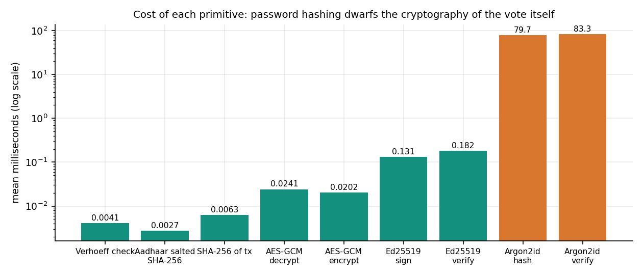
Figure 12: Cost of each primitive on a logarithmic scale.

7.8.6 Latency through HTTP
Twenty-seven voters each signed in, verified an Aadhaar number and cast a vote through uvicorn on 127.0.0.1, nine per minute because of the login limiter. A complete journey took 161 ms on average (p95 214 ms); 98 ms of it is the login. The auditor's integrity check through the API took 41.3 ms on a 29-block chain.
Table 39: Latency of the voter journey over HTTP (27 voters, milliseconds)
Step | Mean | Median | p95 | Max
Login (Argon2id verify) | 97.9 | 93.2 | 131.9 | 154.6
Aadhaar verification | 27.8 | 28.2 | 36.7 | 46.4
Cast (encrypt, sign, block, commit) | 35.1 | 35.2 | 50.0 | 59.2
Whole voter journey | 161.2 | 166.5 | 214.0 | 215.8

The times are for a single client on the same machine as the server, so they include no network delay and no queueing. They say nothing about how the system behaves when many voters arrive together.

7.9 User Acceptance
No user study was carried out. No election official, auditor or voter outside the project team used the application, no usability questionnaire was administered, and no accessibility audit was made. What exists is a scripted walk-through: scripts/capture_screens.py drives a browser through every screen with real data (sign in as each role, create an election, add candidates, verify an Aadhaar number, vote, read the receipt, verify the ledger) and fails if the browser console shows an error or an API call returns an unexpected 4xx or 5xx. The 23 screenshots of Chapter 8 are its output. A walk-through shows that the screens work in sequence; it is not evidence that voters find them clear.

7.10 Limits of the Testing Done
• Concurrency was not tested. Only one vote is in flight at a time in every test and benchmark. A block takes last block index + 1 and the index is unique in the database, so two simultaneous votes would race and one could fail; no test shows how the product behaves.
• The "asynchronous" benchmark is sequential, so no throughput under parallel load exists, and the base paper's parallel batches have no counterpart here.
• The machine was shared. Absolute latencies vary by a factor of two between runs on the same code; relative statements (cryptography is negligible, Argon2id dominates, validation is linear) are robust, absolute ones are not.
• Scale. The 1000-voter benchmark built a chain of about 4,000 blocks, but validation time was measured only up to 301 blocks; larger sizes are extrapolations.
• No penetration test, fuzzing or code audit was performed. The security checks are the ones in Section 7.3.
• The stricter audit is not in the product. It shows what a better check would catch; it does not mean the delivered product catches it.
• Synthetic identities only. No real Aadhaar number, registry or UIDAI interface was involved, so nothing here validates real-world identity assurance.
• Smoke test not re-run for this report; the pytest and HTTP results are fresh, the smoke test is cited only for its existence.

7.11 Summary of Testing

CHAPTER 8: RESULTS AND OUTPUT SCREENS

8.1 Experimental Set-up and Data
This chapter reports what the finished application did when it was run. AegisBallot has no trained model and no external dataset, so the usual accuracy table does not exist; the evidence is of four kinds: what the screens show, how fast the system is, whether its controls hold, and whether tampering is detected.
All timings come from one PC (Intel Core i5-12500, 15.7 GB, Windows 11 Pro, Python 3.11.9) that was shared with other jobs, so absolute latencies are upper bounds and vary between runs by up to a factor of two. The screens, tests and measurements use no real personal data: voters, Aadhaar numbers and names are generated, and the Aadhaar registry is a local table of salted hashes. Statistical significance tests were not applied; the quantities are deterministic checks (pass or fail) and timings whose spread is shown by the mean, median and 95th percentile.

8.2 Output Screens
All 23 screens of the application are shown, grouped by who sees them. They were captured from the running React interface (port 5401) against the FastAPI server (port 8401) holding the data listed above, after real sign-ins, real elections and real votes; no screen is a mock-up. The counters grow by one between the early and the late screens (211 ballots and 212 blocks on the landing page and the dashboard, 212 ballots and 213 blocks on the auditor page) because the voter walk-through of screens 17 to 19 casts one more ballot. The purple-and-dark theme is the default; screens 05 to 08 repeat the landing page in the light theme.

8.2.1 Public pages and sign-in
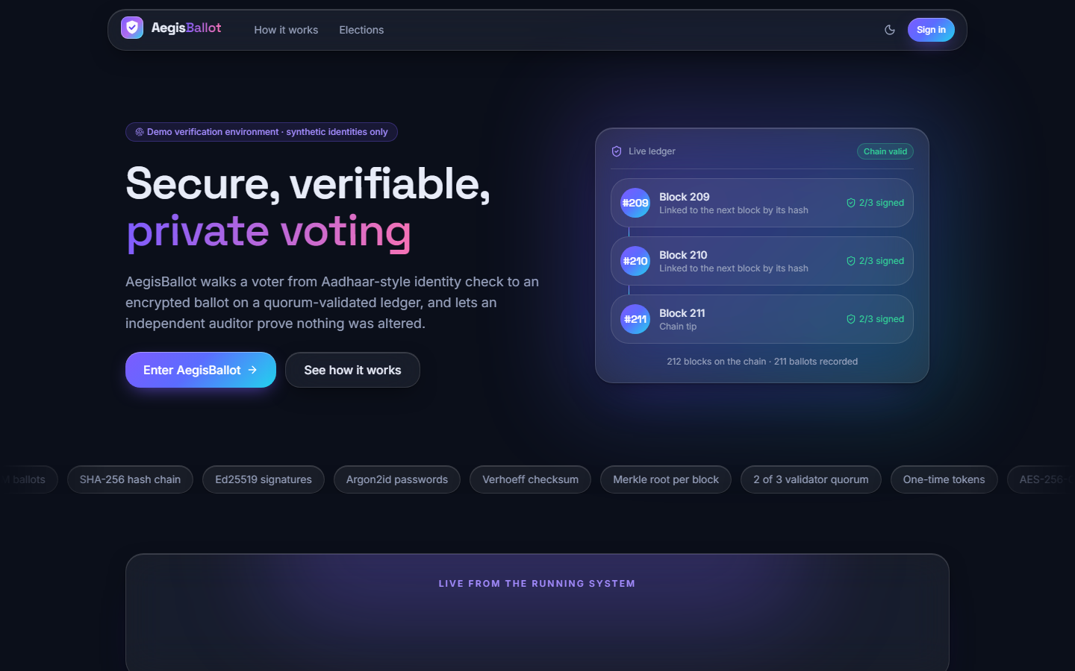  Figure 13: Landing page (dark theme): the headline, a "demonstration environment - synthetic identities only" badge, and a live-ledger card listing the latest blocks (209 to 211) with their "2/3 signed" status and "chain valid". | 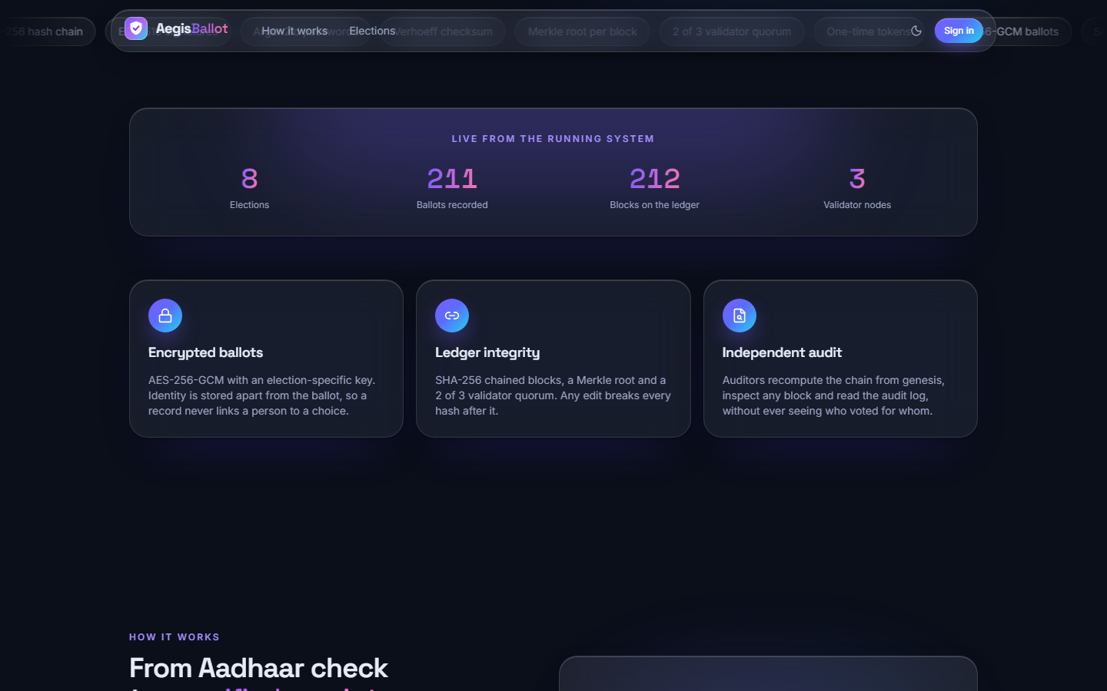  Figure 14: Landing page, live figures: 8 elections, 211 ballots recorded, 212 blocks, 3 validator nodes, read from /api/public/overview, and the three feature cards (encrypted ballots, ledger integrity, independent audit).

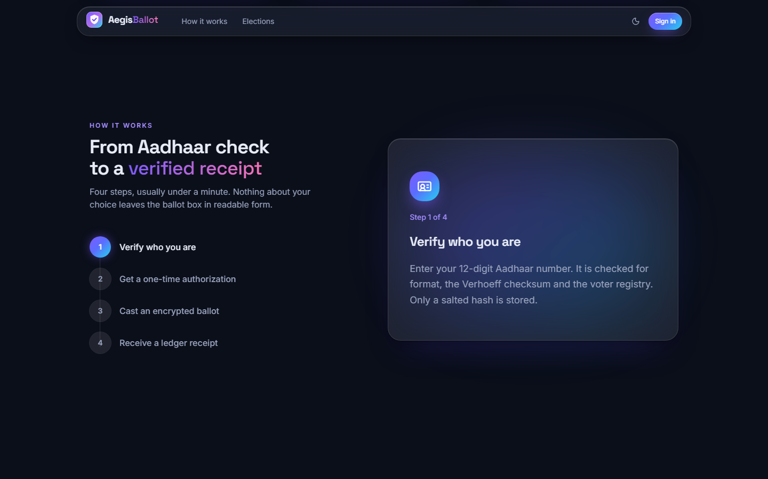  Figure 15: Landing page, "How it works": the four steps (verify who you are, one-time authorisation, encrypted ballot, ledger receipt), with step 1 expanded. The capture caught the header over the section title. | 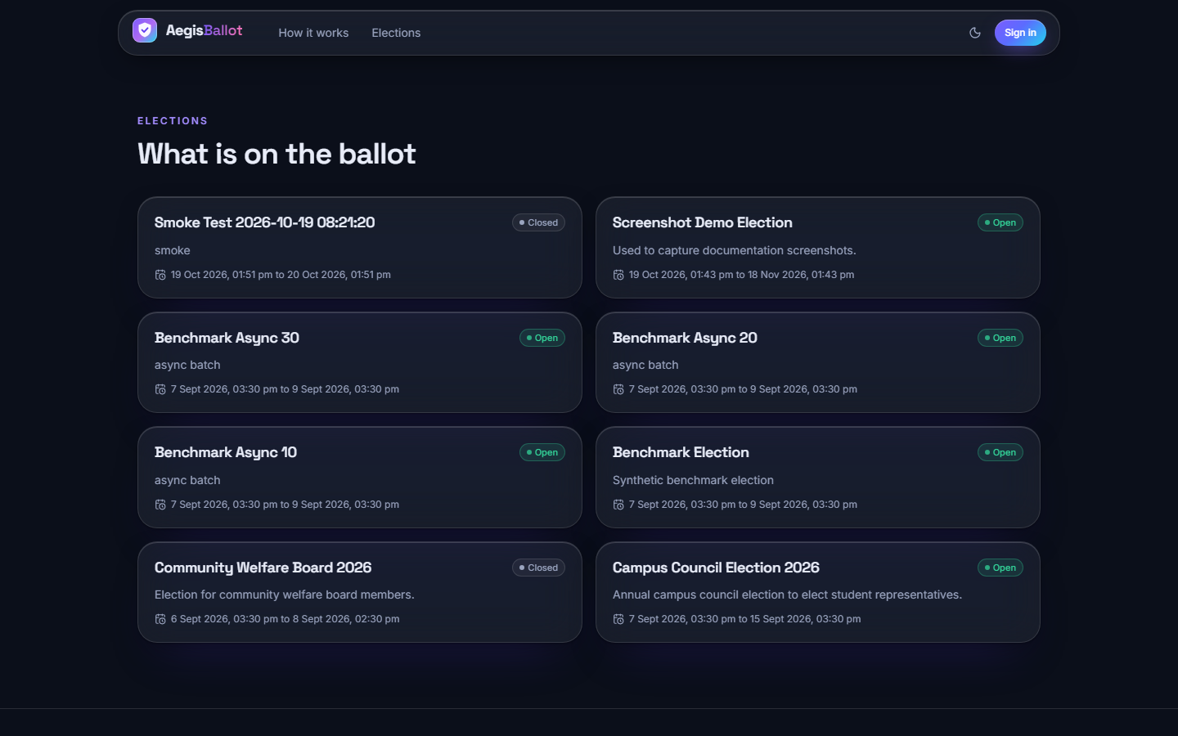  Figure 16: Landing page, "What is on the ballot": all eight elections with their status and window, including the closed Community Welfare Board 2026 and the smoke-test election.

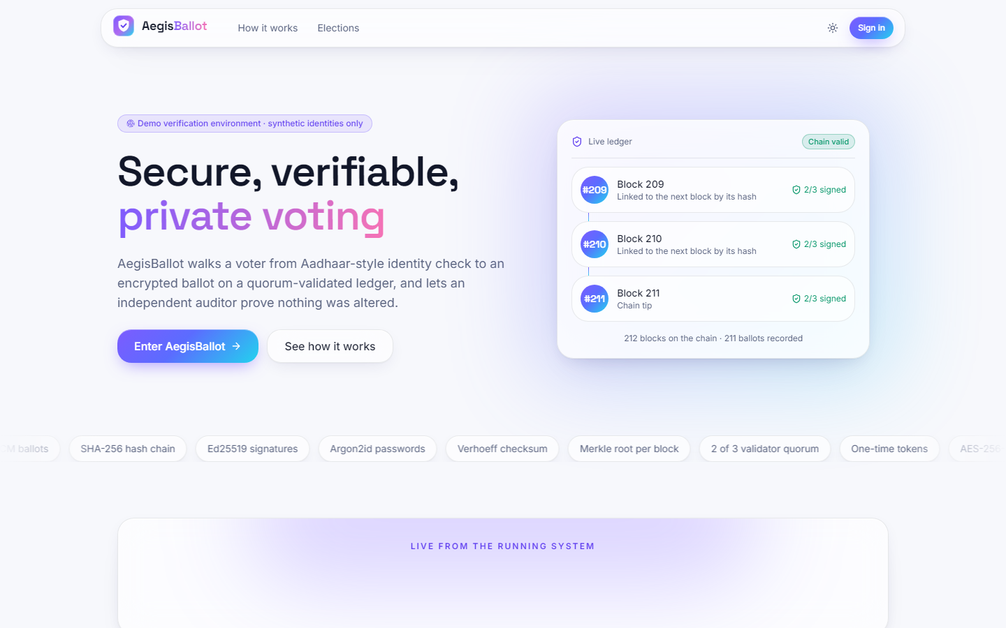  Figure 17: Landing page in the light theme (toggle in the header). | 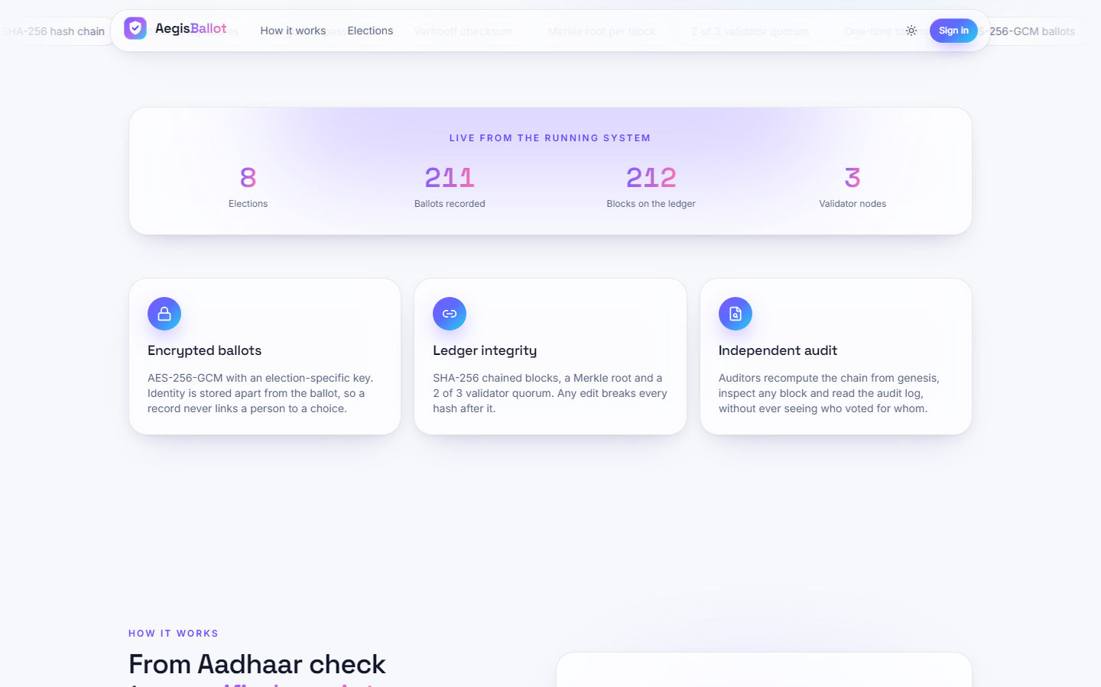  Figure 18: Light theme: live figures and feature cards.

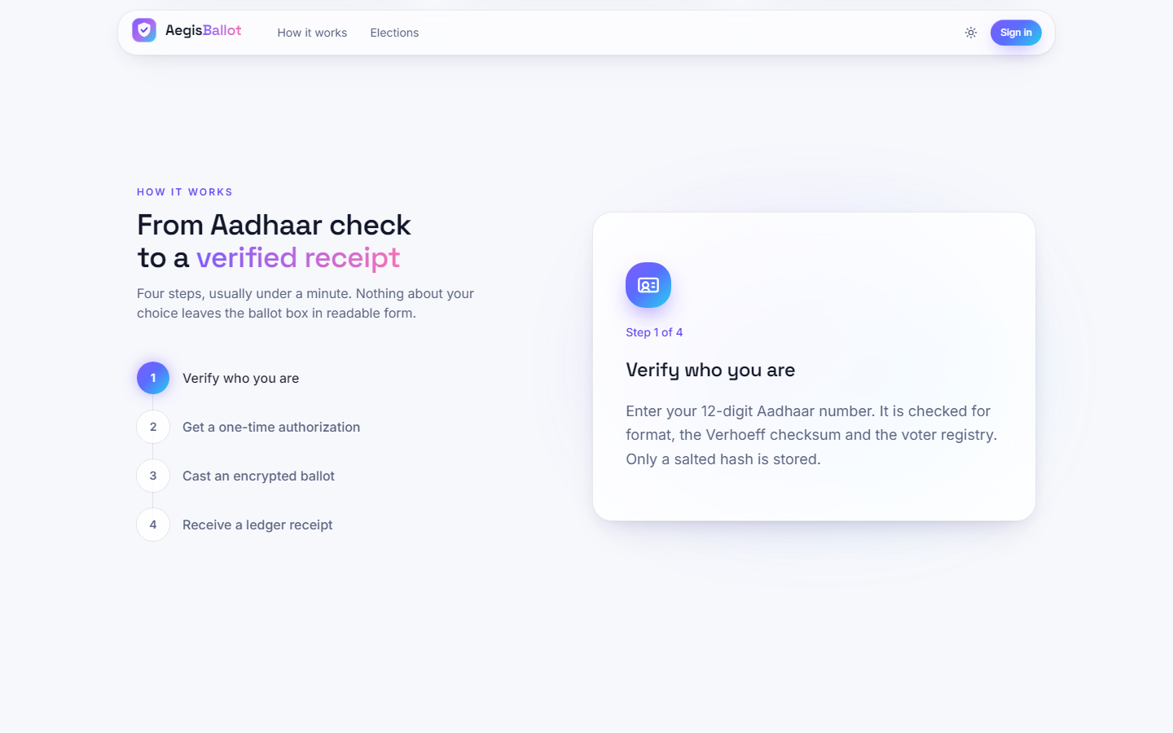  Figure 19: Light theme: the four-step explanation. | 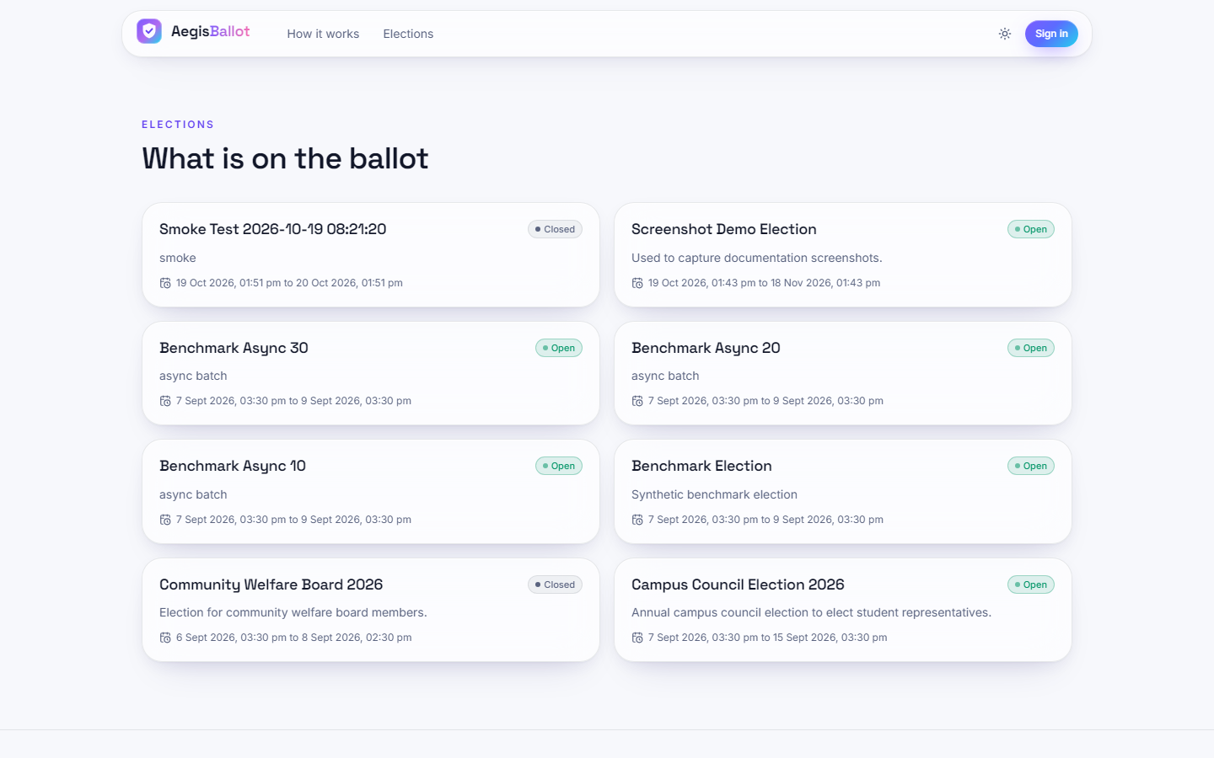  Figure 20: Light theme: the election list.

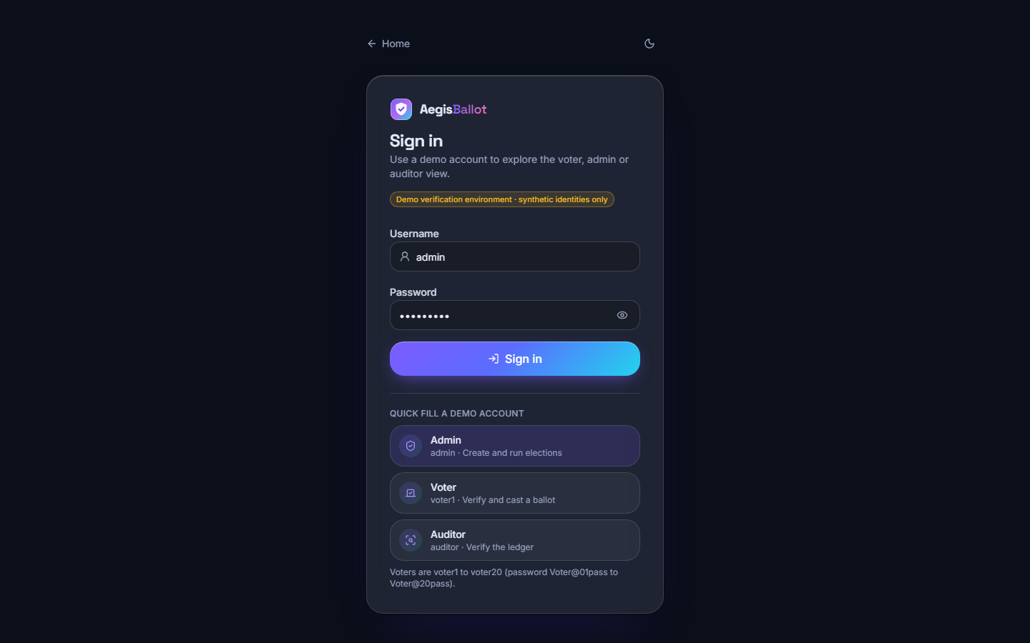
Figure 21: Sign-in page: username and password, the demonstration badge and quick-fill buttons for the admin, voter and auditor demo accounts; voters are voter1 to voter20.

8.2.2 Administrator screens
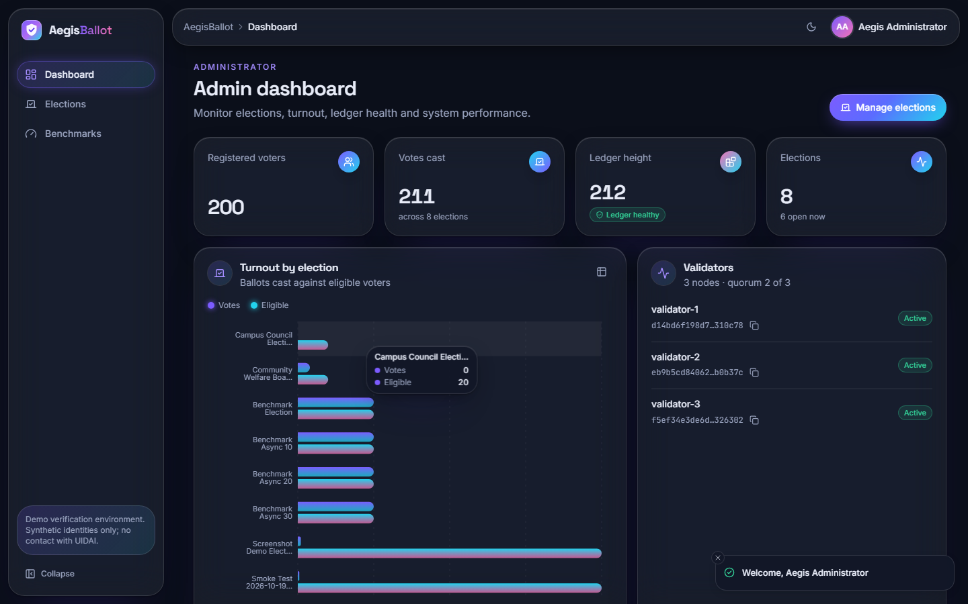  Figure 22: Administrator dashboard: 200 registered voters, 211 votes cast across 8 elections, ledger height 212 with a "ledger healthy" badge, a turnout-by-election bar chart (a tooltip shows 0 of 20 for Campus Council) and the three validators, all active, quorum 2 of 3. | 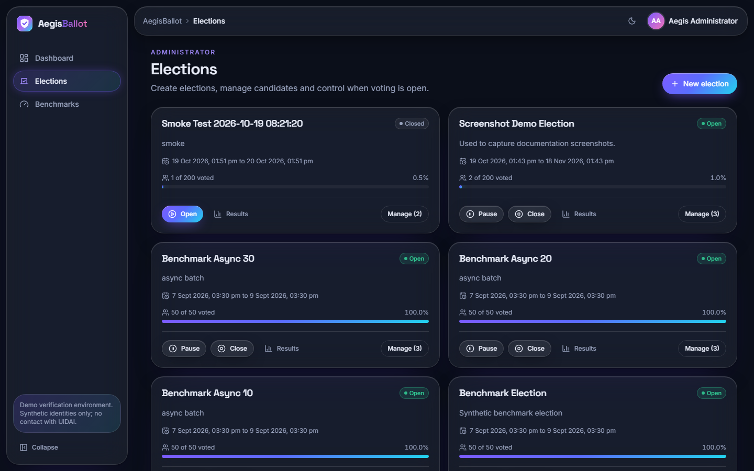  Figure 23: Elections list: each card shows status, window, votes against eligible voters and a progress bar, with Open, Pause, Close, Results and Manage controls. The benchmark elections show 50 of 50 voted.

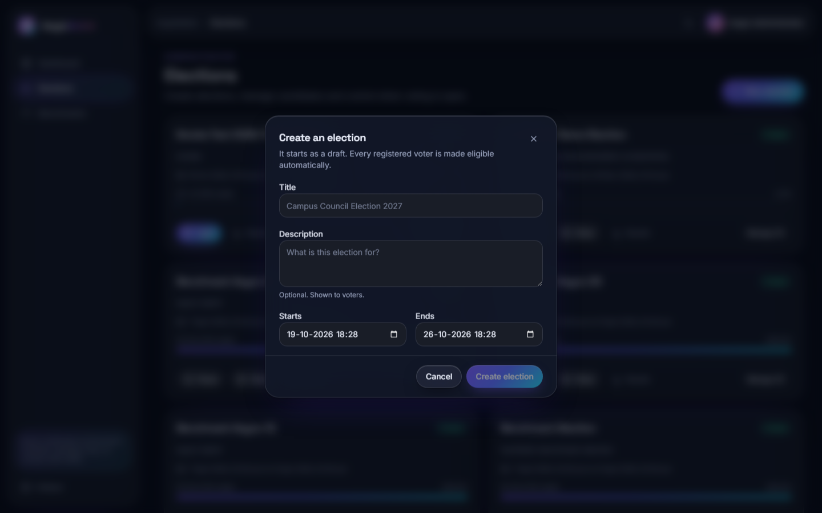  Figure 24: "Create an election" dialog: title, description, start and end. A new election starts as a draft and every registered voter is made eligible automatically. | 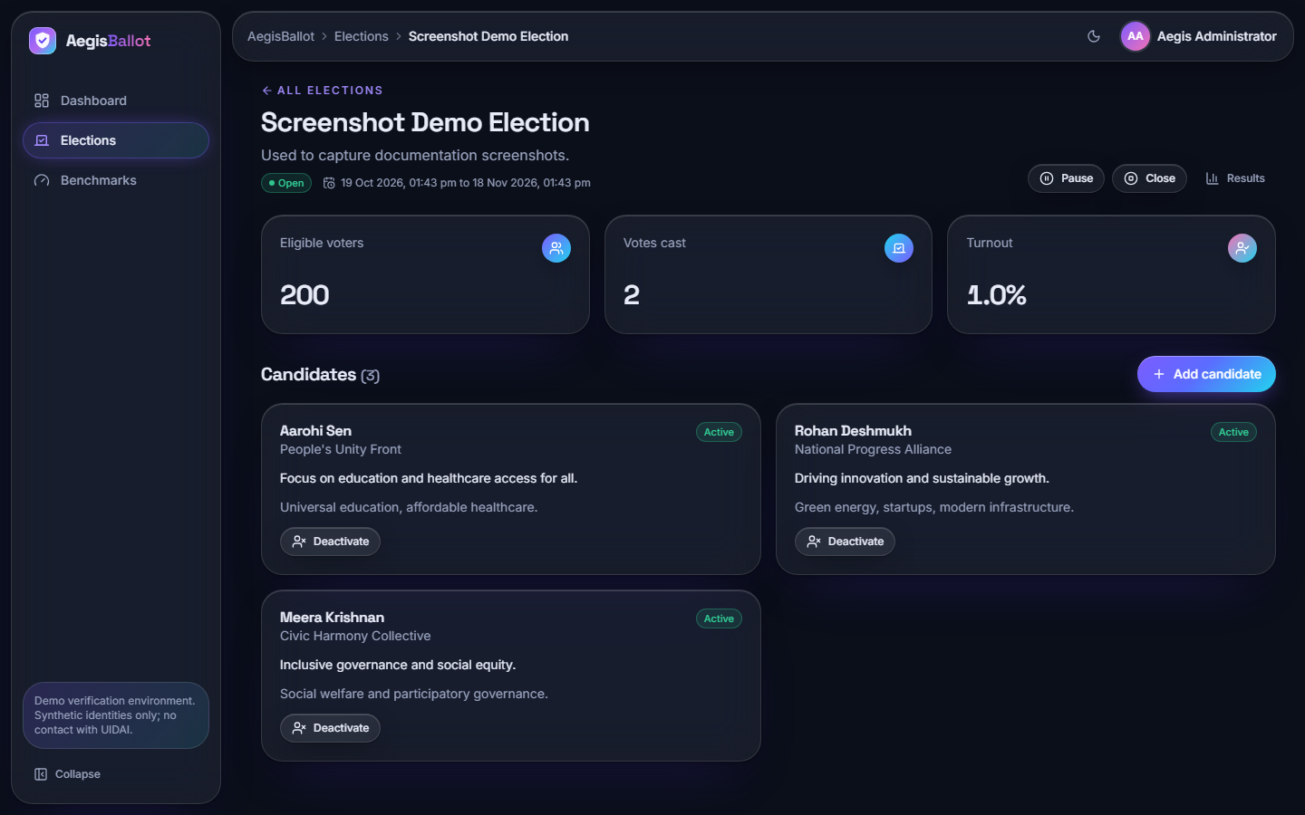  Figure 25: Election detail for the Screenshot Demo Election: 200 eligible voters, 2 votes, 1.0 % turnout, the three candidates with party and manifesto, and Add candidate and Deactivate controls.

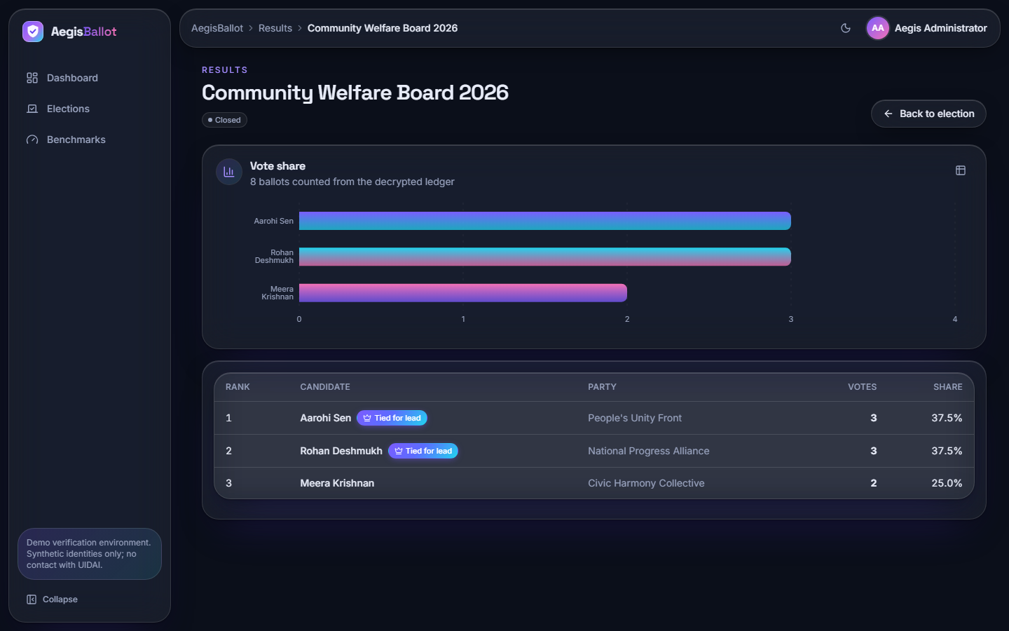  Figure 26: Results of the closed Community Welfare Board 2026: 8 ballots decrypted for the count, a vote-share chart and a ranked table (3, 3 and 2 votes; the first two marked "tied for lead"). | 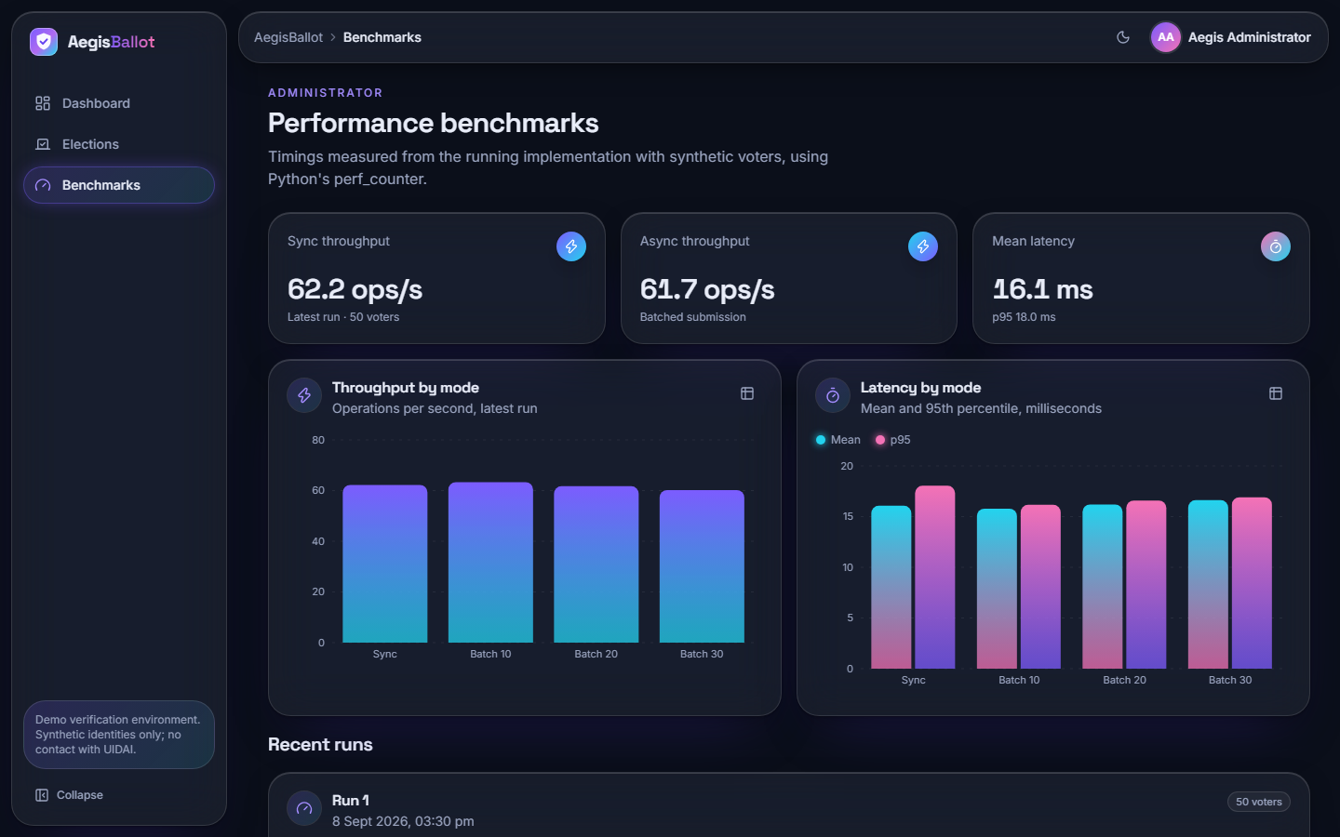  Figure 27: Performance benchmarks: the stored run of 50 voters (62.2 operations per second synchronous, 61.7 batched, mean latency 16.1 ms), throughput and latency charts and the list of recent runs.

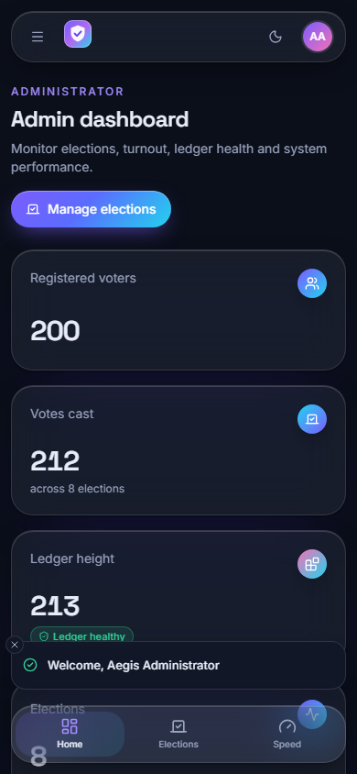
Figure 28: The administrator dashboard at phone width (390 x 844): the layout collapses to one column with a bottom navigation bar.

8.2.3 Voter screens
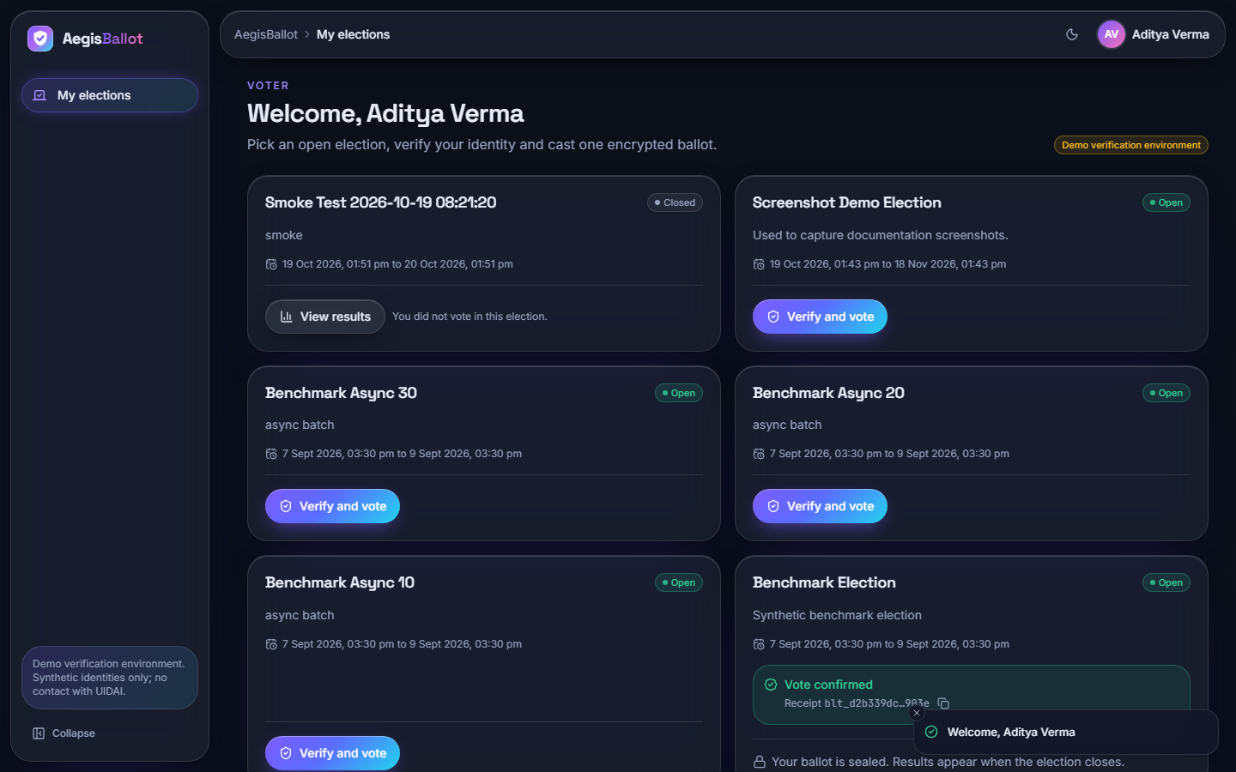  Figure 29: Voter home (voter3, shown as Aditya Verma): open elections with "Verify and vote", a closed election with "View results" and, where the voter has already voted, a "Vote confirmed" box with the receipt id. | 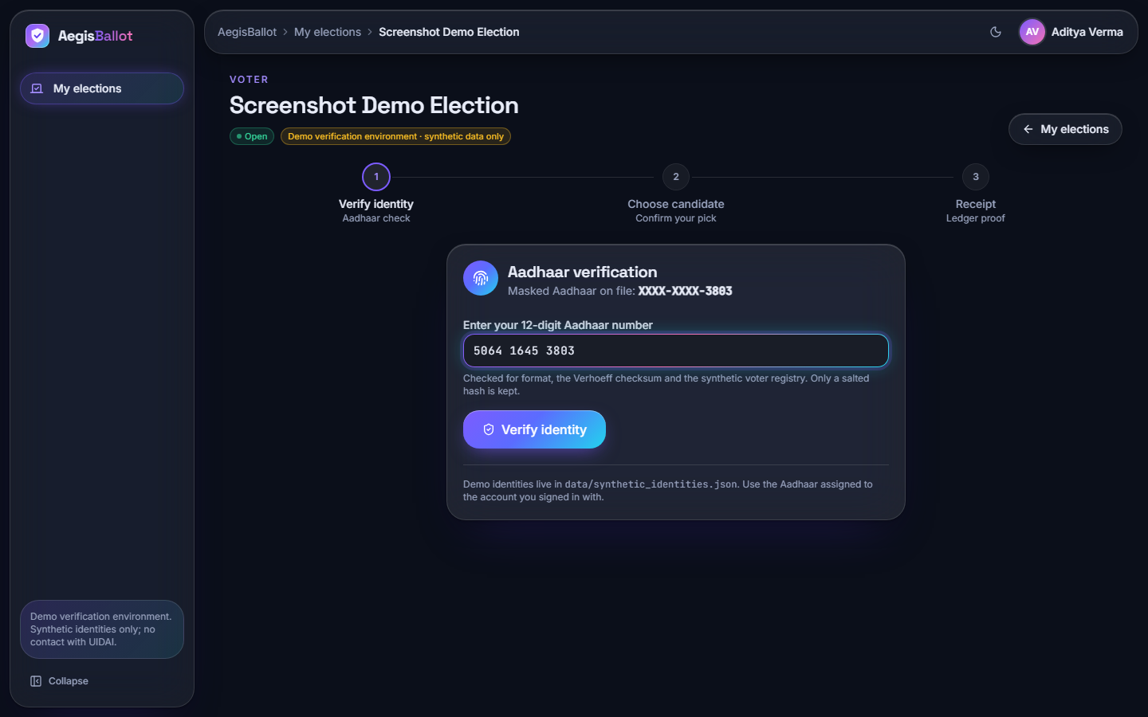  Figure 30: Step 1 of 3, Aadhaar verification: the masked number on file, the 12-digit entry field and the note that only a salted hash is kept.

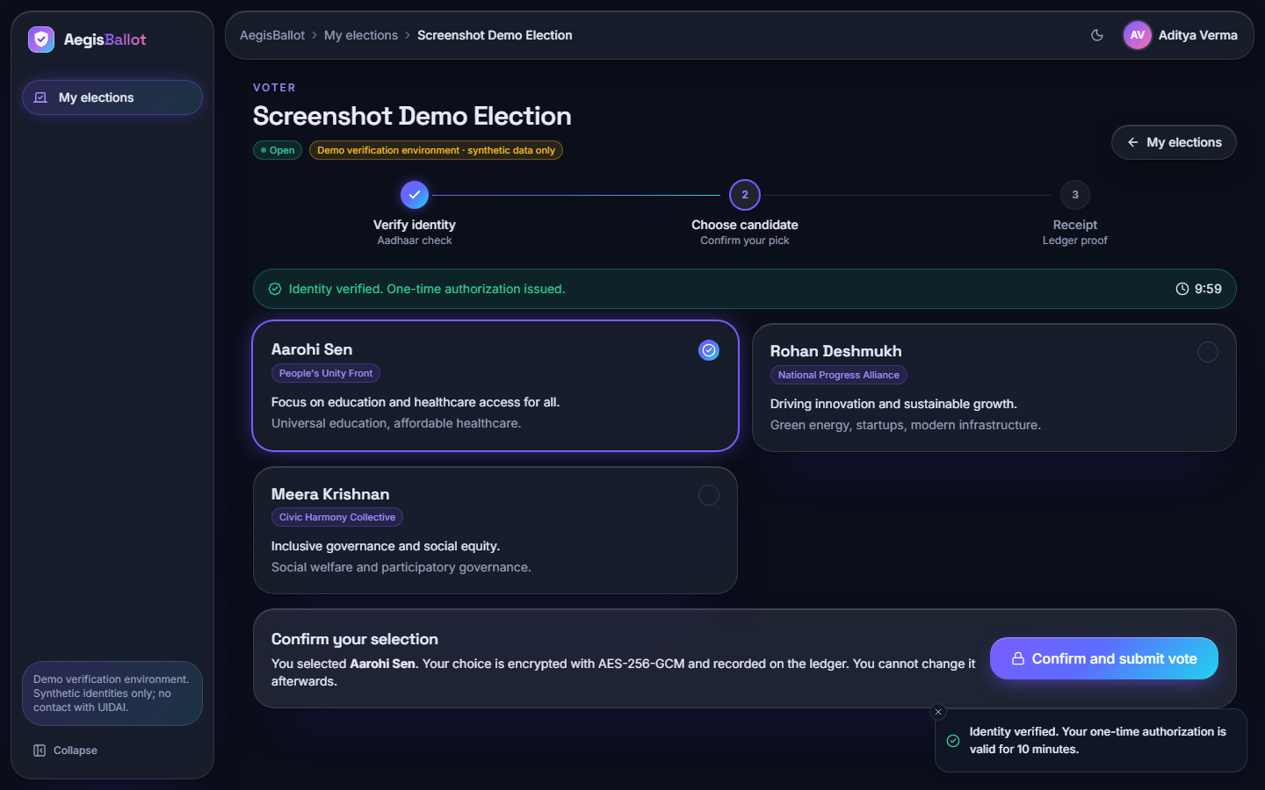  Figure 31: Step 2 of 3: identity verified, a ten-minute countdown for the one-time authorisation, three candidate cards with one selected and a "Confirm and submit vote" bar that warns that the choice is encrypted and cannot be changed. | 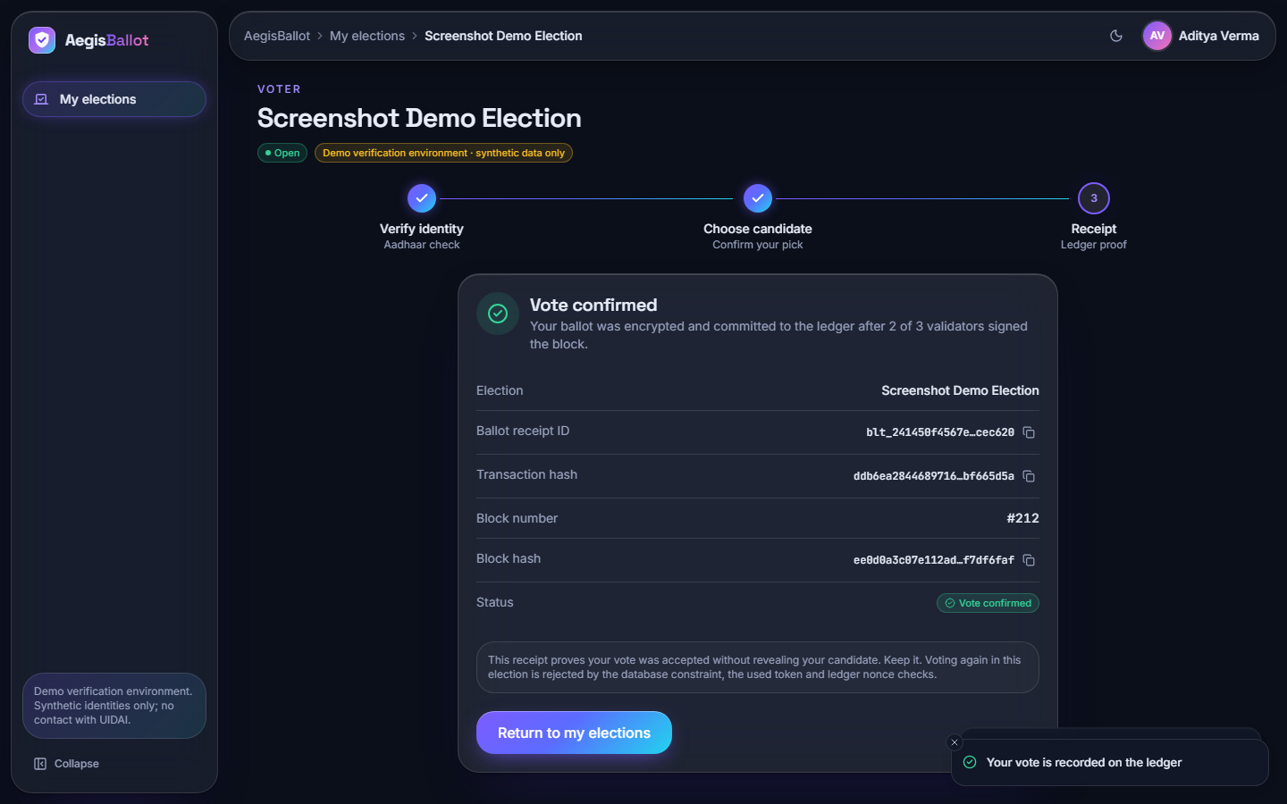  Figure 32: Step 3 of 3, receipt: ballot receipt id, transaction hash, block number 212 and block hash, with the statement that two of three validators signed the block and that the receipt does not reveal the candidate.

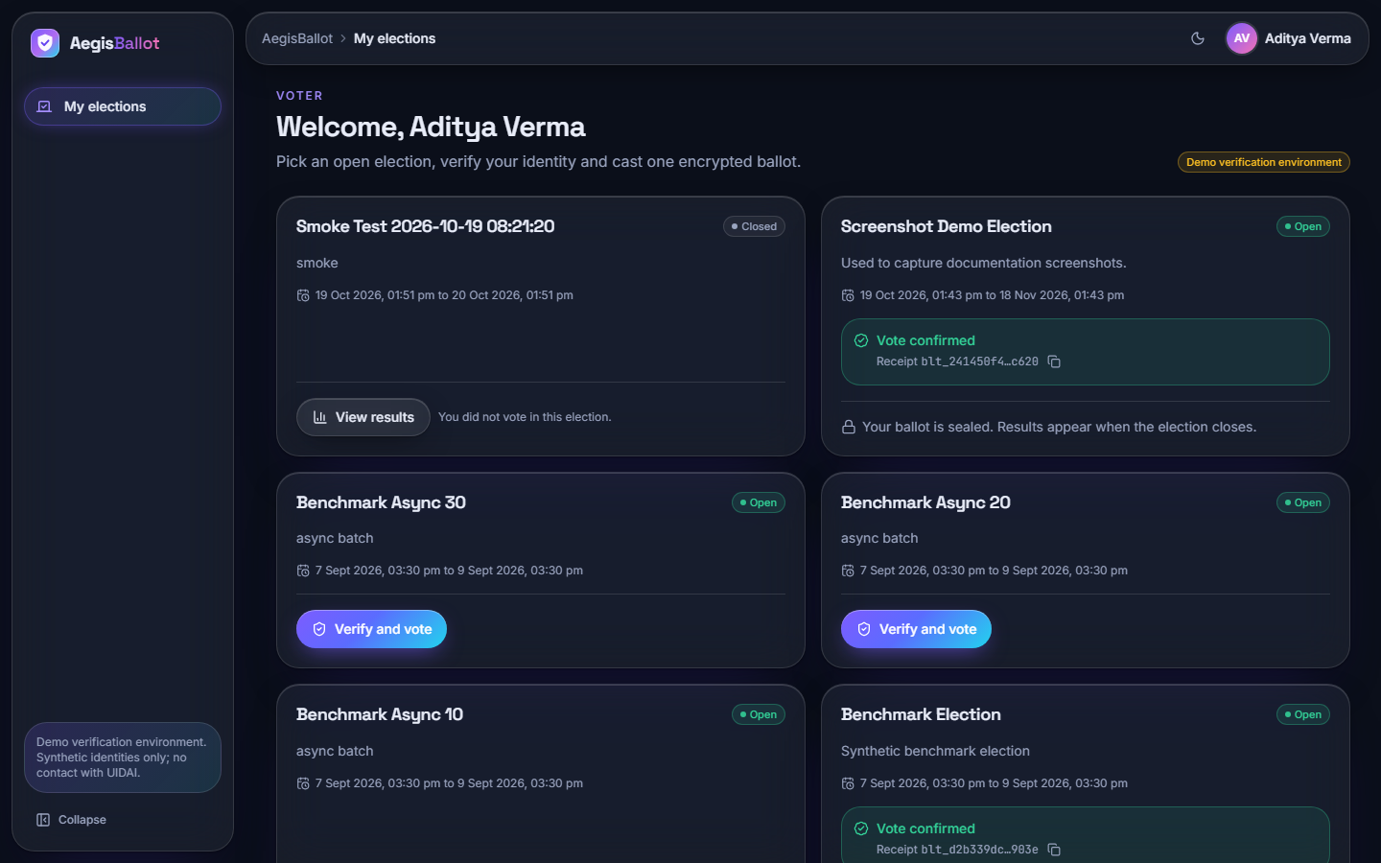
Figure 33: Voter home after voting: the Screenshot Demo Election now shows "Vote confirmed" with the receipt id and "Your ballot is sealed; results appear when the election closes".

8.2.4 Auditor screens
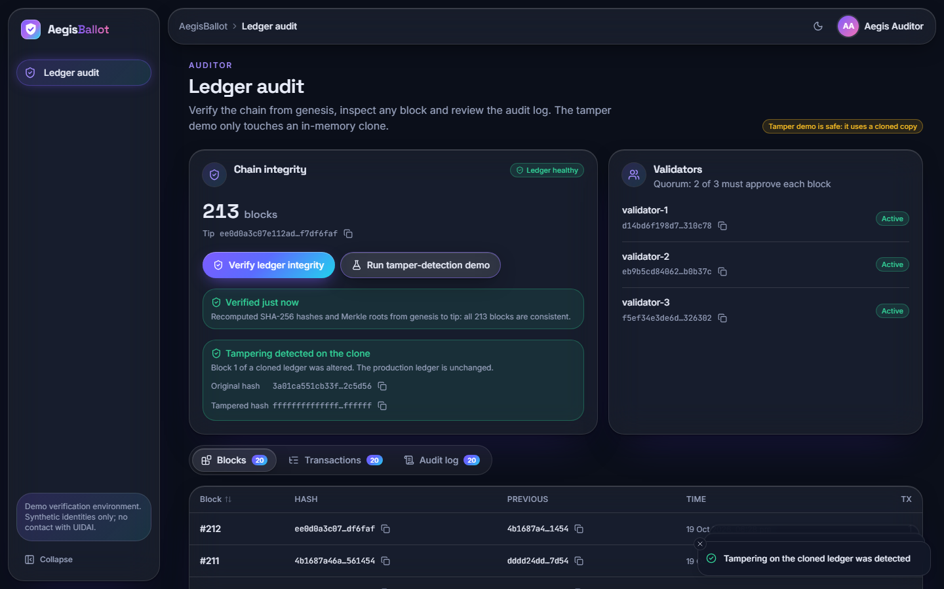  Figure 34: Auditor ledger audit: 213 blocks and the tip hash, "Verified just now: all 213 blocks are consistent", the result of the tamper-detection demo on a clone, the validator list and tabs for blocks, transactions and the audit log. | 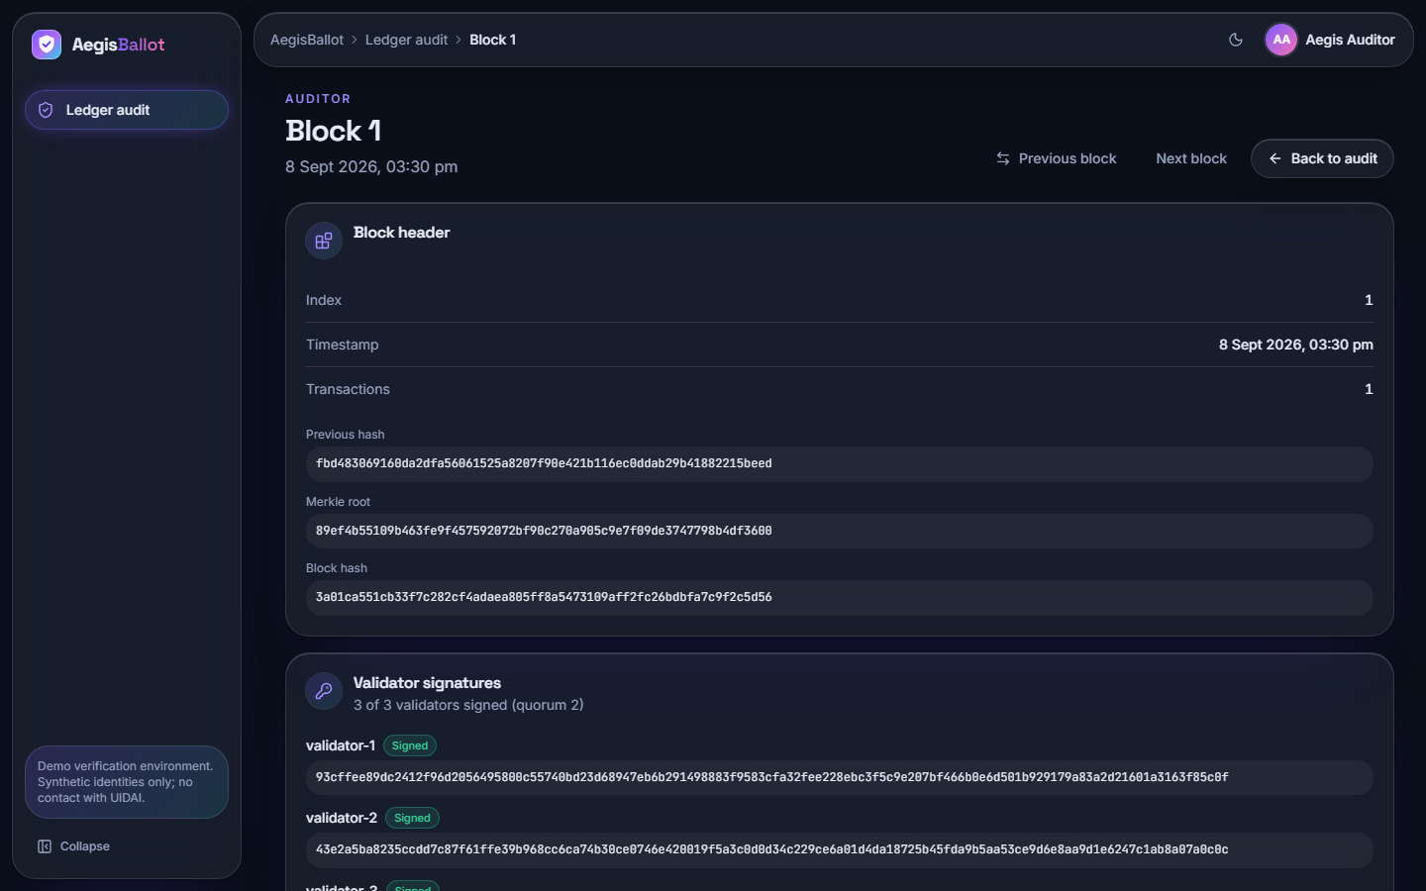  Figure 35: Block detail (block 1): index, timestamp, number of transactions, previous hash, Merkle root, block hash and the three validator signatures (3 of 3 signed, quorum 2), with previous and next navigation.

Reading the screens together, the interface covers the three roles end to end. It also contains one visible limitation that the next sections explain: screen 21 labels its demonstration "safe: it uses a cloned copy", and the message "Tampering detected on the clone" comes from a simulated change (Section 7.6).

8.3 System Performance Results
Since there is no classifier to score, "model performance" here means how quickly the system does its work. The table below gives the headline results; the full tables and charts are in Chapter 7.
Table 40: Headline performance results
Quantity | Result | Conditions
Votes completed in the 1000-voter benchmark | 1000 of 1000 in every mode, 0 failures | In-process, scratch database
Mean time per vote, synchronous | 44.9 ms (median 29.4, p95 75.0) | Shared PC
Throughput, synchronous | 22.3 votes per second | Shared PC
Mean time per vote on an idle PC | 16.1 to 17.3 ms (about 60 votes per second) | Five earlier runs, 50-500 voters
Whole voter journey over HTTP | 161 ms mean, p95 214 ms | 27 voters, 127.0.0.1
Of which login (Argon2id) | 98 ms mean | Same run
Cast a ballot over HTTP | 35 ms mean | Same run
Integrity check of 301 blocks | 146 ms median, linear in chain length | In-process, median of 5
Cryptography of one vote (AES-GCM, SHA-256, Ed25519 sign) | 0.16 ms | Micro-timing means

Three results stand out. First, the work a vote does with cryptography is negligible; the cost of 37 ms of the vote is database work. Second, login is the slowest step by design, 98 ms against 28 ms for the Aadhaar check and 35 ms for the cast. Third, the benchmark's batch sizes make no difference because the batches are sequential, and the throughput of the 1000-voter run is about one third of the idle-machine figure because the PC was busy.
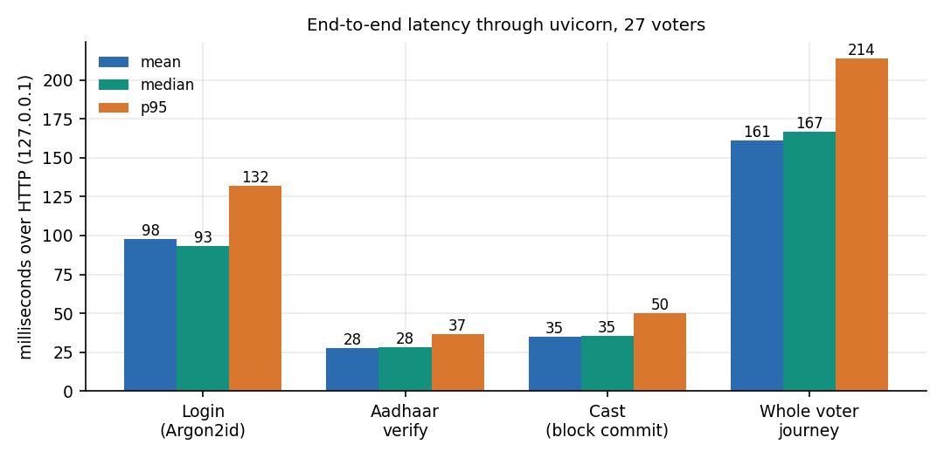
Figure 36: Latency of login, Aadhaar verification, cast and the whole voter journey through HTTP (27 voters).

8.4 Security and Integrity Results
The unit tests passed (17 of 17) and every one of the 25 HTTP checks returned the status it should: unauthenticated and wrongly-roled requests were refused (401, 403), a request without the CSRF header was refused, short, mis-checksummed, unregistered and foreign Aadhaar numbers were refused (400, 403), forged and replayed tokens were refused, a voter could not see a running tally (404), and the eleventh login attempt in a minute was throttled (429).
The tamper study gave the mixed result that matters most for a voting system. Of 13 kinds of tampering applied to a stored chain, the product's integrity check detected 7 and missed 6. A stricter audit that also verifies validator signatures, recomputes transaction hashes and compares the ballots table with the ledger detected all 13. The figure below shows the cases.
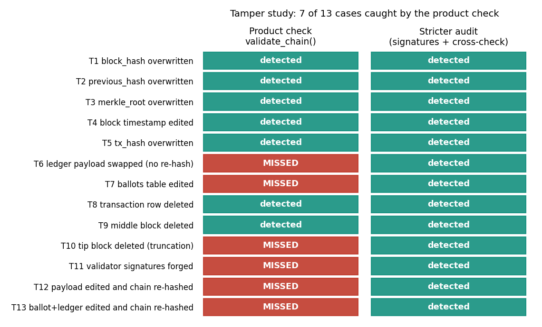
Figure 37: Result of the tamper study: 7 of 13 cases are detected by the product's check, all by the stricter audit.
The detected cases are the ones a hash chain is built for: a changed block hash, previous hash, Merkle root, timestamp or transaction hash, a deleted transaction, a deleted middle block. The missed cases are the ones that need signatures or a link between the ledger and the table the tally reads: an edited ciphertext (in the ledger or in the ballots table), a deleted newest block, forged validator signatures, and an edit followed by a full re-hash from that block to the tip. Two of the missed cases (edited ballots table, and ballots plus ledger edited together with all hashes recomputed) change the result of the election while the auditor's page keeps reporting a healthy chain.

8.5 Comparison with the Base Paper
The base paper [1] proposes and simulates an Ethereum-based model for Oman; the closest related proposal that names Aadhaar is [2], which reports no performance or tamper evaluation. The comparison below is of design and of orders of magnitude only. The two evaluations differ in chain, hardware, language, definition of a transaction and security guarantees, so the numbers must not be read as a head-to-head benchmark.
Table 41: AegisBallot against the base paper
Aspect | Base paper (Oman model) | AegisBallot
Ledger | Ethereum nodes (Geth test chain via Nethereum) with smart contracts; Layer-1 public-chain technology | Local hash-chained ledger in SQLite; three validator keys in one process; no smart contracts, not Ethereum
Decentralisation | Distributed nodes each holding a copy of the chain | None: one server, one database; the quorum of 2 of 3 simulates approval
Voter authentication | Biometric authentication in the simulation; National-ID data in the synthetic population | Password (Argon2id) plus Aadhaar number checked by Verhoeff checksum and a salted-hash registry; synthetic registry, no UIDAI
Application stack | C# / .NET Core 7 clients and web tier, MySQL, Ethereum | Python FastAPI, SQLAlchemy and SQLite, React
Administration | Administrators register officers, voters and candidates and deploy contracts | Admin console for elections, candidates, status; auditor console; audit log
Workload | 1000 synthetic voters; registration and voting transactions | 1000 synthetic voters, vote only (registration is not a transaction here)
Hardware | Intel i7-12700, 12 cores, 16 GB, Windows 10 | Intel i5-12500, 6 cores / 12 threads, 15.7 GB, Windows 11; shared with other jobs
Synchronous time per transaction | About 2000 ms (registration) and 4000 ms (voting), read from Figure 6 | Vote 44.9 ms on the loaded PC, about 16-17 ms idle; cast over HTTP 35 ms
Asynchronous batches | Batches of 10, 20, 30 and 50 submitted concurrently; about 2000 ms and 3000 ms per transaction for a batch of 10 (Figure 9) | Batches of 10, 20 and 30 processed one after another; no concurrency
Tamper evaluation | Qualitative; threats listed (Sybil, 51 %, contract bugs, DoS) | 13 cases applied; product check detects 7, stricter audit 13
Reported limits | Layer-1 throughput (about 119 tx/s for Ethereum, as the paper quotes), synthetic data, no pilot | Single machine, no TLS, partial ballot secrecy, no concurrency test, synthetic data

The base paper's times were read by eye from its Figures 6 and 9, which are charts without tabulated values, so they are approximate (about 2000 ms for a registration, 3000 to 4000 ms for a vote). AegisBallot's vote takes tens of milliseconds, one to two orders of magnitude less. This is no evidence that the design is better. A transaction on a test blockchain waits for block production and confirmation across nodes, whereas AegisBallot's block is committed by a function call that asks three in-process validators to sign. The speed is what a single trusted server buys; the price is that the ledger offers no protection against whoever controls that server, which the tamper study makes concrete.
Where AegisBallot goes beyond the base paper is in workflow and verification, not in distribution: it adds the Aadhaar-style identity check with a checksum and a hashed registry, a complete administrator, voter and auditor workflow with a receipt, an audit log, rate limiting and CSRF protection, and it measures what its own integrity check can and cannot detect. The base paper adds, and AegisBallot lacks, a real distributed chain, smart-contract enforcement and an analysis of public-chain attack classes.

8.6 Sample Inputs and Outputs
The samples below are real. The receipt is the one on screen 19: its values were read from the development database (read-only) and match the screenshot; the other samples come from the scratch runs of Chapter 7.

8.6.1 A successful vote
Step 1, Aadhaar verification (voter signed in, session cookie and CSRF header sent):
POST /api/voter/elections/7/verify
{ "aadhaar": "<12 digits of the signed-in voter>" }

200 OK
{ "auth_token": "<256-bit URL-safe token, shown once>",
"expires_in": 600,
"candidates": [ { "id": ..., "name": "Aarohi Sen", "party": "People's Unity Front", ... }, ... ] }

Step 2, the cast and the receipt (screen 19; the election is the Screenshot Demo Election, number 7):
POST /api/voter/elections/7/cast
{ "candidate_id": <id of the chosen candidate>, "auth_token": "<token from step 1>" }

200 OK
{ "election": { "id": 7, "title": "Screenshot Demo Election", "status": "OPEN", ... },
"receipt": {
"ballot_id": "blt_241450f4567e2c6aee2822667acec620",
"tx_hash": "ddb6ea28446897169940d823fa9612520ac85bbbf27cb97c41a8fe08bf665d5a",
"block_index": 212,
"block_hash": "ee0d0a3c07e112adcd4cb87ec06f78177e6a829f8dc6ae98505bdb2ff7df6faf" } }

The ledger record behind that receipt (auditor screens and ledger_transactions) holds the same ballot id, the transaction hash, the encrypted payload CuhkuG5Z0hLtdWtW5Z0AppaDGQSroY9siOpHcZPR (a 12-byte nonce followed by the AES-256-GCM ciphertext of the candidate id and its tag, base64-encoded), a 16-byte random nonce, the Ed25519 signature of the system key and, in ledger_blocks, the previous hash 4b1687a46a717830..., a Merkle root, the block hash and the signatures of validators 1, 2 and 3. Neither the receipt nor the ledger names the candidate or the voter.

8.6.2 Refusals
Table 42: Sample refused requests and what the application answers
Request | Status | Message or effect
Aadhaar of 11 digits | 400 | Invalid Aadhaar format: must be 12 digits
12 digits, last digit changed | 400 | Invalid Aadhaar checksum (Verhoeff)
Valid checksum, not in registry | 400 | Aadhaar not found in voter registry
Another voter's registered number | 403 | Aadhaar does not match logged-in voter
Second cast with the used token | 400 | Authorization token already used (audit entry vote_rejected)
Cast after the token's ten minutes | 400 | Authorization token expired
Cast in a paused election | 400 | Election is not open for voting
Voter asks for results of an open election | 404 | Results are published when the election is closed
POST without X-CSRF-Token | 403 | CSRF token missing or invalid
Eleventh login attempt within a minute | 429 | Too many attempts. Try again in a minute.

8.6.3 The auditor's check
POST /api/auditor/verify (scratch chain of 29 blocks)

200 OK
{ "valid": true, "height": 29,
"last_hash": "bb5c5dbec53cc723b9ab91cfd89c8838eff408f1d5f260edf887c9a6dfee4105" }

(after tampering, the same call returns, for example)
{ "valid": false, "first_invalid": <block index>, "field": "merkle_root" | "block_hash" | "previous_hash", "expected": "...", "actual": "..." }

The development database also keeps the trace of the smoke test run on 19 October 2026 in its audit log: a verification refused because the Aadhaar belonged to another voter, a verification accepted, a token issued, a cast with an invalid token rejected, a valid cast accepted and a replay with the used token rejected - the same sequence as checks 12, 15, 13, 17 and 18 of Chapter 7.

8.7 Success and Failure Analysis

8.7.1 What worked
• One vote per voter was enforced by four independent layers (eligibility, a unique participation row, a single-use token, and the ledger's nonce check). Every attempt in the tests to vote twice failed, at the service level and over HTTP.
• Identity binding worked as designed against the synthetic registry: format, checksum, registration and ownership of the number are all checked, and a voter cannot verify with someone else's number.
• Ballots were encrypted and receipts did not reveal choices. The ledger and the ballots table hold only ciphertext and a random ballot id.
• The workflow was complete. An administrator created an election, a voter was verified, voted and obtained a receipt, the seeded election Community Welfare Board 2026 was closed and its results page counts eight decrypted ballots, and an auditor verified 213 blocks (screens 10 to 22).
• Basic hardening held: 25 of 25 HTTP checks matched expectation, including roles, CSRF, validation, replay and the login limiter.
• The system is fast enough for its purpose as a local demonstration: tens of milliseconds per vote and about a fifth of a second for a whole voter journey.

8.7.2 What failed or fell short
1. The integrity check misses 6 of 13 tampering cases. The cases that matter most for an election are among them: the ballots table, from which the tally is computed, is not covered by the ledger check, and signatures and transaction hashes are never re-verified. An administrator with database access could change the result and the auditor's page would still show "ledger healthy".
2. The tamper-detection demonstration is simulated. The clone test overwrites a hash in memory and reports detection; it is not an independent verification (Section 7.6).
3. Ballot secrecy is partial. voter_participation stores the voter id with the ballot id, so anyone who can read the database can find a voter's ballot, and with the single AES key in data/secrets.json can decrypt it. The README describes a per-election key; the code (app/config.py) creates one key for all elections.
4. The administrator can read a running tally of an open election (HTTP check 22). The voter is refused, but an election official can see partial results before the poll closes.
5. The polling window is not enforced. Start and end times are shown but never compared with the clock; a vote is accepted whenever the status is OPEN.
6. The login limiter keys on the client address, so a polling station behind one address would be limited to ten sign-ins a minute, and it is lost on every restart because it is held in memory; sessions are in memory too.
7. No TLS and no `Secure` cookie flag, although the abstract lists TLS. Password hashing is Argon2id, not the bcrypt named in the abstract (a stronger choice, but a difference).
8. The benchmark's "asynchronous" batches are sequential, and concurrent voting was never tested; two simultaneous votes compete for the same next block index.
9. Weak assertions in three unit tests (Section 7.2) mean the green result of the pytest run overstates what is verified.

8.7.3 Why the failures matter, and what they do not mean
The failures cluster in one place: the gap between the ledger and the data the application actually trusts. A hash chain protects the records inside it; it does not protect the table next to it. Nothing here shows that the cryptographic primitives are wrong - SHA-256, AES-GCM and Ed25519 were used through standard libraries and behaved correctly in every test - or that the one-vote rule can be bypassed through the interface. What the study shows is that "immutable" is a property of a verified chain, and the delivered verification is incomplete.

8.8 Limitations of the Results
• All identities, Aadhaar numbers and elections are synthetic; the results say nothing about real electoral rolls, UIDAI services or real voters' behaviour.
• The ledger is a single-machine simulation of a permissioned chain; no result applies to a distributed deployment, to network faults or to Byzantine validators.
• Timings come from one shared PC; they show orders of magnitude and relative cost, not guaranteed performance.
• No concurrency, load or penetration testing was done, and no user study.
• The stricter audit that detected all 13 cases is a research script, not part of the product.
• Numbers taken from the base paper's figures are approximate readings.

8.9 Objectives Versus Outcomes
The six objectives are those of the batch's objectives document. Each is judged against the evidence of Chapters 7 and 8, and the verdicts are deliberately conservative.
Table 43: Objectives and outcomes
No. | Objective | Outcome | Evidence and caveat
1 | Voter registration and authentication with Aadhaar-based identity verification | Partly achieved | Password sign-in and the Aadhaar check (format, Verhoeff, registry, ownership) work and are tested. Registration is not a user function (voters are seeded), and the registry is synthetic; UIDAI is not contacted.
2 | One-voter-one-vote through identity binding and duplicate checks | Achieved | Four layers; unit tests 5, 6 and 11; HTTP checks 12, 18 and 19; database uniqueness constraints on three tables.
3 | Record each ballot immutably using blockchain and cryptographic hashing | Partly achieved | Each ballot is a signed transaction in a hash-chained, validator-signed block. Edits to hashes and links are detected (7 of 13 cases), but the tally source is not covered, signatures are not verified by the audit, and the chain is not distributed.
4 | Administration portal for elections, candidates and polling windows | Mostly achieved | Elections, candidates and status are managed through the interface (screens 11-13). Windows are stored and displayed but not enforced.
5 | Results automatically when the poll closes, with a chronological audit trail | Achieved, with caveats | Closing is an administrator action; once CLOSED the tally is computed on request and published to signed-in roles (screens 14, 20). The audit log records actions in time order. The administrator can also see a live tally.
6 | RBAC, input validation and TLS; evaluate integrity and performance | Partly achieved | RBAC, CSRF, validation, rate limiting achieved (25 of 25 checks). TLS not achieved. Integrity and performance evaluated with the limits stated here.

In summary, the platform delivers the voting workflow and the one-vote guarantee convincingly, delivers the ledger as a tamper-evident record for the part of the data it covers, and is honest about the rest: the pieces that remain are listed again as future work in Chapter 10.

CHAPTER 9: CONCLUSION

9.1 Summary of the work
This project set out to build a secure voting system in which an Aadhaar-based identity check binds one ballot to one voter and a blockchain-style ledger makes the record tamper-evident and independently checkable. The result is AegisBallot, a local web application with an administrator, voter and auditor console on a FastAPI and React stack. A voter signs in, enters an Aadhaar number that is validated by format, Verhoeff checksum and a salted-hash registry, receives a single-use ten-minute token, and casts one ballot that is encrypted with AES-256-GCM, signed with Ed25519 and committed as a block approved by two of three validators. The voter keeps a receipt, the administrator sees turnout and results, and the auditor can recompute the chain and read the audit log.
The system was built, run and measured. It is a demonstration on one machine: the registry is synthetic, the validators are in-process keys, and TLS is not configured. We make no claim that it is ready for a public election.

9.2 Objectives achieved
Table 44: Objectives against outcomes
No. | Objective (from the batch) | Status | Evidence
1 | Voter registration and authentication with Aadhaar-based identity verification | Partly achieved (registration is provisioning only) | Argon2id login; verification by 12 digits, Verhoeff checksum, registry and ownership (matrix checks 9-12). Synthetic registry, no UIDAI; no self-registration screen
2 | One voter, one vote through identity binding and duplicate checks | Achieved | Four layers; duplicate-vote and replay checks returned 400; 17 of 17 tests passed
3 | Record each ballot immutably with blockchain and cryptographic hashing | Partly achieved | Hash-chained, signed blocks; the product check detects 7 of 13 tamper cases and misses edits to the tally table, re-hashed chains, forged signatures and tip removal
4 | Admin portal for elections, candidates and polling windows | Mostly achieved | Create, add, deactivate, open, pause, close; windows are stored but voting is governed by the status flag, not the clock
5 | Results on close with a complete chronological audit trail | Achieved, with caveats | Tally published when the status is CLOSED (manual close, no scheduler); audit log records login, verification, cast, election changes, integrity checks
6 | RBAC, input validation and TLS; evaluate integrity and performance | Partly achieved (TLS not achieved) | RBAC and validation: 25 of 25 checks as expected; TLS not configured; integrity and performance evaluated (Chapter 8)

9.3 Key findings
• Cost of a vote. On an idle machine one vote took 16.1 to 17.3 ms (about 57.7 to 62.2 votes per second); in the 1000-voter run on a shared PC the mean was 44.9 ms with all 1000 votes succeeding. Block proposal (16.8 ms), token authorisation (11.0 ms) and persistence (9.5 ms) dominate; the cryptography of the vote takes 0.53 ms.
• Whole journey. Over HTTP a voter's login, verification and cast took 161 ms on average (214 ms at the 95th percentile), of which login with Argon2id was 98 ms, verification 28 ms and casting 35 ms.
• Integrity check scales linearly. validate_chain took 146 ms at 301 blocks; a stricter audit that verifies signatures took 788 ms on 361 blocks.
• The ledger check has gaps. 7 of 13 tamper cases were detected; 6 were missed, including an attacker who edits a ballot and recomputes every hash. 13 of 13 were detected once validator signatures, transaction hashes and the ballots table were checked.
• Batch size had no effect. The benchmark's batches are sequential, so the differences between them are noise.
Against the base paper [1], the comparison is qualitative. It reports roughly two seconds for a registration and three to four seconds for a vote on an Ethereum test chain with a C# client, read from its figures; AegisBallot takes a few tens of milliseconds in-process because it has no network or mining step. The base paper's argument for decentralised verification is exactly what a single-machine simulation cannot show, and the conclusion of that paper, that pilots and threat modelling are needed, applies equally here.
The security checks gave a consistent picture. All 25 HTTP checks behaved as designed: anonymous requests received 401, a voter on an administrator or auditor route received 403, a missing CSRF header 403, a malformed or checksum-invalid Aadhaar number 400, another voter's valid number 403, a forged or replayed token 400, and the eleventh login attempt inside a minute 429. The automated test suite covers the same ground from inside the application, including expiry of a token and the separation of identity from the ballot. What the checks could not show is whether an operator with access to the machine can alter the outcome; the tamper study addresses that question and its answer is the most useful result of the project.

9.4 Practical applications
• Classroom and laboratory demonstration of identity-bound, hash-chained voting and of auditor tooling.
• A starting point for small association or campus council elections run by a trusted operator, after TLS, persistent sessions and the audit fixes in Chapter 10.
• A test bed for e-governance research: the identity provider interface, the ledger and the tamper study can be reused to compare other designs.
• It is not a candidate for a national or state election, which would need a real identity service, distributed validators, formal review and legal approval.

9.5 Known limitations
The limitations listed earlier in this report stand: synthetic identity, simulated distribution of trust, partial ballot secrecy, an integrity check that does not cover signatures or the tally table, no TLS, and untested concurrency. The most important lesson of the project is that a ledger is only as trustworthy as the check that reads it, and that the check must be tested as carefully as the ledger.

CHAPTER 10: FUTURE SCOPE

10.1 Improvements to the present design
The tamper study and the code review identify fixes that are small and would close the largest gaps.
1. Extend validate_chain to verify each validator signature against the stored public keys, recompute every transaction hash from its fields, verify the transaction signature, and cross-check the ballots table against the ledger. The stricter audit in scripts/run_experiments.py already does this and detected all 13 cases, at about 5 times the cost of the present check.
2. Compute a real binary Merkle tree so that a voter can check inclusion of their ballot from a short proof.
3. Use a key per election, keep it out of the application database, and decrypt only when the election is closed; hide the live tally from the administrator.
4. Split the voter-to-ballot link: record participation without the ballot id, or use blind-signature or mix-based schemes [26], so that the database alone does not reveal a choice.
5. Serve the application over TLS behind a reverse proxy, set the Secure flag on the cookie, and replace the development secrets.
6. Make sessions persistent and rate limits shared (for example in a database or Redis) and key them by account as well as by IP address.
7. Enforce the election window by the clock as well as the status flag, and close elections automatically.

10.2 Additional features
• A second identity factor: OTP to a registered phone or a biometric match, as proposed in the Aadhaar-based work [2] and the base paper.
• A real identity adapter for an official sandbox, behind the existing IdentityVerificationProvider interface, with consent and data-protection handling in line with the Aadhaar Act [27].
• Cryptographic verifiability: zero-knowledge proofs or homomorphic tallying, as surveyed [6, 9], so that the result can be checked without trusting the decrypting party.
• A public receipt-verification page where a voter pastes the ballot id and sees the block and its hashes.
• Voter self-registration with approval by the administrator, and multi-election and constituency support.

10.3 Scalability and deployment
• Run the three validators as separate services on separate hosts, exchange proposals and signatures over the network, and adopt a tested protocol such as PBFT or Raft [18] in place of the in-process loop.
• Replace SQLite with PostgreSQL, add a lock or a serialisable transaction around block creation, and then run a real concurrent load test (the present benchmark is sequential).
• Batch several ballots per block and add database indexes so that validation does not issue queries per block.
• Package the application in containers with the secrets supplied from outside the image, and add monitoring of chain height and validation time.
• Compare the throughput of the revised design with the figures in the base paper on the same hardware, including a Layer-2 comparison as the base paper proposes.
Table 45: Suggested order of work
Step | Change | Effort | Closes
1 | Signature-aware, ballot-cross-checking audit in validate_chain | Small: logic already prototyped in the experiment script | Tamper cases T6, T7, T10-T13
2 | TLS proxy, Secure cookie, non-default secrets | Small | Plain-HTTP session exposure
3 | Lock or serialisable transaction around block creation; concurrent load test | Medium | Untested concurrency and the unique block-index race
4 | Per-election keys; hide the live tally; split voter and ballot ids | Medium | Operator linking of voter to choice
5 | Real Merkle tree with inclusion proofs; receipt-check page | Medium | Voter-side verification
6 | Separate validator services with a tested consensus protocol | Large | Single-host trust
7 | Official identity sandbox adapter, OTP or biometric factor | Large; needs approval | Synthetic registry

The order puts the cheap, high-value corrections first. The first step alone would raise the detection result of the study from the present figure to all thirteen cases without a change of architecture; the later steps change what the system is and should follow only once the earlier ones are measured.

10.4 Further research
• Formal modelling of the voting protocol and its privacy and verifiability properties, in the manner of analyses of deployed systems [10, 11, 12].
• A penetration test and a threat model that includes insider and operator attacks on the key files.
• A usability and accessibility study with real voters and polling staff, including voters who cannot use the web interface.
• A study of coercion-resistance and receipt-freeness: the present receipt proves that a ballot exists but not what it contains, which is intended, and this property should be argued formally.
• A longitudinal measurement of chain growth, storage and audit time over many elections.

REFERENCES
[1] A. Shaikh, N. Adhikari, A. Nazir, A. S. Shah, S. Baig and H. Al Shihi, "Blockchain-enhanced electoral integrity: a robust model for secure digital voting systems in Oman," F1000Research, vol. 14, art. 223, version 3, Sep. 2025, doi: 10.12688/f1000research.160087.3.
[2] S. Chouhan and G. Sharma, "A new era of elections: leveraging blockchain for fair and transparent voting," arXiv:2502.16127, Feb. 2025.
[3] T. Lloyd, D. O Broin and M. Harrigan, "The on-chain and off-chain mechanisms of DAO-to-DAO voting," arXiv:2603.00708, Feb. 2026.
[4] M. Ray, V. Ojha and W. Rhmann, "Electronic voting system powered by blockchain technology: a study," SSRN Electronic Journal, 2024, doi: 10.2139/ssrn.4483852. [SSRN lists the posting as May 2023 (ICCS 2023); the batch records 2024.]
[5] K. Krishan, S. Raj and P. Raj, "Decentralized trust: a blockchain-based framework for secure electronic voting," SSRN preprint, Mar. 2026.
[6] T. Aswini, "Blockchain in electronic voting systems: trust and security challenges," Sci. J. Artif. Intell. Blockchain Technol., vol. 2, no. 4, pp. 69-77, Oct.-Dec. 2025, doi: 10.63345/sjaibt.v2.i4.108.
[7] S. Bramasto, S. F. Savitri and E. R. Djuwitaningrum, "Electronic voting (e-voting) sebagai aplikasi terdesentralisasi pada Vexanium blockchain," Faktor Exacta, vol. 17, no. 2, pp. 96-107, Jun. 2024, doi: 10.30998/faktorexacta.v17i2.19405.
[8] U. Jafar, M. J. Ab Aziz and Z. Shukur, "Blockchain for electronic voting system - review and open research challenges," Sensors, vol. 21, no. 17, art. 5874, 2021.
[9] H. O. Ohize et al., "Blockchain for securing electronic voting systems: a survey of architectures, trends, solutions, and challenges," Cluster Comput., vol. 28, no. 2, art. 132, 2025 (online Nov. 2024), doi: 10.1007/s10586-024-04709-8.
[10] D. Springall et al., "Security analysis of the Estonian internet voting system," in Proc. ACM SIGSAC Conf. Comput. Commun. Secur. (CCS), 2014, pp. 703-715.
[11] B. Adida, "Helios: web-based open-audit voting," in Proc. 17th USENIX Security Symp., 2008, pp. 335-348.
[12] M. A. Specter, J. Koppel and D. Weitzner, "The ballot is busted before the blockchain: a security analysis of Voatz, the first internet voting application used in U.S. federal elections," in Proc. 29th USENIX Security Symp., 2020, pp. 1535-1553.
[13] F. S. Hjalmarsson, G. K. Hreioarsson, M. Hamdaqa and G. Hjalmtysson, "Blockchain-based e-voting system," in Proc. IEEE 11th Int. Conf. Cloud Comput. (CLOUD), 2018, pp. 983-986.
[14] N. Kshetri and J. Voas, "Blockchain-enabled e-voting," IEEE Softw., vol. 35, no. 4, pp. 95-99, Jul./Aug. 2018.
[15] S. Nakamoto, "Bitcoin: a peer-to-peer electronic cash system," 2008. [Online]. Available: https://bitcoin.org/bitcoin.pdf
[16] V. Buterin, "A next-generation smart contract and decentralized application platform (Ethereum white paper)," 2014.
[17] E. Androulaki et al., "Hyperledger Fabric: a distributed operating system for permissioned blockchains," in Proc. 13th EuroSys Conf., 2018, art. 30.
[18] M. Castro and B. Liskov, "Practical Byzantine fault tolerance," in Proc. 3rd Symp. Operating Syst. Design Implement. (OSDI), 1999, pp. 173-186.
[19] R. C. Merkle, "A digital signature based on a conventional encryption function," in Advances in Cryptology - CRYPTO '87, ser. LNCS, vol. 293. Berlin, Germany: Springer, 1988, pp. 369-378.
[20] National Institute of Standards and Technology, "Secure hash standard (SHS)," FIPS PUB 180-4, Aug. 2015.
[21] M. Dworkin, "Recommendation for block cipher modes of operation: Galois/Counter Mode (GCM) and GMAC," NIST Special Publication 800-38D, Nov. 2007.
[22] S. Josefsson and I. Liusvaara, "Edwards-curve digital signature algorithm (EdDSA)," IETF RFC 8032, Jan. 2017.
[23] A. Biryukov, D. Dinu and D. Khovratovich, "Argon2: new generation of memory-hard functions for password hashing and other applications," in Proc. IEEE Eur. Symp. Secur. Privacy (EuroS&P), 2016, pp. 292-302.
[24] A. Biryukov, D. Dinu, D. Khovratovich and S. Josefsson, "Argon2 memory-hard function for password hashing and proof-of-work applications," IETF RFC 9106, Sep. 2021.
[25] J. Verhoeff, "Error detecting decimal codes," Mathematisch Centrum, Amsterdam, The Netherlands, Math. Centre Tract 29, 1969.
[26] D. L. Chaum, "Untraceable electronic mail, return addresses, and digital pseudonyms," Commun. ACM, vol. 24, no. 2, pp. 84-90, 1981.
[27] Government of India, "The Aadhaar (Targeted Delivery of Financial and Other Subsidies, Benefits and Services) Act, 2016," The Gazette of India, Act No. 18 of 2016.
[28] OWASP Foundation, "OWASP Application Security Verification Standard (ASVS) version 4.0.3," 2021. [Online]. Available: https://owasp.org/www-project-application-security-verification-standard/
[29] S. Ramirez, "FastAPI documentation," 2024. [Online]. Available: https://fastapi.tiangolo.com/
[30] M. Bayer, "SQLAlchemy," in The Architecture of Open Source Applications, Volume II, A. Brown and G. Wilson, Eds. 2012.
[31] Meta Platforms, Inc., "React documentation," 2024. [Online]. Available: https://react.dev/

APPENDIX A: IMPORTANT CODE
The listings are copied from 8.ProjectCode in the state in which the results of Chapter 8 were measured; each is a whole function or a stated range of one. They are the pieces on which the security arguments of Chapters 5 to 8 rest. Comments in the code are the authors' own and are reproduced as written.

A.1 Verhoeff checksum (`app/identity/verhoeff.py`)
def validate_verhoeff(num: str) -> bool:
if not num.isdigit():
return False
c = 0
# iterate reversed
for i, ch in enumerate(reversed(num)):
c = d_table[c][p_table[(i % 8)][int(ch)]]
return c == 0

A.2 Aadhaar verification provider (`app/identity/provider.py`)
class DemoAadhaarProvider(IdentityVerificationProvider):
"""
Simulated/demo identity provider for Aadhaar verification.
Does NOT contact UIDAI. Uses locally generated synthetic records.
Can be replaced by a real adapter implementing the same interface.
"""
def verify(self, aadhaar_number: str, db: Session) -> dict:
# checks
clean = aadhaar_number.replace(" ", "").replace("-", "")
if len(clean) != 12 or not clean.isdigit():
return {"success": False, "reason": "Invalid Aadhaar format: must be 12 digits"}
if not validate_verhoeff(clean):
return {"success": False, "reason": "Invalid Aadhaar checksum (Verhoeff)"}
# check existence
h = hash_aadhaar(clean)
profile = db.query(VoterProfile).filter(VoterProfile.aadhaar_hash == h).first()
if not profile:
return {"success": False, "reason": "Aadhaar not found in voter registry"}
user = db.query(User).filter(User.id == profile.user_id).first()
return {
"success": True,
"profile": profile,
"user": user,
"masked": profile.aadhaar_masked,
"reason": "Verified via DemoAadhaarProvider (local synthetic registry)"
}

demo_provider = DemoAadhaarProvider()

A.5 Issuing the one-time token (`app/services/voting_service.py`)
def issue_authorization(db: Session, election_id: int, voter_user_id: int) -> str:
# check eligibility
elig = db.query(VoterEligibility).filter(VoterEligibility.election_id==election_id, VoterEligibility.voter_user_id==voter_user_id).first()
if not elig or not elig.is_eligible:
raise ValueError("Voter not eligible for this election")
# check already voted
part = db.query(VoterParticipation).filter(VoterParticipation.election_id==election_id, VoterParticipation.voter_user_id==voter_user_id).first()
if part:
raise ValueError("Voter has already voted in this election")
# check existing auth not used
existing = db.query(VotingAuthorization).filter(VotingAuthorization.election_id==election_id, VotingAuthorization.voter_user_id==voter_user_id).first()
if existing and not existing.is_used:
# reuse if not expired
if existing.expires_at > datetime.utcnow():
raise ValueError("Authorization already issued and pending")
else:
db.delete(existing)
db.commit()
token = secrets.token_urlsafe(32)
th = hash_token(token)
auth = VotingAuthorization(
election_id=election_id,
voter_user_id=voter_user_id,
token_hash=th,
is_used=False,
expires_at=datetime.utcnow()+timedelta(minutes=10)
)
db.add(auth)
db.commit()
return token

A.6 Casting a ballot (`app/services/voting_service.py`)
def cast_vote(db: Session, election_id: int, voter_user_id: int, token: str, candidate_id: int) -> dict:
election = db.query(Election).filter(Election.id==election_id).first()
if not election:
raise ValueError("Election not found")
if election.status != "OPEN":
raise ValueError("Election is not open for voting")
cand = db.query(Candidate).filter(Candidate.id==candidate_id, Candidate.election_id==election_id, Candidate.is_active==True).first()
if not cand:
raise ValueError("Invalid candidate")
# verify auth
auth = verify_authorization(db, election_id, voter_user_id, token)
# check participation constraint
exists = db.query(VoterParticipation).filter(VoterParticipation.election_id==election_id, VoterParticipation.voter_user_id==voter_user_id).first()
if exists:
raise ValueError("Duplicate vote detected")
# encrypt ballot
ballot_id = generate_ballot_id()
nonce = generate_nonce()
plaintext = str(candidate_id)
encrypted = encrypt_ballot(plaintext)
# transaction hash
tx_payload = {
"election_id": election_id,
"ballot_id": ballot_id,
"encrypted_payload": encrypted,
"nonce": nonce,
"timestamp": datetime.utcnow().isoformat(),
}
tx_hash = sha256_hex(canonical_serialize(tx_payload))
# sign with system key
priv, pub = get_system_keypair()
sig = sign_message(priv, tx_hash.encode())
tx = {
**tx_payload,
"tx_hash": tx_hash,
"signature": sig,
"pubkey": pub
}
# propose block (single tx per block for simplicity, quorum)
block = propose_block(db, [tx])
# create ballot record
ballot = Ballot(
election_id=election_id,
ballot_id=ballot_id,
encrypted_choice=encrypted,
nonce=nonce,
tx_hash=tx_hash,
block_index=block.block_index
)
db.add(ballot)
# mark auth used
auth.is_used = True
# add participation
part = VoterParticipation(election_id=election_id, voter_user_id=voter_user_id, ballot_id=ballot_id)
db.add(part)
db.commit()
return {
"ballot_id": ballot_id,
"tx_hash": tx_hash,
"block_index": block.block_index,
"block_hash": block.block_hash,
"encrypted_payload": encrypted
}

A.8 Block proposal, validator quorum and commit (`app/ledger/ledger.py`)
The loop in which each validator checks the transactions (lines 151 to 190) is omitted from the listing; the first part builds the block, the second part signs, tests the quorum and commits.
def propose_block(db: Session, transactions: list[dict]) -> LedgerBlock:
"""
transactions: list of dict with election_id, ballot_id, encrypted_payload, nonce, timestamp, tx_hash, signature
Implements 3 validators quorum 2/3
"""
init_validators(db)
# ensure genesis
create_genesis_block(db)
last_block = db.query(LedgerBlock).order_by(LedgerBlock.block_index.desc()).first()
next_index = last_block.block_index + 1
ts = datetime.utcnow()
ts_iso = ts.isoformat()
prev_hash = last_block.block_hash
tx_hashes = [t["tx_hash"] for t in transactions]
merkle = compute_merkle_root(tx_hashes)
block_hash = compute_block_hash(next_index, ts_iso, prev_hash, merkle, tx_hashes)

# validator validation
...
if valid:
# sign block hash
priv = privates.get(nid)
if priv:
sig = sign_message(priv, block_hash.encode())
approvals[nid] = sig
else:
approvals[nid] = "missing-priv"
else:
rejections.append((nid, reason))
# quorum 2/3
if len(approvals) < 2:
raise ValueError(f"Block rejected by validators: {rejections}")
# commit block
block = LedgerBlock(
block_index=next_index,
timestamp=ts,
previous_hash=prev_hash,
merkle_root=merkle,
block_hash=block_hash,
validator_signatures=json.dumps(approvals),
transaction_count=len(transactions)
)
db.add(block)
# add transactions
for t in transactions:
lt = LedgerTransaction(
tx_hash=t["tx_hash"],
block_index=next_index,
election_id=t["election_id"],
ballot_id=t["ballot_id"],
encrypted_payload=t["encrypted_payload"],
nonce=t["nonce"],
timestamp=datetime.fromisoformat(t["timestamp"]) if isinstance(t["timestamp"], str) else t["timestamp"],
signature=t.get("signature", "")
)
db.add(lt)
db.commit()
return block

A.9 Chain validation (`app/ledger/ledger.py`)
def validate_chain(db: Session) -> dict:
blocks = db.query(LedgerBlock).order_by(LedgerBlock.block_index.asc()).all()
if not blocks:
return {"valid": False, "reason": "empty chain"}
for i, b in enumerate(blocks):
# recompute merkle and hash
txs = db.query(LedgerTransaction).filter(LedgerTransaction.block_index == b.block_index).all()
tx_hashes = [t.tx_hash for t in txs]
expected_merkle = compute_merkle_root(tx_hashes)
if b.merkle_root != expected_merkle:
return {"valid": False, "first_invalid": b.block_index, "expected": expected_merkle, "actual": b.merkle_root, "field": "merkle_root"}
ts_iso = b.timestamp.isoformat() if isinstance(b.timestamp, datetime) else str(b.timestamp)
# need to ensure same format as creation; we stored iso from datetime; recompute using same iso
# To avoid mismatch, we recompute using stored timestamp iso
expected_hash = compute_block_hash(b.block_index, ts_iso, b.previous_hash, b.merkle_root, tx_hashes)
if b.block_hash != expected_hash:
return {"valid": False, "first_invalid": b.block_index, "expected": expected_hash, "actual": b.block_hash, "field": "block_hash"}
if i > 0:
prev = blocks[i-1]
if b.previous_hash != prev.block_hash:
return {"valid": False, "first_invalid": b.block_index, "expected": prev.block_hash, "actual": b.previous_hash, "field": "previous_hash"}
return {"valid": True, "height": len(blocks), "last_hash": blocks[-1].block_hash if blocks else None}

A.11 Session guard, role guard and login route (`app/api_v1.py`)
def current(request: Request, db: Session = Depends(get_db)):
token = request.cookies.get(SESSION_COOKIE)
sess = get_session(token) if token else None
user = db.query(User).filter(User.id == sess["user_id"]).first() if sess else None
if not user:
raise HTTPException(401, "Not authenticated")
if request.method in ("POST", "PUT", "PATCH", "DELETE"):
if request.headers.get("x-csrf-token") != sess["csrf"]:
raise HTTPException(403, "CSRF token missing or invalid")
return {"user": user, "sess": sess, "token": token}

def role_required(role: str):
def dep(cu=Depends(current)):
if cu["user"].role != role:
raise HTTPException(403, f"{role.title()} access required")
return cu
return dep

admin_only = role_required("ADMIN")
voter_only = role_required("VOTER")
auditor_only = role_required("AUDITOR")

class LoginIn(BaseModel):
username: str = Field(min_length=1, max_length=64)
password: str = Field(min_length=1, max_length=256)

@router.post("/auth/login")
def login(body: LoginIn, request: Request, response: Response, db: Session = Depends(get_db)):
ip = request.client.host if request.client else "unknown"
if is_rate_limited(f"login:{ip}", max_req=10, window_sec=60):
raise HTTPException(429, "Too many attempts. Try again in a minute.")
user = db.query(User).filter(User.username == body.username).first()
if not user or not verify_password(user.password_hash, body.password):
audit(request, db, None, "login_failed", "user", body.username, "invalid credentials")
raise HTTPException(401, "Invalid username or password")
token = create_session(user.id, user.username, user.role)
audit(request, db, user, "login_success", "user", user.id, f"role {user.role}")
response.set_cookie(key=SESSION_COOKIE, value=token, httponly=True, samesite="lax", path="/")
return {"user": user_out(user), "csrf": get_session(token)["csrf"]}

APPENDIX B: INSTALLATION AND USER GUIDE

B.1 Requirements
• Windows 10 or 11 (the launcher is a batch file; macOS and Linux use the manual commands).
• Python 3.11 or 3.12 with pip on the PATH, and Node.js 20 or newer with npm.
• About 1 GB of free disk space for .venv and node_modules; no database server, wallet, public-chain account or government credentials.
• Ports 8401 (backend) and 5401 (web app) free; both can be changed in .env (BACKEND_PORT, FRONTEND_PORT).

B.2 Installation and start (automatic)
1. Open the project folder 8.ProjectCode and double-click run.bat.
2. The script checks for Python and Node, creates .venv if missing, installs requirements.txt, creates and seeds the database (python -m app.seed) and runs npm install in frontend/ on the first run.
3. It refuses to start if port 8401 or 5401 is already in use, then starts uvicorn on 8401 and Vite on 5401, each in its own console window, and opens http://localhost:5401.
4. Wait until the backend window shows Uvicorn running on http://127.0.0.1:8401 and the Vite window shows Local: http://localhost:5401/.
5. To stop the system, close the two console windows.

B.3 Manual start
python -m venv .venv
.venv\Scripts\activate
pip install -r requirements.txt
python -m app.seed
uvicorn app.main:app --host 127.0.0.1 --port 8401
:: in a second window
cd frontend
npm install
npm run dev

Docker is also supported (docker build -t aegisballot .); the image runs only the backend and serves the original server-rendered pages on port 8000, not the React application.

B.4 Demonstration accounts
Table 46: Accounts created by the seed script
Username | Password | Role
admin | Admin@123 | ADMIN
auditor | Audit@123 | AUDITOR
voter1 ... voter20 | Voter@01pass ... Voter@20pass | VOTER

Each voter's synthetic Aadhaar number is written to data/synthetic_identities.json together with its masked form; the voter must type the number that belongs to the account that is signed in, otherwise the server answers 403. The seed also creates two elections: "Campus Council Election 2026" (open, four candidates) and "Community Welfare Board 2026" (closed, three candidates, eight seeded votes).

B.5 User guide by role
Voter. Sign in with a voter account and open My elections. Choose an open election and press Verify and vote. Type the 12-digit Aadhaar number (spaces and hyphens are allowed) and press Verify identity; the screen shows a ten-minute countdown. Select a candidate, read the confirmation (the choice cannot be changed afterwards) and press Confirm and submit vote. The receipt page shows the ballot id, transaction hash, block number and block hash; copy them if you wish to check the block later. Back in My elections the election now shows that you have voted, and the results appear after the administrator closes it.
Administrator. Sign in as admin. The dashboard shows voters, votes, ledger height, turnout per election, the three validators, the latest benchmark, recent blocks and recent audit entries. In Elections press New election, enter a title, description, start and end, and create it (it starts as DRAFT and every registered voter becomes eligible). Open the election, add candidates (name, party, description, manifesto), then press Open. Pause stops voting without closing; Close ends it and publishes the results, which can then be opened from the election page. Benchmarks shows the throughput and latency of the stored runs.
Auditor. Sign in as auditor. Ledger audit shows the chain height and the validators. Verify ledger integrity recomputes the chain and reports the first invalid block and field, if any; Run tamper-detection demo shows the in-memory demonstration. The Blocks, Transactions and Audit log tabs list recent entries; selecting a block opens its detail page with previous hash, Merkle value, block hash and the validator signatures. The auditor never sees a candidate choice.

B.6 Tests, benchmark and smoke test
python -m pytest tests :: 17 tests; set DATABASE_URL to a scratch file first (the fixture drops all tables)
python -m app.benchmarks.run_benchmark --voters 1000
python scripts\smoke_test.py :: needs both servers running
python scripts\run_experiments.py <scratch-dir> :: growth, tamper and HTTP studies

B.7 Troubleshooting
Table 47: Common problems
Symptom | Cause and remedy
Python or Node not found | Install them and tick "Add to PATH"; reopen the terminal
Port 8401 or 5401 already in use | Close the other program or change the port in .env
Web app says it cannot reach the AegisBallot server | The backend window is not running; start it with run.bat
Login answers "Too many attempts" | The limit is 10 logins per minute per address; wait one minute (also after the smoke test or the screenshot script)
Vote fails with 400 | The message names the reason: wrong or expired token, election not open, Aadhaar not matching the account, duplicate vote
npm run dev fails with a memory error | Close other programs, or run npm run build and npm run preview in frontend/
Corrupted environment or database | Delete .venv, or data/aegisballot.db and data/secrets.json, and run again; the seed recreates the demo data and a new encryption key

APPENDIX C: ADDITIONAL SCREENS
These screens complement the output screens of Chapter 8. All were captured from the running application at 1440 by 900 pixels (the phone view at 390 by 844) with the demonstration data: 200 registered voters, 8 elections, 211 ballots and 212 blocks at the time of capture.
Figure 38: Landing page, live counters (elections, ballots recorded, blocks on the ledger, validators) and the three feature cards. | Figure 39: Landing page, "From Aadhaar check to a verified receipt": the four steps of a vote.

Figure 40: Landing page, "What is on the ballot": the elections held in the database with their status. | Figure 41: Administrator: election list with status, turnout and the open, pause, close and results actions.

Figure 42: Administrator: election detail with eligible voters, votes cast, turnout and the candidate cards. | Figure 43: Administrator: stored benchmark run with throughput, mean latency and per-mode charts.

